





Lab Guide

on

watsonx.data

Table of Contents

Introduction to IBM Watsonx.data 5

Quick Start 6

IBM Userid 6

Requesting a TechZone image 6

Accessing the Image 7

Wireguard Setup 7

VNC Access (Optional) 7

SSH Access 8

Open Ports 8

Passwords 9

Portainer 10

Documentation 11

Requesting an IBM Userid. 11

Requesting a TechZone image 12

Accessing the watsonx.data TechZone Image 21

Wireguard VPN Access 28

Download the VPN Certificate 28

Wireguard VPN Client 32

Wireguard Not Starting 36

Using VNC (Virtual Console) 36

Access watsonx.data on a Mac OSX system 37

Access watsonx.data on a Windows system 40

**UltraVNC** 40

**Using UltraVNC** 52

Access watsonx.data with no VPN or VNC access 56

Restrictions on using the VM Remote Console or VNC 63

SSH Access 63

Copying Files 63

watsonx.data Ports 64

Passwords 66

Portainer 69

Documentation 71

Troubleshooting watsonx.data 72

**What are the passwords for the services?** 72

**I Can't Open up a Terminal Window with VNC or Guacamole** 73

**A SQL Statement failed, but there are no error messages** 73

**Apache Superset isn't Starting** 74

**Apache Superset screens differ from the lab** 75

**My VPN doesn't work** 75

**I am unable to use a VPN** 75

**Presto doesn't appear to be working** 77

**Displaying Db2 Schema is failing** 77

**Db2 is not allowing connections after a system restart** 78

**Queries are failing with a 400 code** 78

**Queries are failing with a 500 code** 78

**Queries fail become of insufficient memory** 79

**Too many incorrect logins using VNC and now I'm blocked from connecting** 80

**SSH, VNC and watsonx.data UI are not working** 80

**Wireguard Not Starting** 84

**No access to Presto/Minio UI after restart** 84

**Firefox and Chrome freeze when connecting to MinIO** 85

Datasets 85

Data Location 85

External Datasets 86

Loading your own data 86

Great Outdoors Company 96

Disclaimer 97

Table Definitions 97

On-Time Performance Dataset 134

Disclaimer 135

Tables 135

Chicago Taxi Data 141

Disclaimer 141

Tables 141

Database Connections 142

watsonx.data Presto Access 143

**Presto Internal Access** 143

**Presto External Access** 143

Db2 Access 144

**Db2 Internal Access** 144

**Db2 External Access** 144

PostgreSQL Access 145

**PostgreSQL Internal Access** 145

**PostgreSQL External Access** 145

Adding a Database to watsonx.data 146

Accessing watsonx.data via Python 146

Python and Jupyter Connection Code 148

Accessing watsonx.data via Pandas Dataframes 150

IBM watsonx.data VMware Image 153

**VMware URLs** 154

Starting the VMware Image 155

Using External Ports with VMware/Virtual Box 160

**VMware** 160

**VirtualBox** 162

Terminal Command Window 164

**Local Terminal Shell** 164

**Terminal Window in Virtual Machine** 164

Glossary 166



# Introduction to IBM Watsonx.data

The next-gen watsonx.data lakehouse is designed to overcome the costs and complexities enterprises face. This will be the world’s first and only open data store with multi-engine support that is built for hybrid deployment across your entire ecosystem.

* WatsonX.Data is the only lakehouse with multiple query engines allowing you to optimize costs and performance by pairing the right workload with the right engine.
* Run all workloads from a single pane of glass, eliminating trade-offs with convenience while still improving cost and performance.
* Deploy anywhere with full support for hybrid-cloud and multi cloud environments.
* Shared metadata across multiple engines eliminates the need to re-Catalog, accelerating time to value while ensuring governance and eliminating costly implementation efforts.

This lab uses the watsonx.data developer package. The Developer package is meant to be used on single nodes. While it uses the same code base, there are some restrictions, especially on scale. In this lab, we will open some additional ports as well to understand how everything works. We will also use additional utilities to illustrate connectivity and what makes the watsonx.data system “open”.

We organized this lab into a number of sections that cover many of the highlights and key features of watsonx.data.

* Access a TechZone or VMWare image for testing
* Starting watsonx.data
* Introduction to watsonx.data components
* Analytical SQL
* Advanced SQL functions
* Time Travel and Federation
* Working with Object Store Buckets

In addition, there is an Appendix which includes common errors and potential fixes or workarounds.

Get started by reserving a TechZone image!

## **Quick Start**

The following sections describe how to get started quickly with the watsonx.data developer system. If you are not familiar with the tools mentioned below, select the details link for more instructions.

* [Requesting an IBM userid](https://db2-dte-poc.github.io/wxddemo/wxd-quick/#ibm-userid)
* [Requesting a TechZone image](https://db2-dte-poc.github.io/wxddemo/wxd-quick/#requesting-a-techzone-image-individual-use)
* [Accessing the Image](https://db2-dte-poc.github.io/wxddemo/wxd-quick/#accessing-the-image-techzone)
* [Wireguard Setup](https://db2-dte-poc.github.io/wxddemo/wxd-quick/#wireguard-setup)
* [VNC Access](https://db2-dte-poc.github.io/wxddemo/wxd-quick/#vnc-access)
* [SSH Access](https://db2-dte-poc.github.io/wxddemo/wxd-quick/#ssh-access)
* [Open Ports](https://db2-dte-poc.github.io/wxddemo/wxd-quick/#open-ports)
* [Passwords](https://db2-dte-poc.github.io/wxddemo/wxd-quick/#passwords)
* [Portainer Console](https://db2-dte-poc.github.io/wxddemo/wxd-quick/#portainer)
* [Documentation](https://db2-dte-poc.github.io/wxddemo/wxd-quick/#documentation)

## **IBM Userid**

An IBMid is needed to access IBM Technology Zone. If you do not have an IBMid, click on the following link and request a new IBMid.

https://techzone.ibm.com

More details: [Creating an IBM Userid](https://db2-dte-poc.github.io/wxddemo/wxd-reference-ibmid/)

## **Requesting a TechZone image**

Log into Techzone (<https://techzone.ibm.com>) and search for the watsonx.data Developer Base Image or use the following link.

<https://techzone.ibm.com/collection/ibm-watsonxdata-developer-base-image>

Make sure to **enable VPN access** in the reservation.

Problem with reservations failing? Check the TechZone status page at <https://techzone.status.io>.

More details: [Reserving a TechZone image](https://db2-dte-poc.github.io/wxddemo/wxd-reference-techzone/)

## **Accessing the Image**

The email from TechZone indicating that the image is ready will contain a link to your reservations. Click on the link and search for the watsonx.data reservation. Make sure to download the VPN certificate onto your machine. **Do not use the VM Remote Console button on the reservation.**

More details: [Accessing a TechZone image](https://db2-dte-poc.github.io/wxddemo/wxd-reference-access/)

## **Wireguard Setup**

Install Wireguard (or similar utility) that allows a VPN certificate to be imported and used to access the virtual machine. Import the certificate that was downloaded in the previous step and activate the connection. There is no need to turn off IBM VPN when using Wireguard, but we recommend you turn off Wireguard when done with the lab.

More details: [Wireguard Setup](https://db2-dte-poc.github.io/wxddemo/wxd-reference-wireguard/)

## **VNC Access (Optional)**

The entire lab (excluding dBeaver access) can be run using your local browser and a command window. In order to use the dBeaver tool (optional), you will need to connect to the console of the watsonx server.

Once the Wireguard VPN service is enabled, you can access the machine console using the following IP address: 192.168.252.2:5901. For Mac OSX users, place the following value into the Safari browser to access the console: vnc://192.168.252.2:5901.

The password for the VNC connection is watsonx.data when using OSX screen sharing and watsonx. for users on Windows systems.

More details: [VNC Access](https://db2-dte-poc.github.io/wxddemo/wxd-reference-vnc/)

## **SSH Access**

Open a terminal window and use the following syntax to connect as the watsonx userid.

ssh watsonx@192.168.252.2

To become the root user, issue the following command.

sudo su -

Password for both users is watsonx.data.

You can copy files into and out of the server using the following syntax:

scp myfile.txt watsonx@192.168.252.2:/tmp/myfile.txt

scp watsonx@192.168.252.2:/tmp/myfile.txt myfile.txt

More details: [SSH Access](https://db2-dte-poc.github.io/wxddemo/wxd-reference-ssh/)

## **Open Ports**

The following URLs and Ports are used to access the watsonx.data services. Most browsers will work with these URLs. However, Mac OSX users should be aware that accessing the MinIO console may occasionally cause Firefox and Chrome to lock up. If you find that this occurs, try using Safari which appears to work fine.

The ports that are used in the lab are listed below.

* <https://192.168.252.2:9443> - watsonx.data management console
* <http://192.168.252.2:8080> - Presto console
* <http://192.168.252.2:9001> - MinIO console (S3 buckets)
* <https://192.168.252.2:6443> - Portainer (Docker container management)
* <http://192.168.252.2:8088> - Apache Superset (Query and Graphing)
* vnc://192.168.252.2:5901 - VNC Access (Access to GUI in the machine)
* 8443 - Presto External Port
* 5432 - Postgres External Port
* 50000 - Db2 Database Port

**The Apache Superset link will not be active until started as part of the lab.**

More details: [Open Ports](https://db2-dte-poc.github.io/wxddemo/wxd-reference-ports/)

## **Passwords**

This table lists the passwords for the services that have "fixed" userids and passwords.

| **Service** | **Userid** | **Password** |
| --- | --- | --- |
| Virtual Machine | watsonx | watsonx.data |
| Virtual Machine | root | watsonx.data |
| watsonx.data UI | ibmlhadmin | password |
| Presto | None | None |
| Minio | Generated | Generated |
| Postgres | admin | Generated |
| Apache Superset | admin | admin |
| Portainer | admin | watsonx.data |
| Db2 | db2inst1 | db2inst1 |

Use the following commands to get the generated userid and password for MinIO.

export LH_S3_ACCESS_KEY=$(docker exec ibm-lh-presto printenv | grep LH_S3_ACCESS_KEY | sed "s/.*=//")

export LH_S3_SECRET_KEY=$(docker exec ibm-lh-presto printenv | grep LH_S3_SECRET_KEY | sed 's/.*=//')

echo "MinIO Userid : " $LH_S3_ACCESS_KEY

echo "MinIO Password: " $LH_S3_SECRET_KEY

Use the following command to get the password for Postgres.

export POSTGRES_PASSWORD=$(docker exec ibm-lh-postgres printenv | grep POSTGRES_PASSWORD | sed 's/.*=//')

echo "Postgres Userid : admin"

echo "Postgres Password : " $POSTGRES_PASSWORD

You can get all passwords for the system when you are logged in as the watsonx user by using the following command.

passwords

If you receive the following message:

(zenity:29252): Gtk-WARNING **: 11:27:32.683: cannot open display:

You will need to issue the command with the text option.

passwords text

**Note**: You cannot cut and paste a value into a VNC screen.

More details: [Passwords](https://db2-dte-poc.github.io/wxddemo/wxd-reference-passwords/)

## **Portainer**

This lab system has Portainer installed. Portainer provides an administrative interface to the Docker images that are running on this system. You can use this console to check that all the containers are running and see what resources they are using. Open your browser and navigate to:

* Portainer console - <https://192.168.252.2:6443>
* Credentials: userid: admin password: watsonx.data

More details: [Portainer](https://db2-dte-poc.github.io/wxddemo/wxd-reference-portainer/)

## **Documentation**

The following links provide more information on the components in this lab.

* watsonx.data - <https://www.ibm.com/docs/en/watsonxdata/1.0.x>
* Presto SQL - <https://prestodb.io/docs/current/sql.html>
* Presto Console - <https://prestodb.io/docs/current/admin/web-interface.html>
* MinIO - <https://min.io/docs/minio/linux/administration/minio-console.html>
* Apache Superset - <https://superset.apache.org/docs/creating-charts-dashboards/exploring-data>
* dBeaver - <https://dbeaver.com/docs/wiki/Application-Window-Overview/>
* Db2 SQL - <https://www.ibm.com/docs/en/db2/11.5?topic=queries-select-statement>
* PostgreSQL SQL - <https://www.postgresql.org/docs/current/sql.html>

# Requesting an IBM Userid.

An IBMid is needed to access IBM Technology Zone. If you do not have an IBMid, click on the following link.

https://techzone.ibm.com

You should see the following login screen for TechZone.

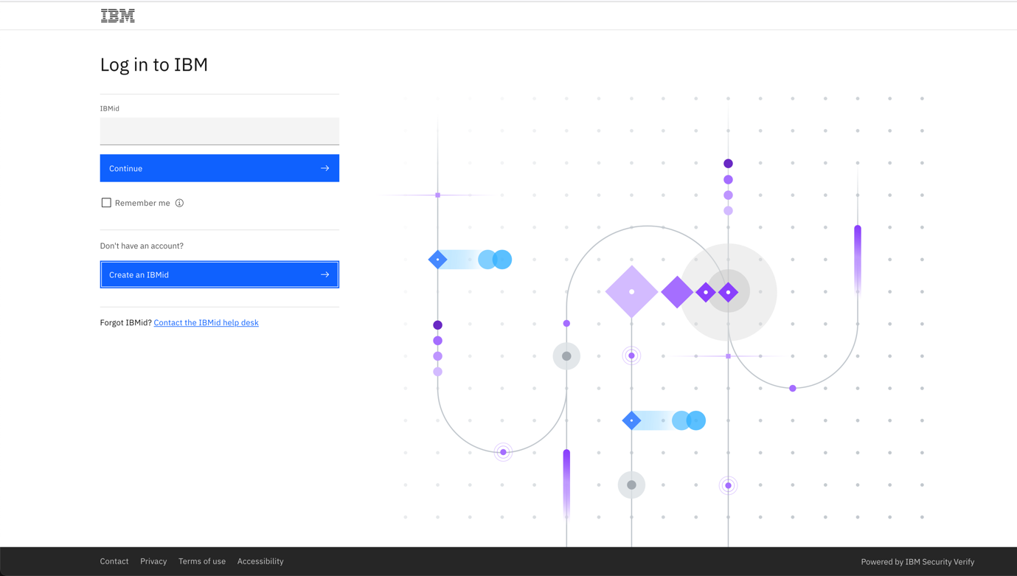

Click on the `Create an IBMid`` button and proceed to fill in the details on this form:

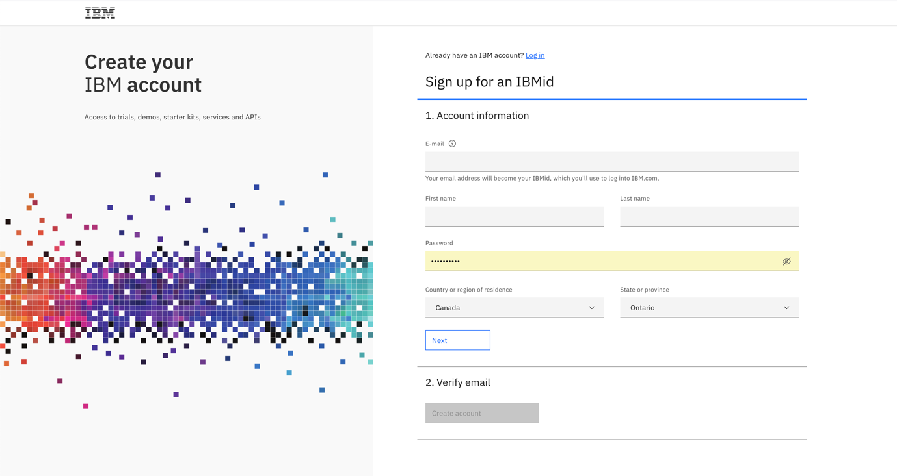

Once you have verified your account, you can continue onto logging into the TechZone server.

# Requesting a TechZone image

Log into Techzone (<https://techzone.ibm.com>) and search for the watsonx.data Developer Base Image or use the following link.

<https://techzone.ibm.com/collection/ibm-watsonxdata-developer-base-image>

If you have not logged into the IBM Cloud site, you will be asked to authenticate with your IBM userid. If you do not have an IBM userid, you will need to register for one. This lab is open to IBMers and Business Partners. Once you have logged in, you should see the following.

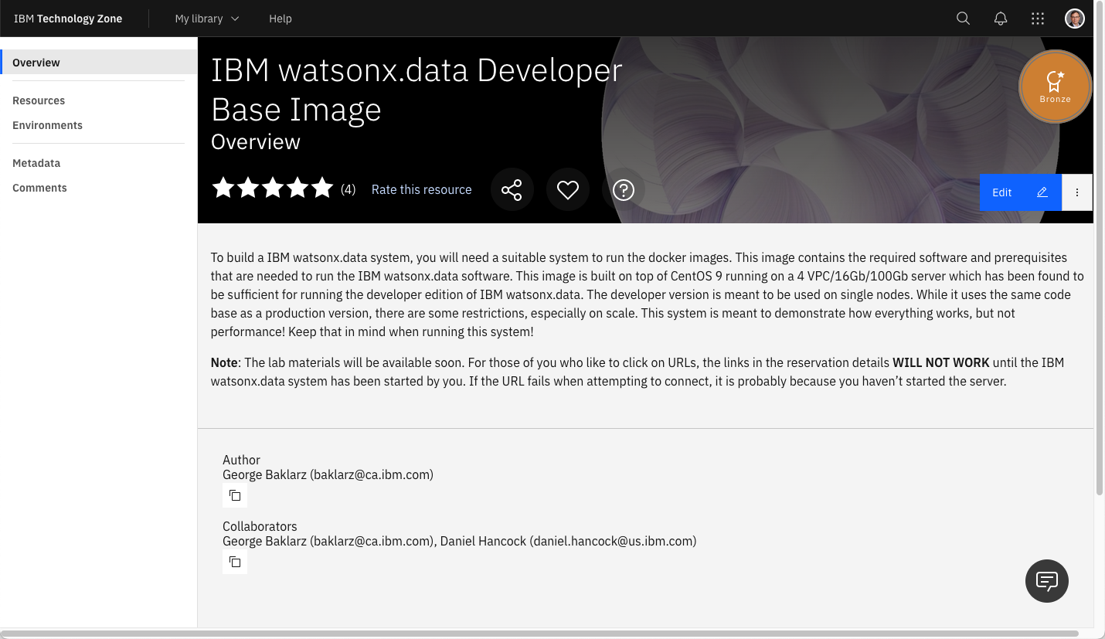

Select the Environment tab on the far-left side.

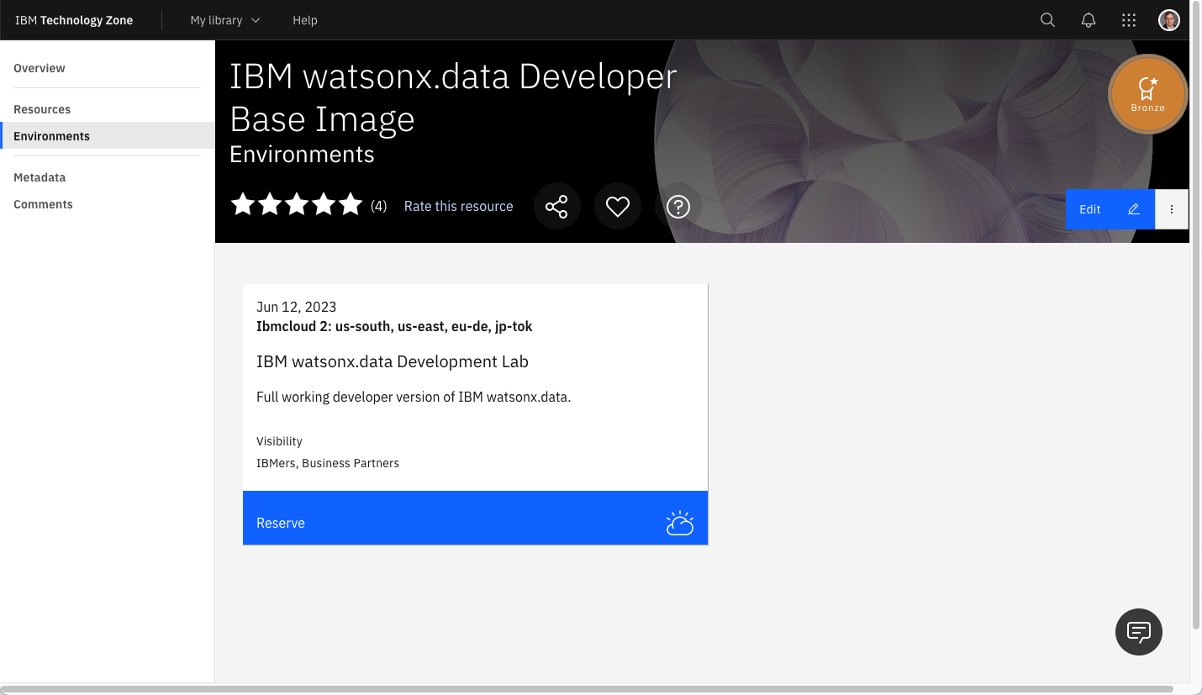

Press the Reserve button.

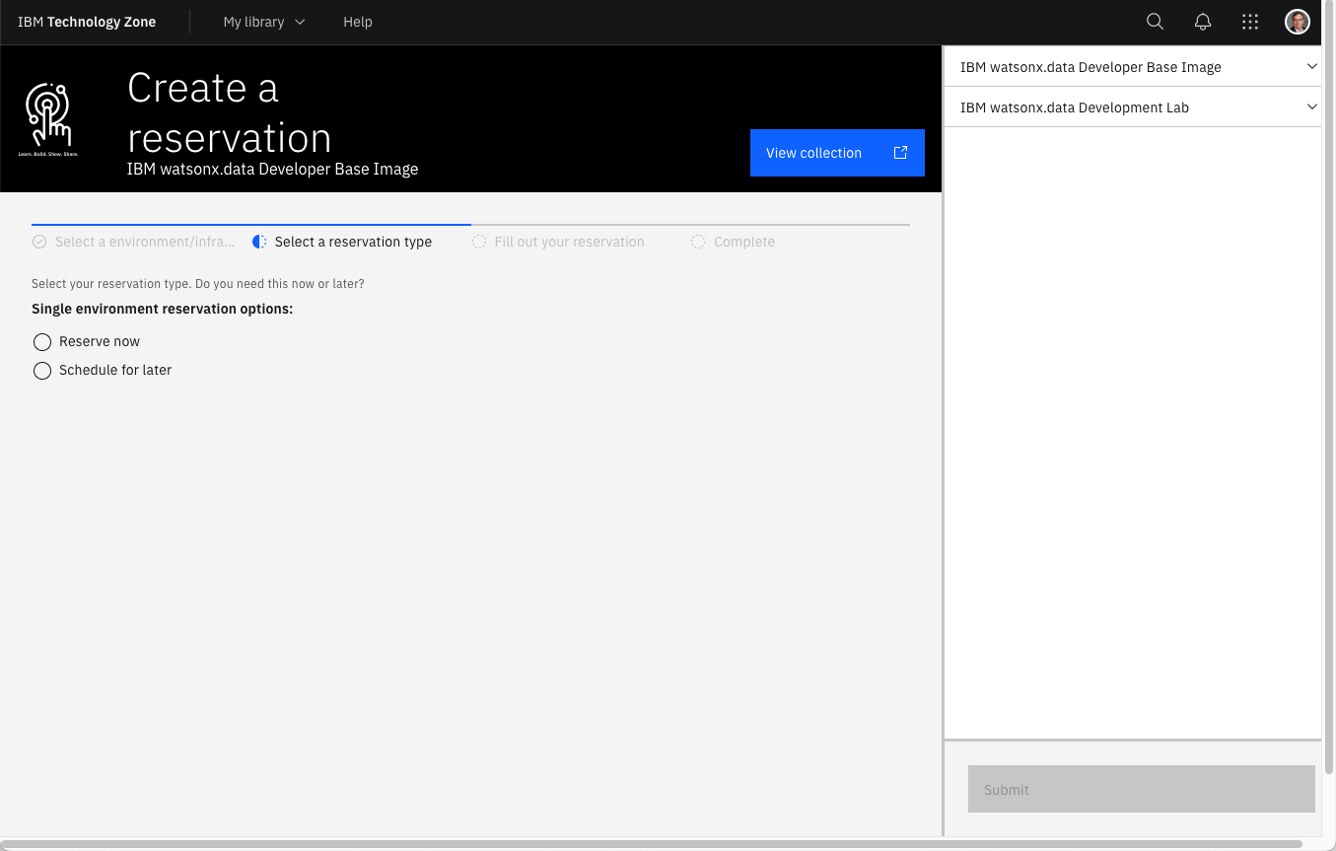

Select “reserve now” (why wait?).

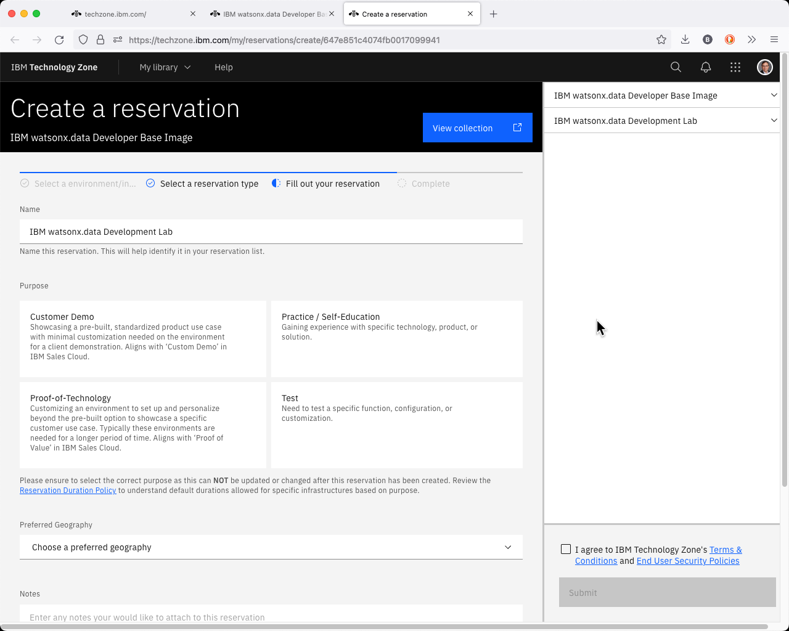

For “Purpose” select Self Education. This will expand to request additional information.

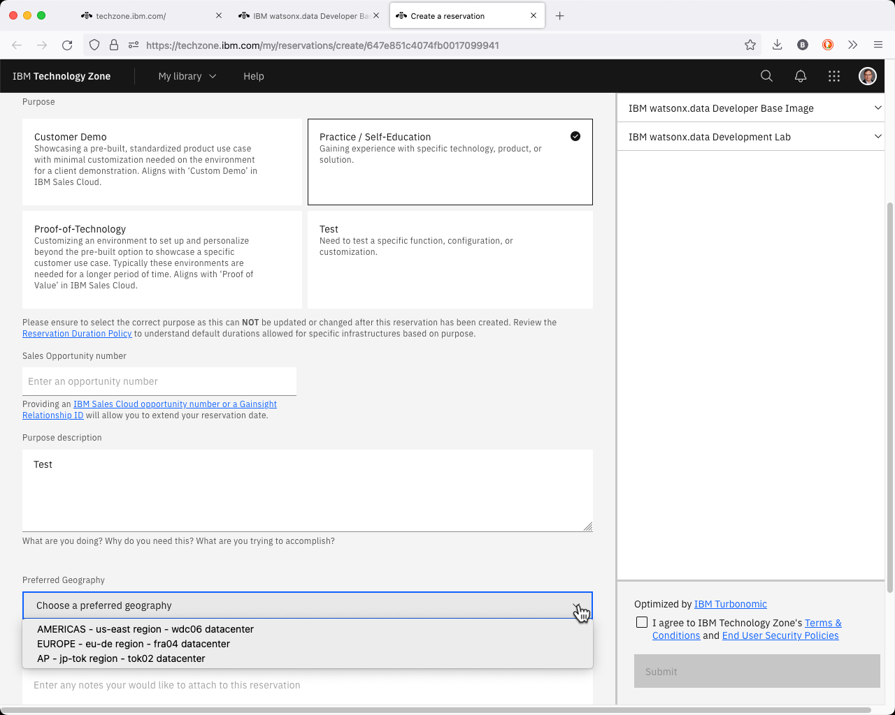

Fill in the purpose field with something meaningful (watsonx.data education). Next select preferred Geography for the image.

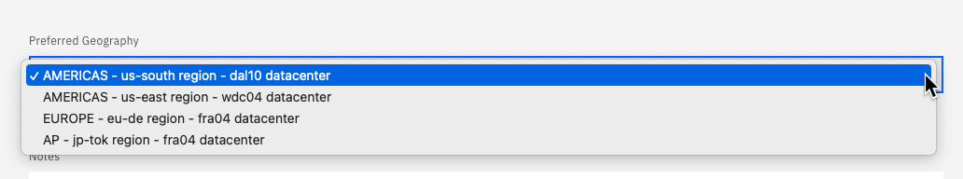

Choose any of the regions that are closest to your location.

**Note**: During periods of high TechZone utilization, the provisioning of your lab environment may fail. This is not an error with the lab itself, but a consequence of the popularity of running workloads on TechZone. The recommendation is to try to reserve the environment again and choose a different data center. To check the status of the TechZone environment, please refer to the TechZone status page at <https://techzone.status.io>.

Next select the end date for the lab.

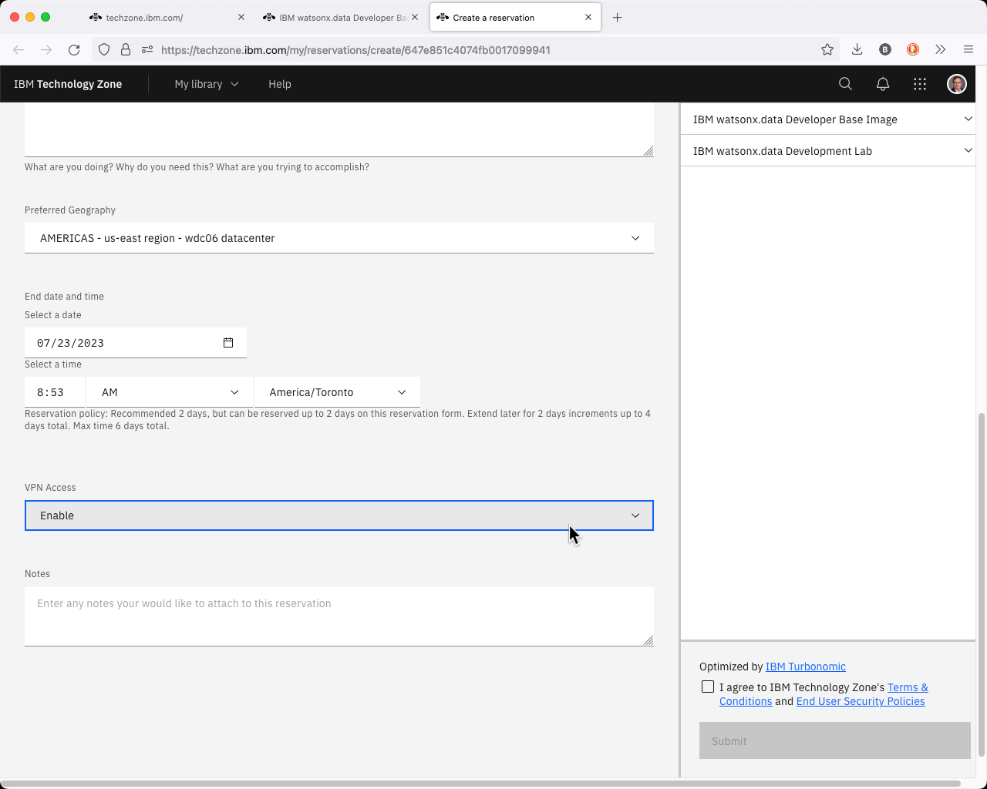

Make sure you select enough time for you to use the lab! It defaults to 2 days, but you can extend the reservation! **You must enable VPN Access**. If you do not enable VPN you will have to run the lab entirely in the TechZone browser.

Once you have completed the form, check the box indicating that you agree to the terms and conditions of using TechZone and click SUBMIT on the bottom right-hand corner.

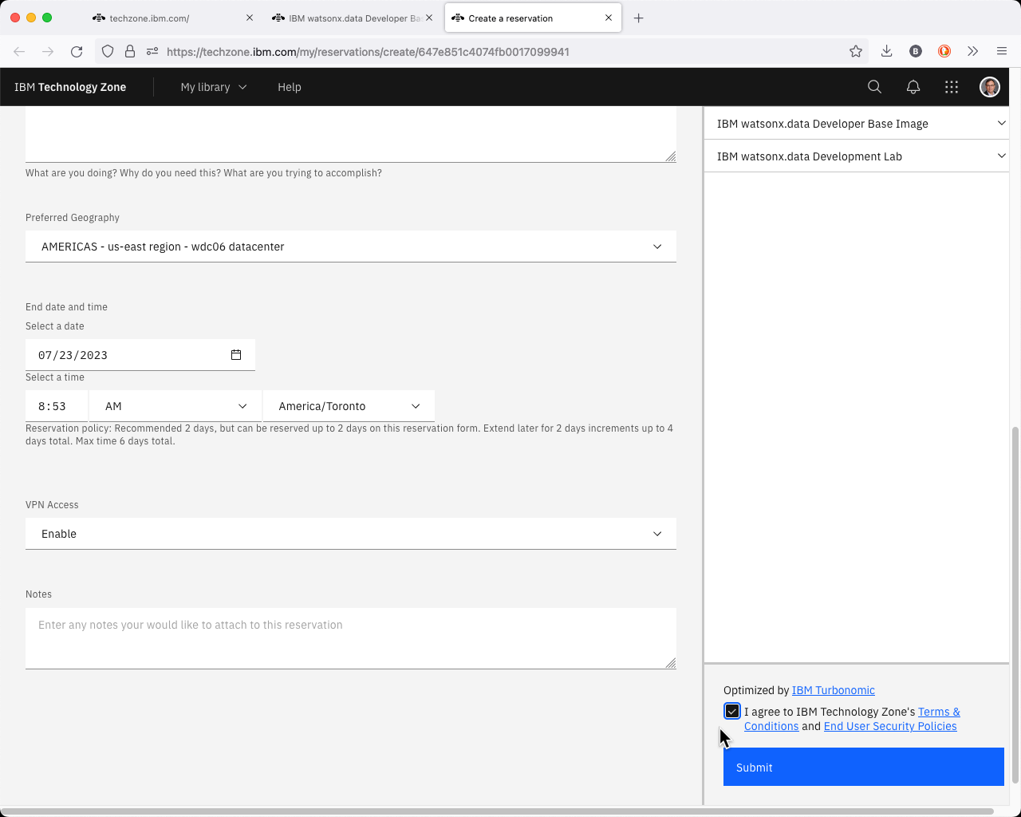

At this point you will need to wait patiently for an email that acknowledges that your request has been placed into Provisioning mode.

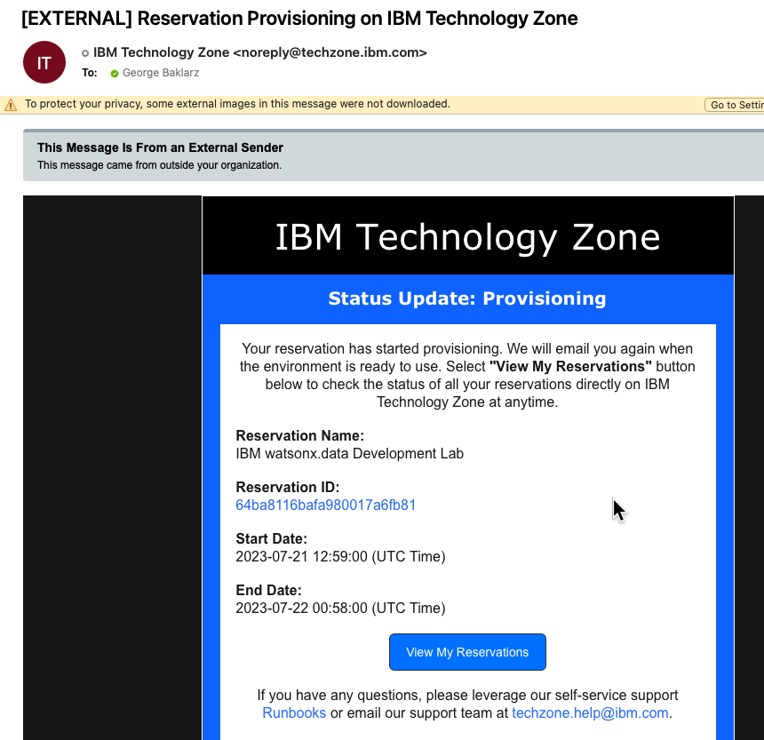

Eventually you will receive an email confirming that the system is ready to be used. Note that this can take a number of hours depending on the load on the TechZone servers.

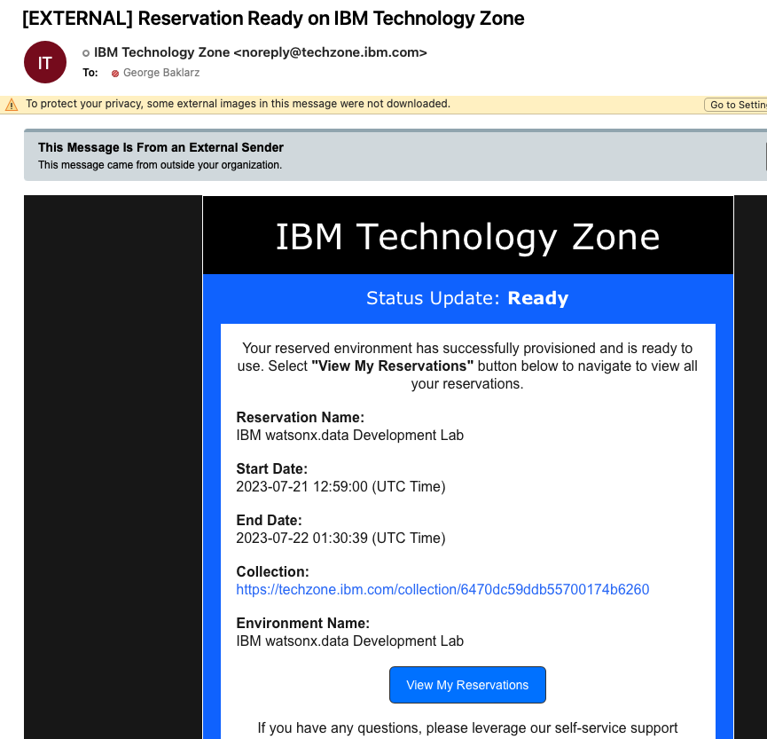

You may also get a message telling you that the system provisioning has Failed.

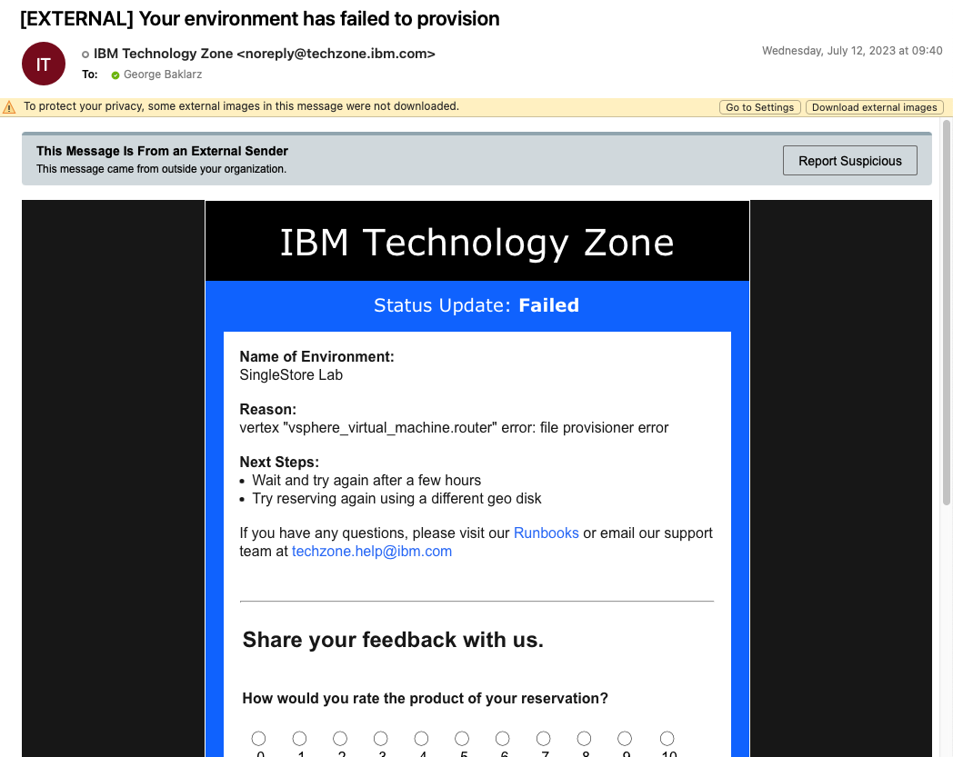

Ignore the reason field since it is usually related to an environment failure caused by lack of resources. Check the status of Techzone first (<https://techzone.status.io>). If the systems appear to be okay, try requesting another image or using a different server location if possible. Contact TechZone support if you are having difficulties provisioning a system.

# Accessing the watsonx.data TechZone Image

The reservation email from TechZone is extremely important since it provides a link to your reservation.



Click on the **View My Reservations** to access your reservations.

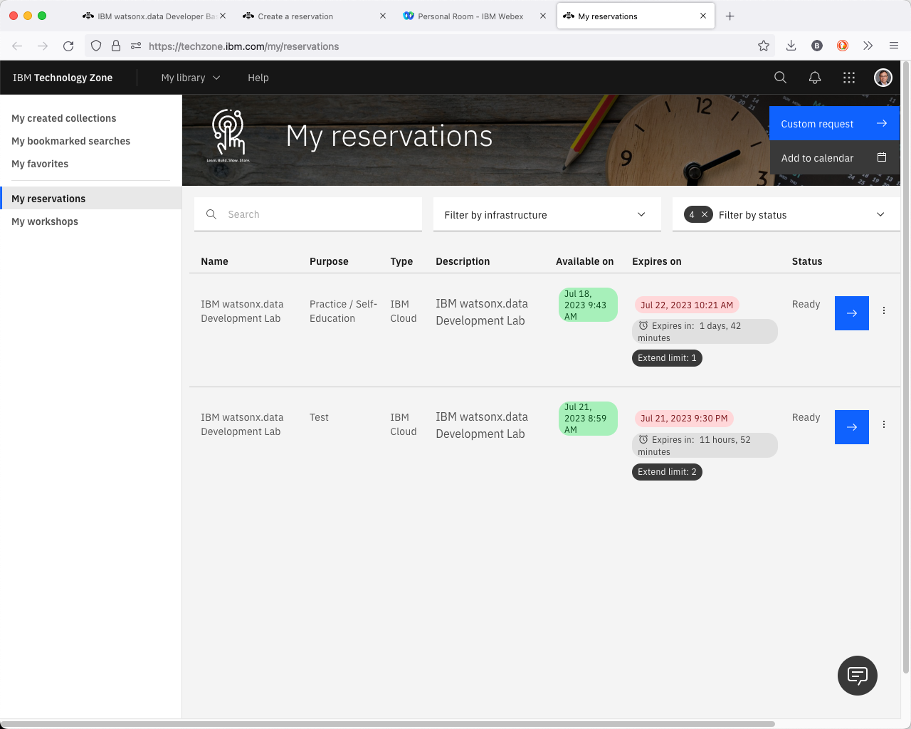

Click on the arrows that corresponds to the watsonx.data reservation. The menu button that is beside the arrow provides options to extend or delete the reservation.

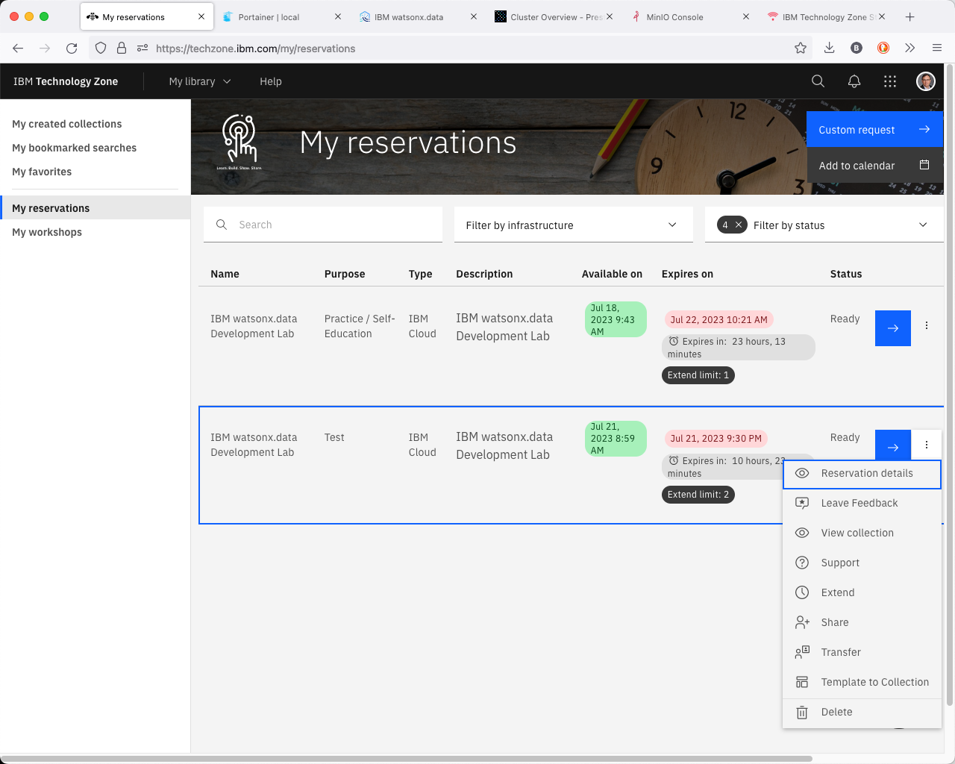

When you click on the arrow the browser will display the details of your image.

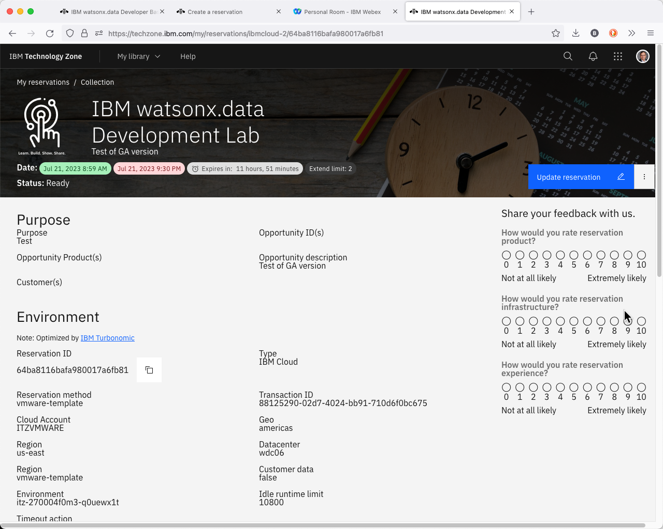

Scroll down to the bottom of the web page to get the VPN certificate.

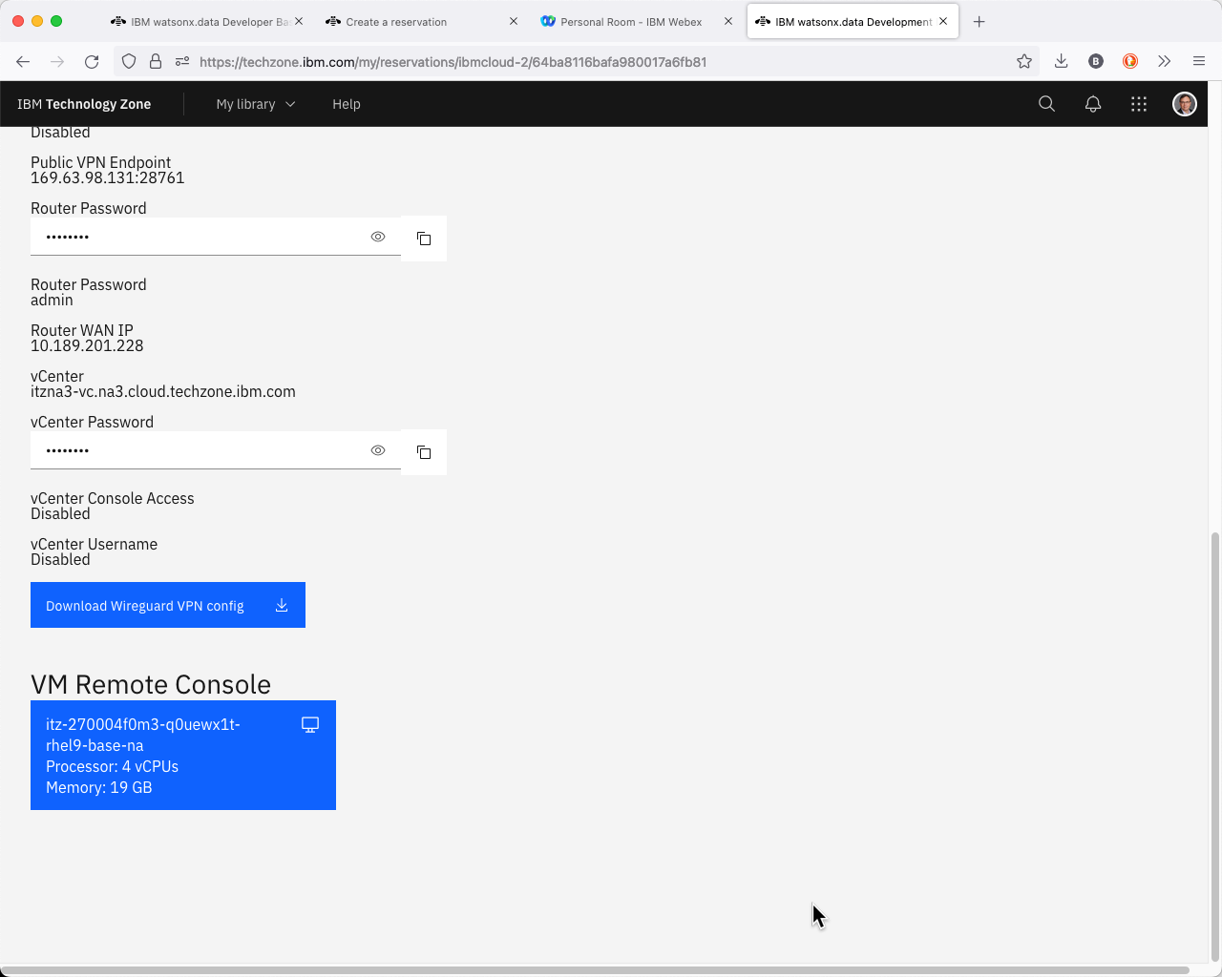

Click the Download VPN certificate to your machine and remember the filename for later use.

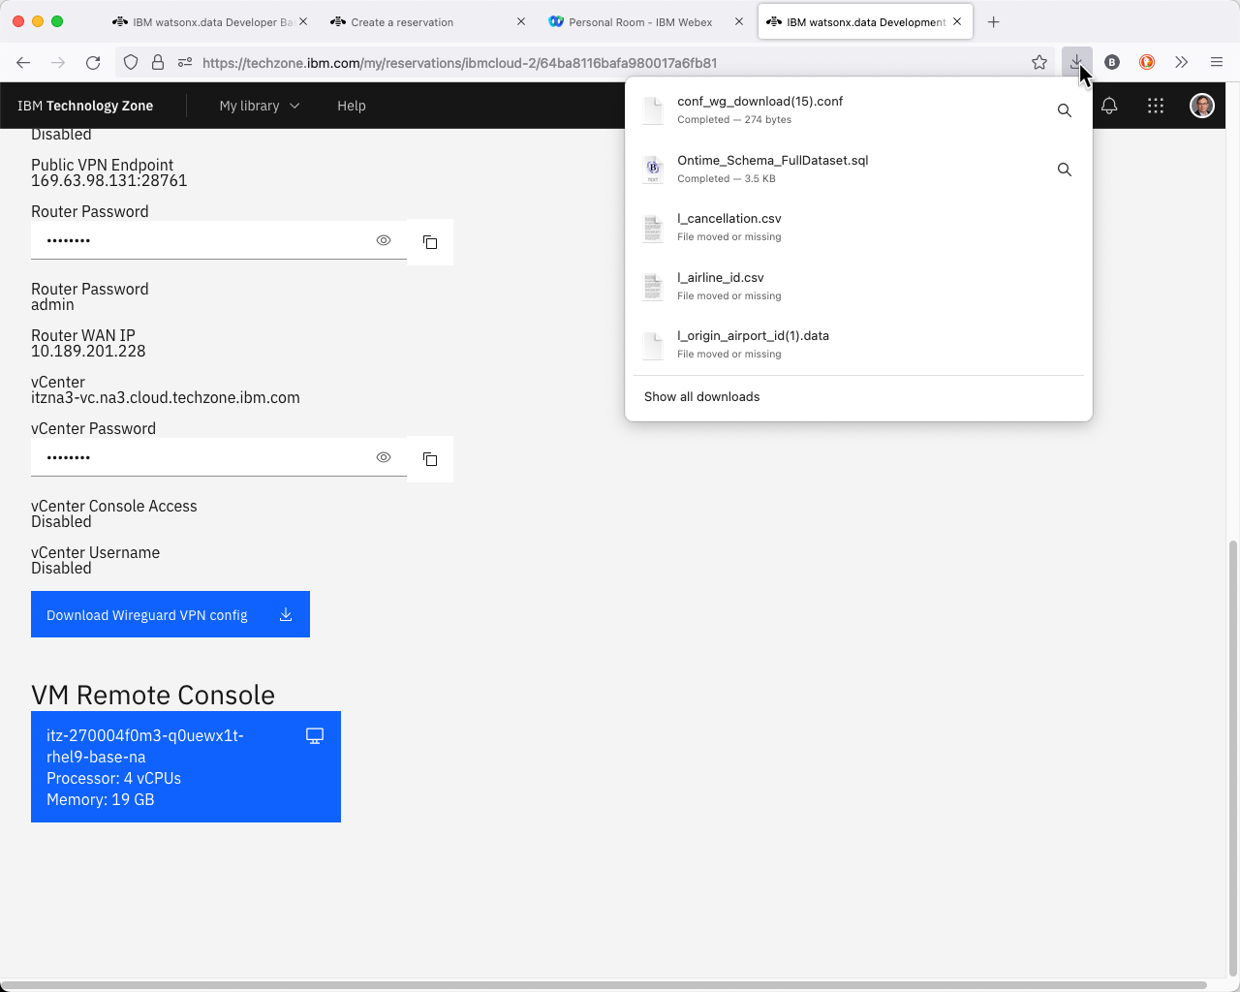

You can access the logon screen of the virtual machine by pressing the VM Remote Console button. **It is not recommended to use this interface for accessing the virtual machine.**

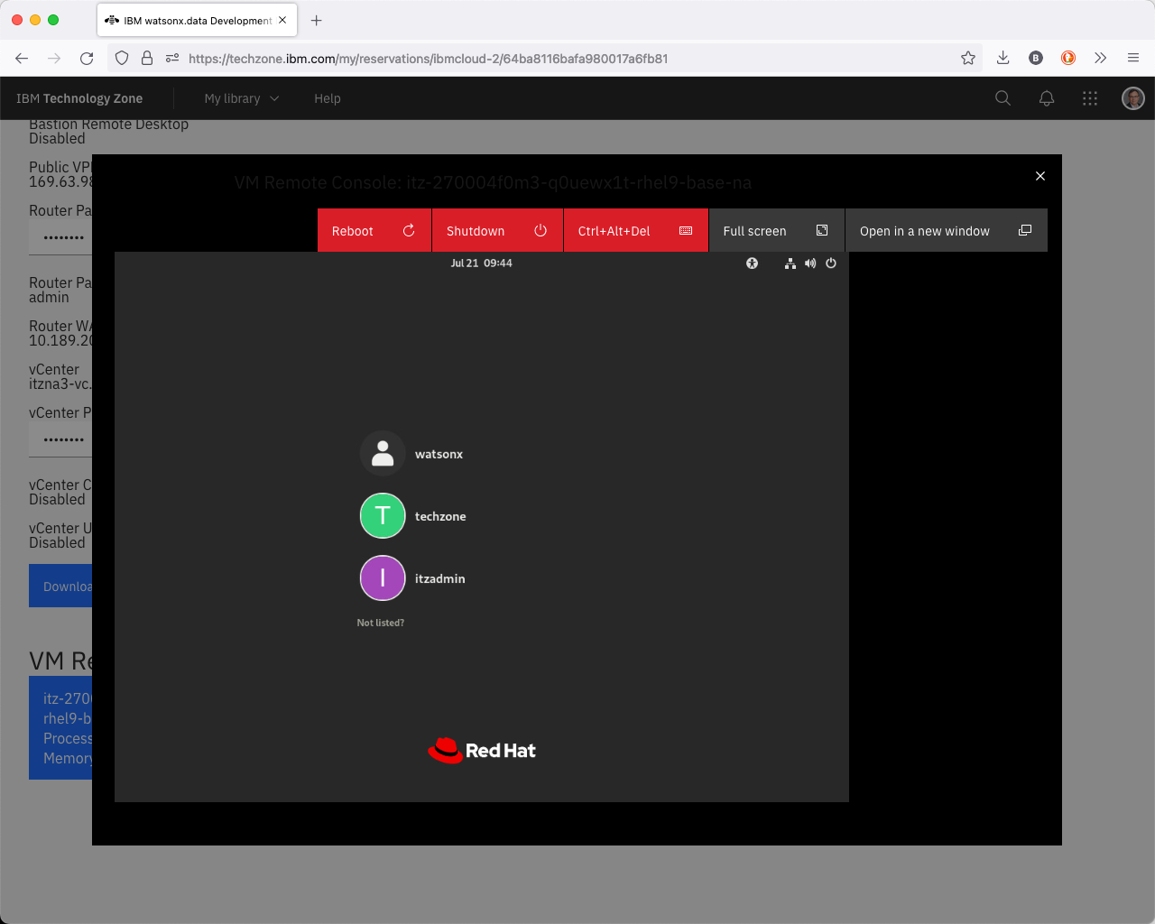

Refer to the section on [Using VNC](https://db2-dte-poc.github.io/wxddemo/wxd-reference-vnc/) for more details.

# Wireguard VPN Access

**Note:** If you cannot install a VPN program like Wireguard on your system, you will need to skip this section and use the VM Remote Console. See [Using VNC](https://db2-dte-poc.github.io/wxddemo/wxd-reference-vnc/#techzone-guacamole-access) for more details.

## **Download the VPN Certificate**

If you have not already downloaded the VPN certificate, follow these steps.

Access your reservation from the TechZone site. Click on the arrows that corresponds to the watsonx.data reservation.



When you click on the arrow the browser will display the details of your image.



Scroll down to the bottom of the web page to get the VPN certificate.



Click the Download VPN certificate to your machine and remember the filename for later use.



## **Wireguard VPN Client**

WireGuard uses state-of-the-art cryptography and network code to create an encrypted tunnel between two devices based on symmetric encryption. Wireguard can run at the same time as the IBM VPN client.

If you do not have this software on your system, download the software from the following site.

[https://www.wireguard.com/install](https://www.wireguard.com/install/)

Once you have the VPN downloaded, you must start the Wireguard VPN client. It will display a list of existing connections. The following system has no certificates loaded and immediately asks if you want to import a certificate.

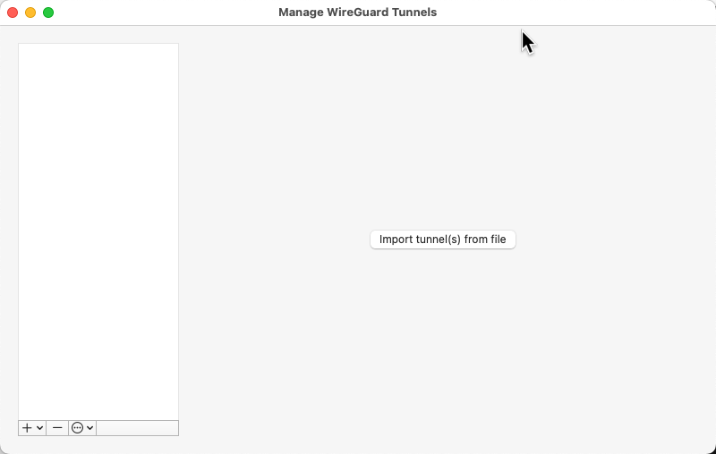

If you have existing connections, the screen looks similar to this.

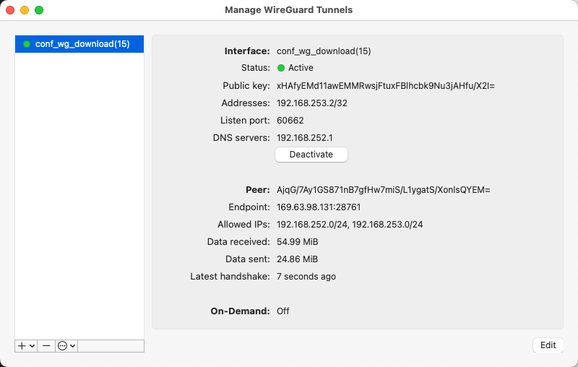

In the OSX (Mac) environment, press the [+] button in the bottom left corner of the list.

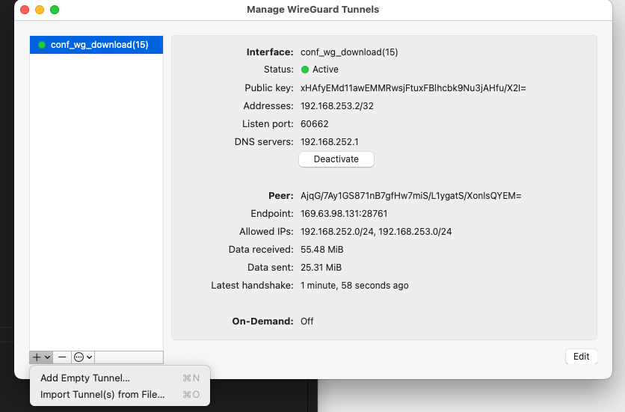

Choose “Import Tunnels(s) from File”.

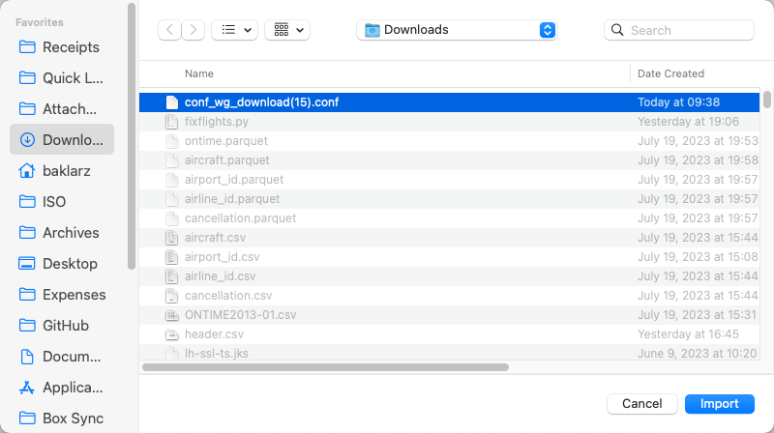

Here you can see the “cong_wg_download(15).conf” file is highlighted. Select the name of the file on your system to import it.

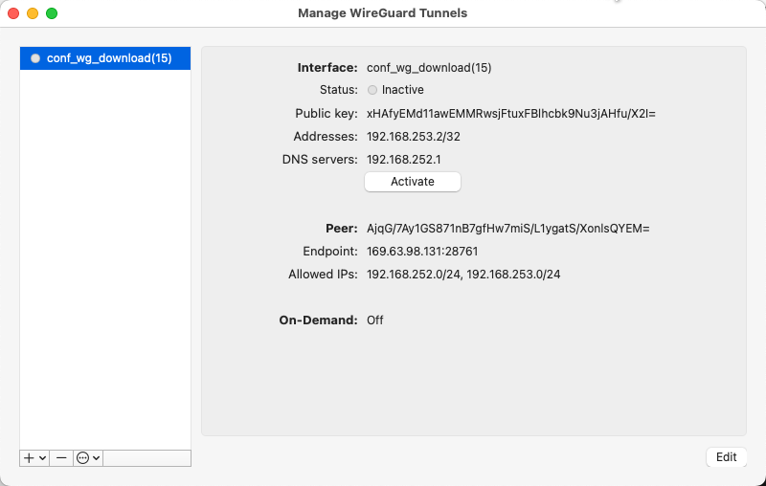

Now that the VPN configuration is in the list, select it and press the Activate button. You should see the Status turn on.

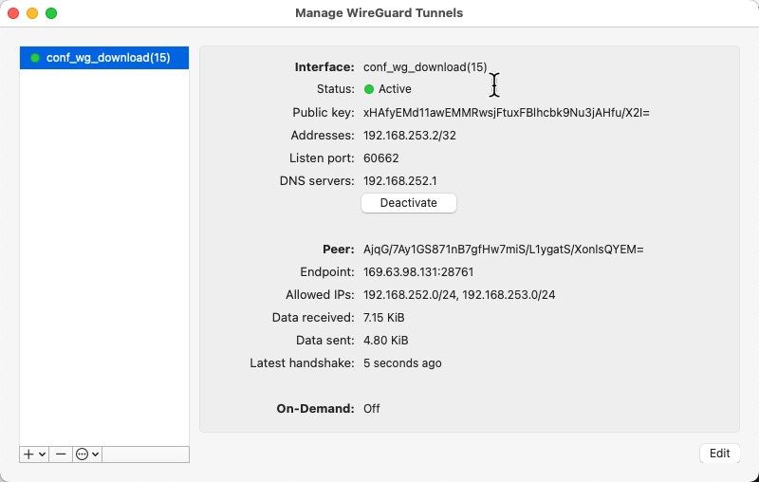

At this point, any IP addresses starting with 192.168.252.2 will route to your Lab machine. In addition, you will be able to use your Terminal session locally to shell into the server, without having to use the VM Console.

Once you are done with your lab, you should **disconnect the service**. Note that leaving this service on can sometimes cause IP address issues with other websites (even IBM internal sites!).

## **Wireguard Not Starting**

On the Mac, the Wireguard application will not always display in the Dock. If it doesn't appear to "start", it may be sitting in the Systray at the bottom or top of your screen. The icon will be gray if no connections are active.



# Using VNC (Virtual Console)

The watsonx server that has been provisioned has no physical monitor attached to it (headless is what it is commonly referred to) and so we need to use a different technique to view the desktop of the main user or the system (watsonx).

The first thing to consider is whether you need to use VNC at all. All the services like the watsonx.data UI, MinIO, Presto, Apache Superset and Portainer, are all web-based servers which means you just need to use your own browser to access these programs.

Connecting into the watsonx virtual machine can be done using the secure shell command (ssh) which provides access to all the low-level commands you might need to use like starting the Apache Superset service. Note that Apache Superset is not up and running by default, so you will need to start it before attempting to connect to it.

So what's VNC required for? One program that has been provided to view the database schemas is dBeaver, a community edition of software that provides a query interface to 100's of data sources, including the watsonx.data environment. You can only use this program using VNC. You do have the option of installing this software on your own machine if you wish.

Select the section which best describes your environment:

* [I am on a Mac OSX system and I can use VPN (Wireguard)](https://db2-dte-poc.github.io/wxddemo/wxd-reference-vnc/#access-watsonxdata-on-a-mac-osx-system)
* [I am on a Windows system and I can use VPN (Wiregaurd)](https://db2-dte-poc.github.io/wxddemo/wxd-reference-vnc/#access-watsonxdata-on-a-windows-system)
* [I am on a system which is locked down and cannot install software](https://db2-dte-poc.github.io/wxddemo/wxd-reference-vnc/#access-watsonxdata-with-no-vpn-or-vnc-access)

## **Access watsonx.data on a Mac OSX system**

In order to access the console of the watsonx.data server, a VNC service needs to be used. Once your reservation is active, you can connect to the machine using the VNC service that has been started on the machine.

* VNC for watsonx userid (OSX) - vnc://192.168.252.2:5901

Use the Mac screen sharing app to connect to watsonx.data. You can connect using the OSX Safari browser by using the URL provided above. It will automatically start the screen sharing application.

**Note**: The VNC URL format is only valid in Safari and will not work in other browsers.

When the service connects to the server it will prompt for the password of the watsonx user - watsonx.data.

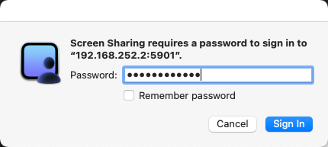

Once connected you will see the console of the watsonx user.

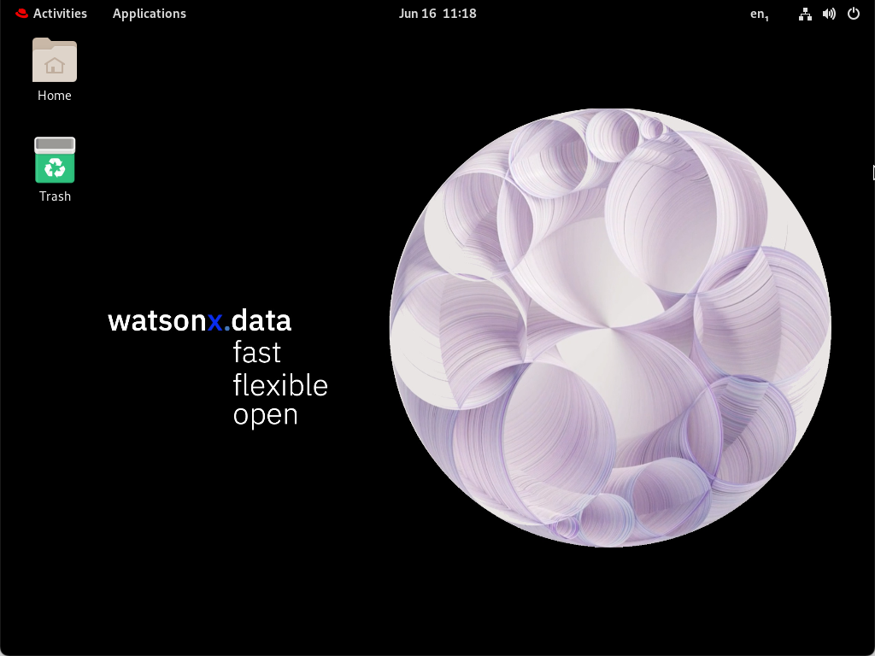

You may also want to consider making the screen size larger. Use the drop-down menu (Applications) at the top of the screen to select Other -> Settings.

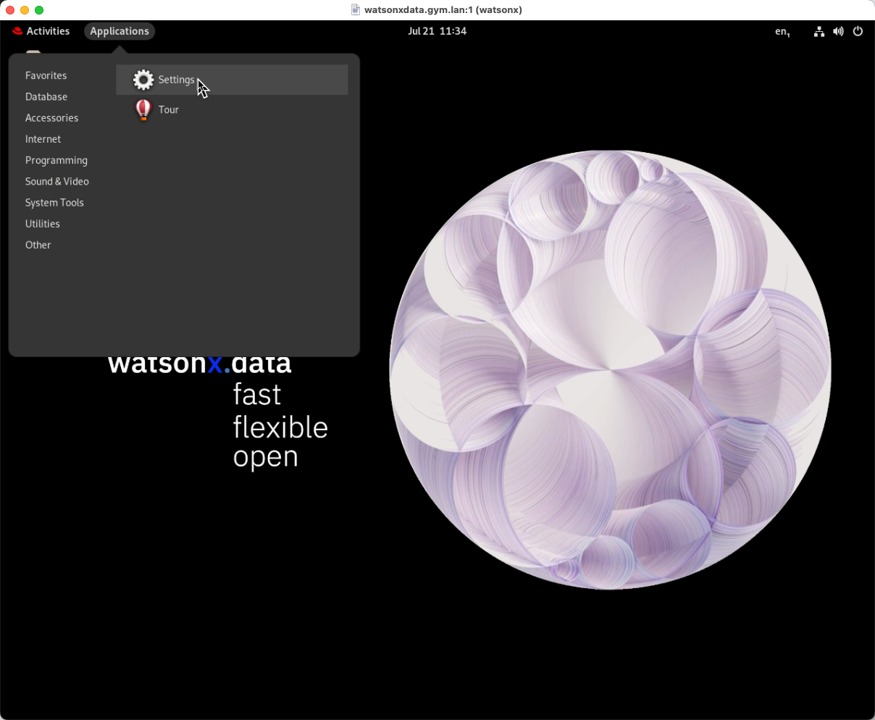

In the Devices section of the Setting menu, select Displays and choose a resolution that is suitable for your environment.

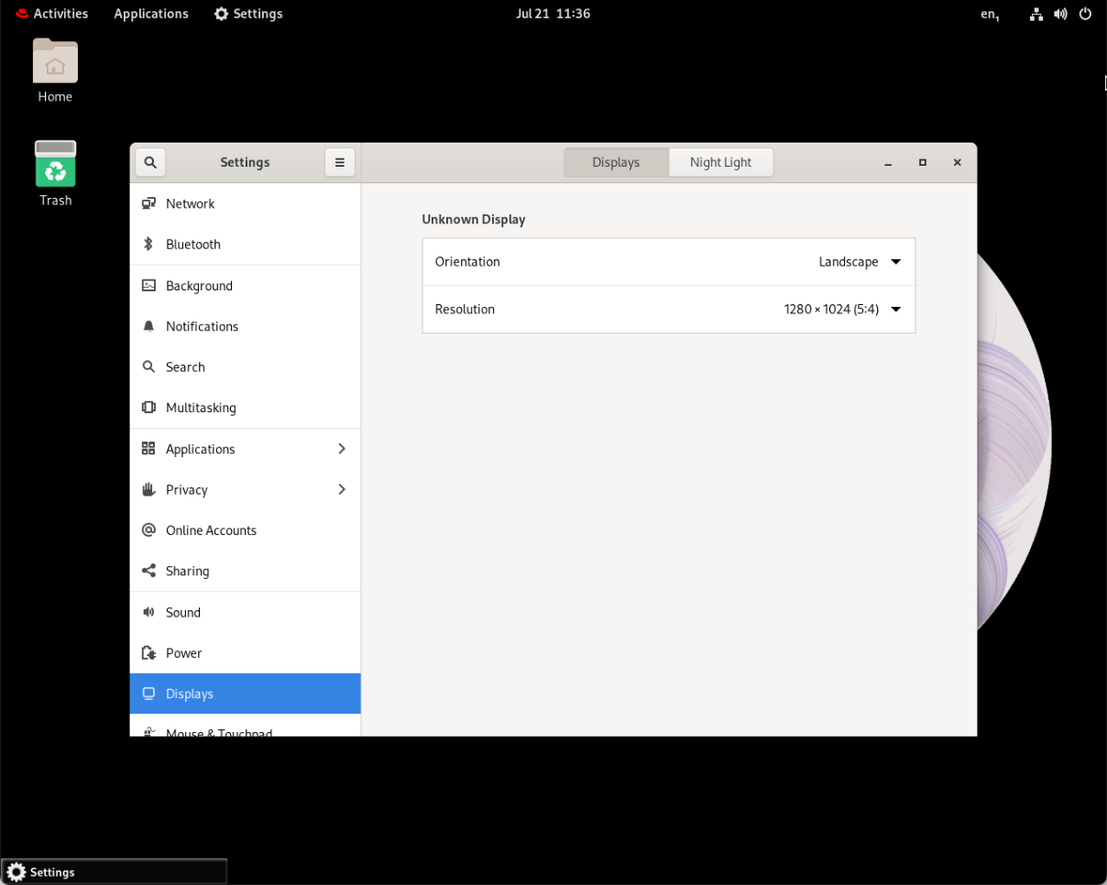

Please review [Restrictions on using VNC](https://db2-dte-poc.github.io/wxddemo/wxd-reference-vnc/#restrictions-on-using-the-vm-remote-console-or-vnc) below.

## **Access watsonx.data on a Windows system**

Windows does not supply a native VNC browser. You will need to install a program like RealVNC or UltraVNC to access the console. Directions for installing UltraVNC are shown below.

### **UltraVNC**

UltraVNC is a VNC browser for the Windows environment. This is an open-source offering that can be found on Github in the [UltraVNC project](https://github.com/ultravnc/ultravnc).

The developers of this code have additional offerings that they sell for a fee and use advertising on their site to support their work on this and other projects. Because of the way the website has been designed, there are a number of ads and buttons that might distract you from the actual product you want to download.

The official web page of UltraVNC is <https://uvnc.com/>. Instead of going through all the menus, use the following link to go directly to the download screen:

* [UltraVNC Download Link](https://uvnc.com/component/jdownloads/summary/453-ultravnc-1431-x64-setup.html)

The website will display an initial download page that will wait for 10 seconds before you can do anything. This gives you time to read the advertising or make a voluntary donation to their coding efforts.

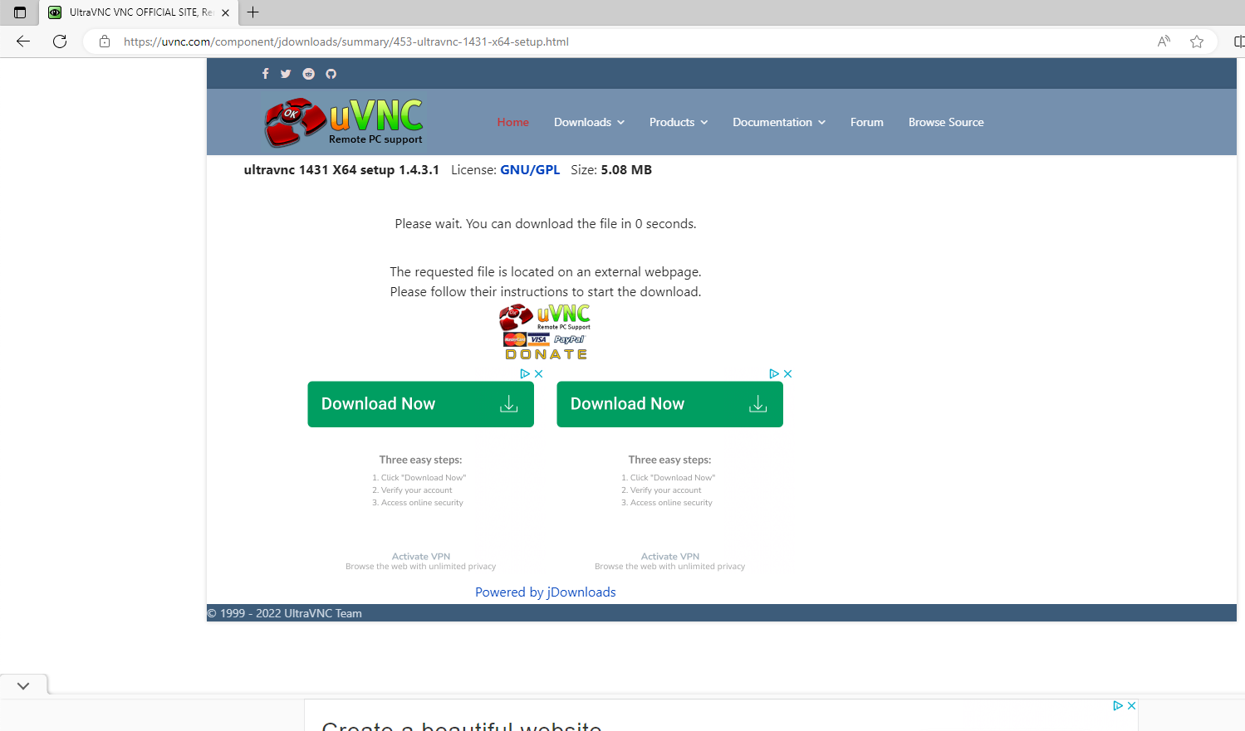

Once the wait time has expired, you will see the following screen:

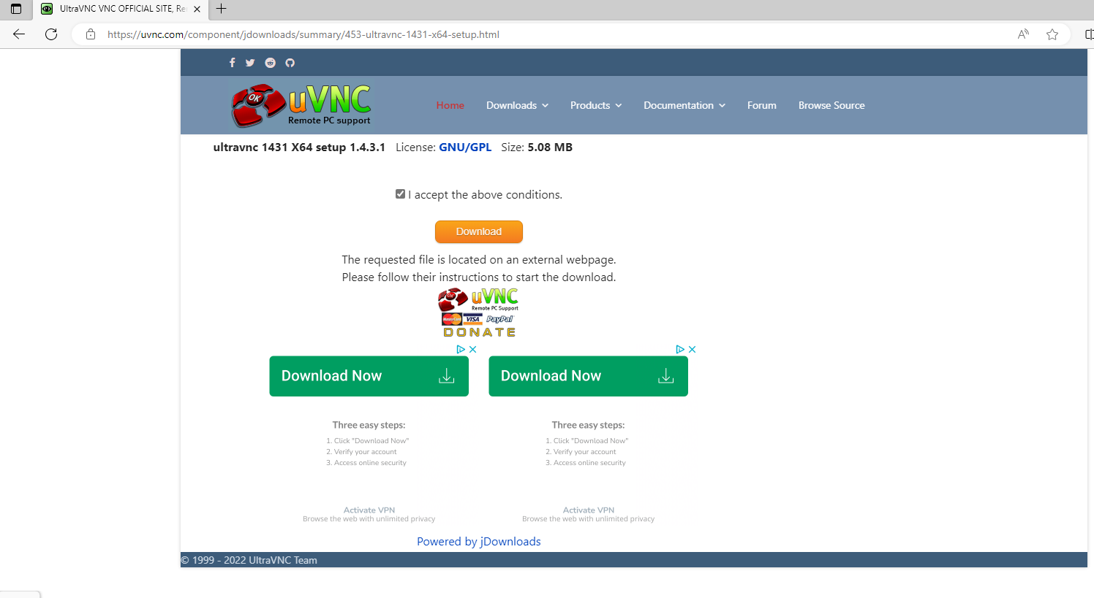

Make sure to check that you accept the above conditions and press the download button. You should see the download progress in your browser.

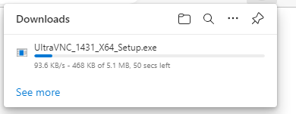

Click "Open File" against the downloaded file.

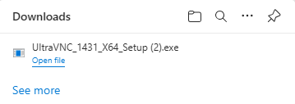

Once the installer starts it will ask for you to approve changes to the system.

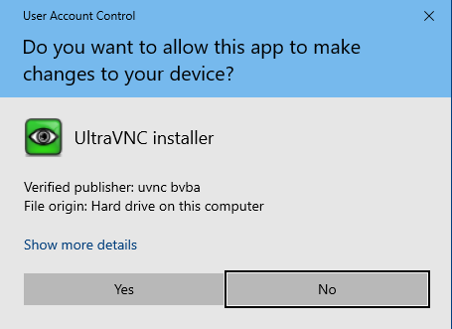

Press Yes and then select the language you want.

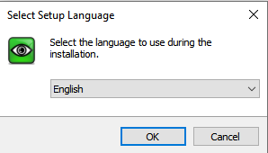

Press OK.

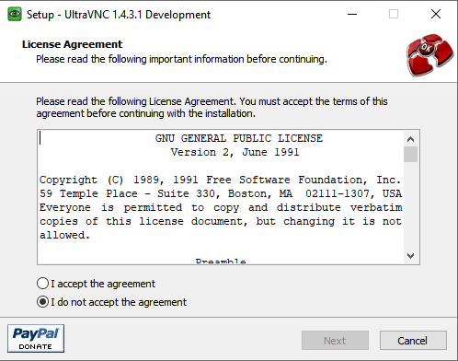

Select Accept the license agreement and press Next.

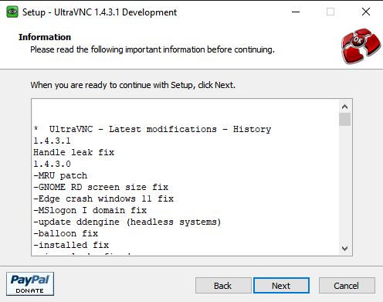

The summary of what it is going to install is shown on this screen. You will then have to provide the installation location or use the default location for the code.

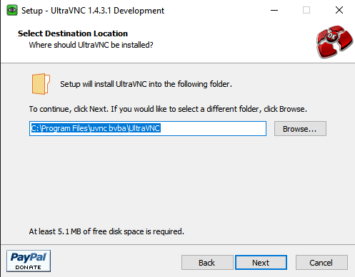

The next panel asks which components you want to install. **Only** install the viewer.

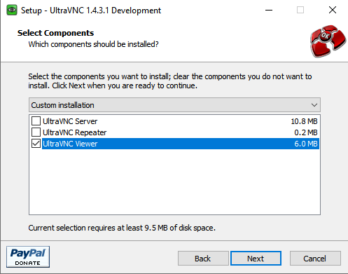

Then it requests the name of the Shortcut folder. Just keep the name it recommends.

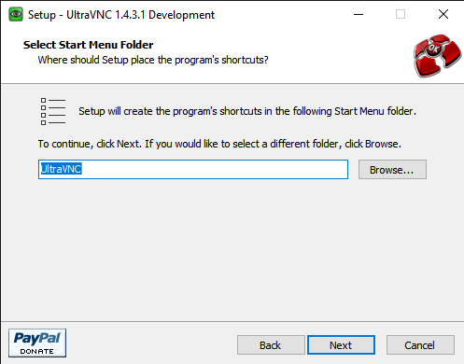

Press Next. The next panel comes up that asks if you want a desktop shortcut. Probably a good idea if you are going to use it for a long period of time. Notice how they make this install take longer than expected to get you to donate?

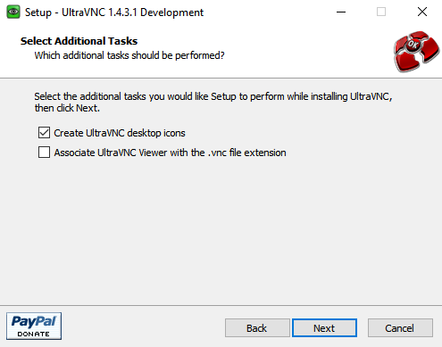

After all of that you will see the final installation screen.

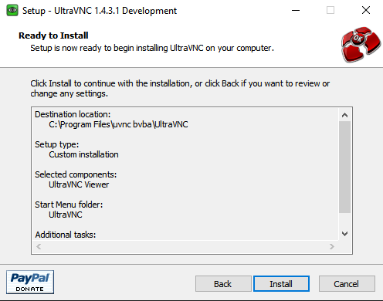

Click on Install and eventually you will get the completion notice.

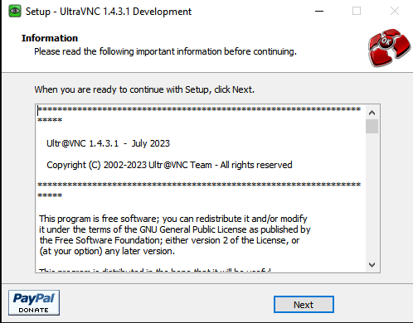

Pressing Finish will give you one final chance to donate. Make sure to unselect "Show latest releases" or else you will be directed back to their website.

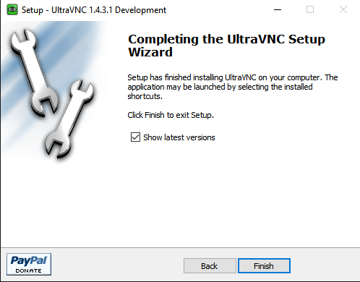

### **Using UltraVNC**

Start UltraVNC viewer by scrolling through your applications on your desktop. Choose the UltraVNC Viewer (not the listen mode ones **unless** you want to watch someone else using the desktop).

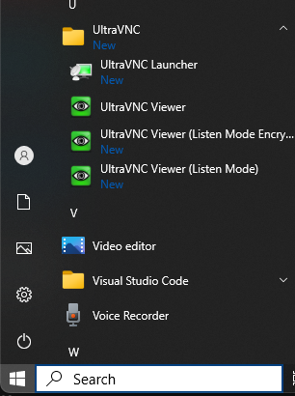

When the service starts, it will ask for the server and port. Enter 192.168.252.2:5901 in this field.

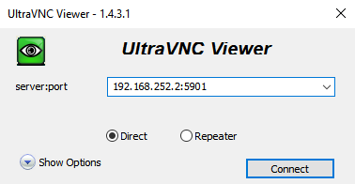

Before hitting enter, you may want to select the options button and change the setting in Miscellaneous to prevent advertising from being displayed while working with this program.

Press connect when done.

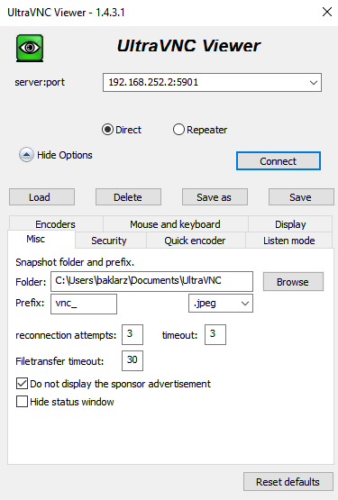

The password for the service is watsonx. which is watsonx with a period . at the end.

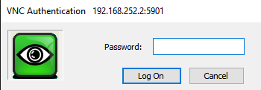

At this point you should see the desktop of the virtual machine.

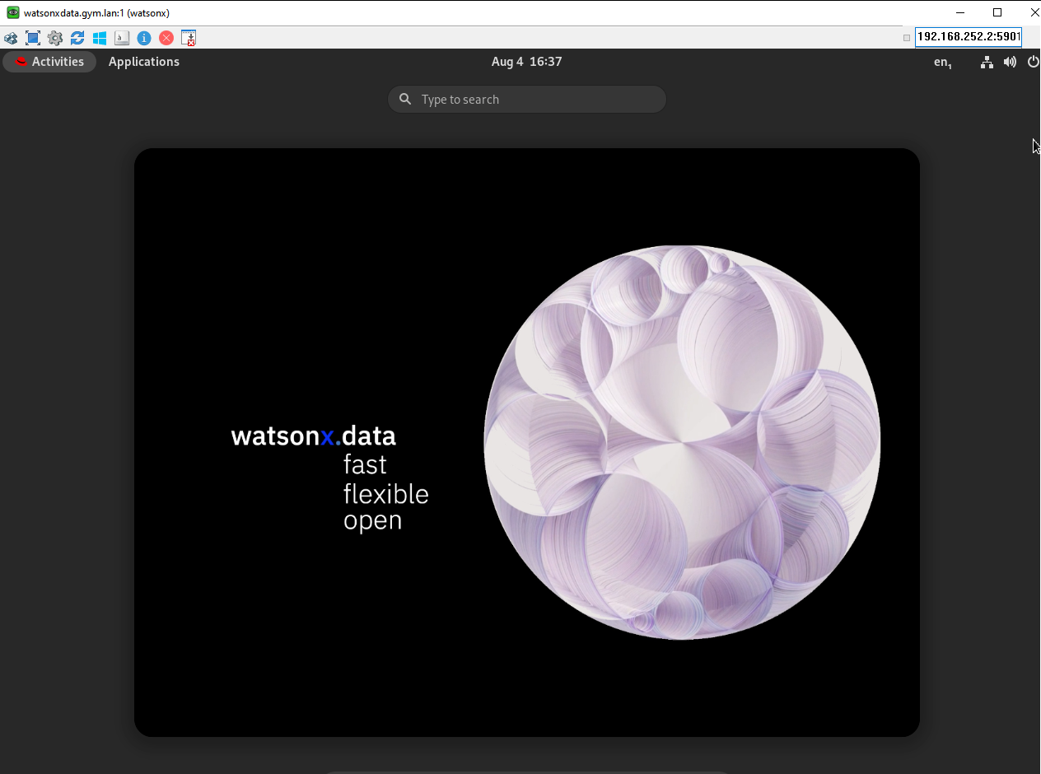

You are now connected and can work on the watsonx.data desktop.

If you find that performance is sluggish, this may be due to network latency. In the settings toolbar of the UltraVNC window, change the color resolution from Full to 256. Your screen may look a bit washed out, but this will reduce the amount of data that needs to be sent over the network to render your screen.

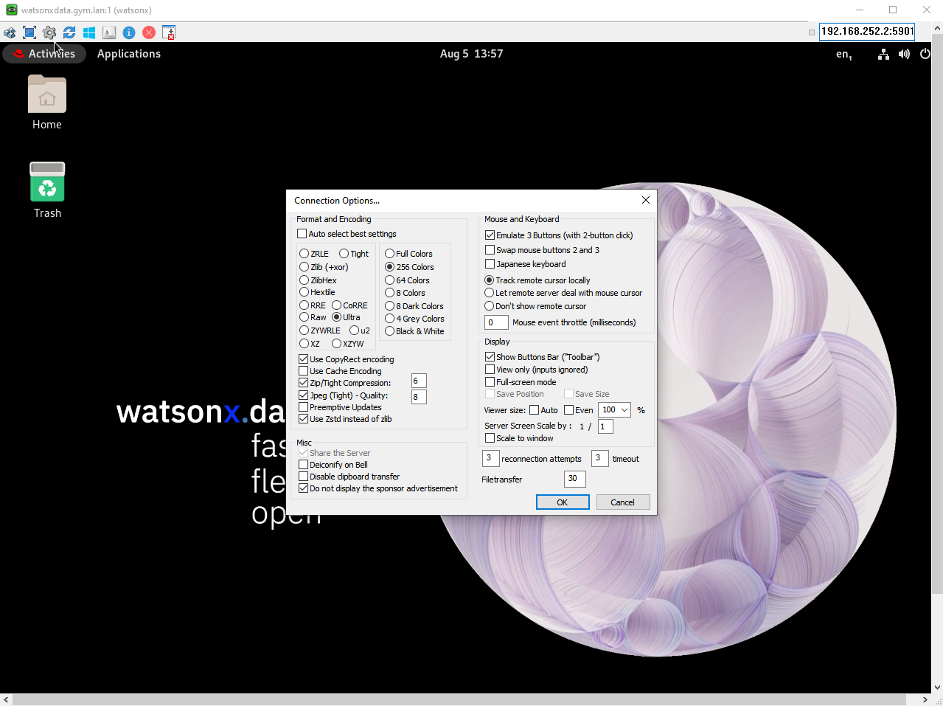

Please review [Restrictions on using VNC](https://db2-dte-poc.github.io/wxddemo/wxd-reference-vnc/#restrictions-on-using-the-vm-remote-console-or-vnc) below.

## **Access watsonx.data with no VPN or VNC access**

Special thanks to Max Simpson for providing guidance on how to use the VM Remote Console.

**Do not use this interface unless you cannot install Wireguard or UltraVNC software on your machine.**

Find your email message that contains details of your reservation. Details of what the reservations and the page containing details of the reservation can be found in the [Accessing the reservation](https://db2-dte-poc.github.io/wxddemo/wxd-reference-access/) section.

Once the details appear, scroll down to the bottom of the web page, and you will see the VM Remote Console button along with the VPN certificates.



You can access the logon screen of the virtual machine by pressing the VM Remote Console button.

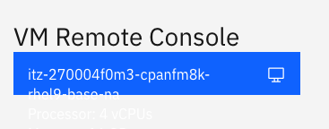

Clicking on this button will display the logon screen for the server.



Select the techzone user and use IBMDem0s! as the password.

Once you are connected to the desktop of the user, select the Terminal App found at the bottom of the screen.

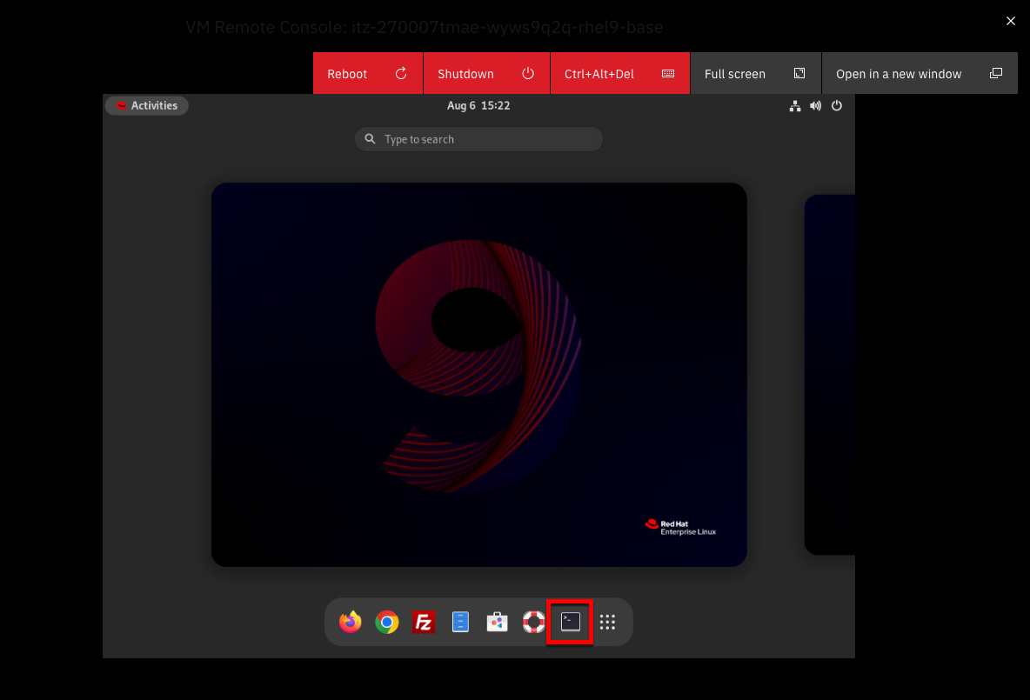

The terminal app should display.

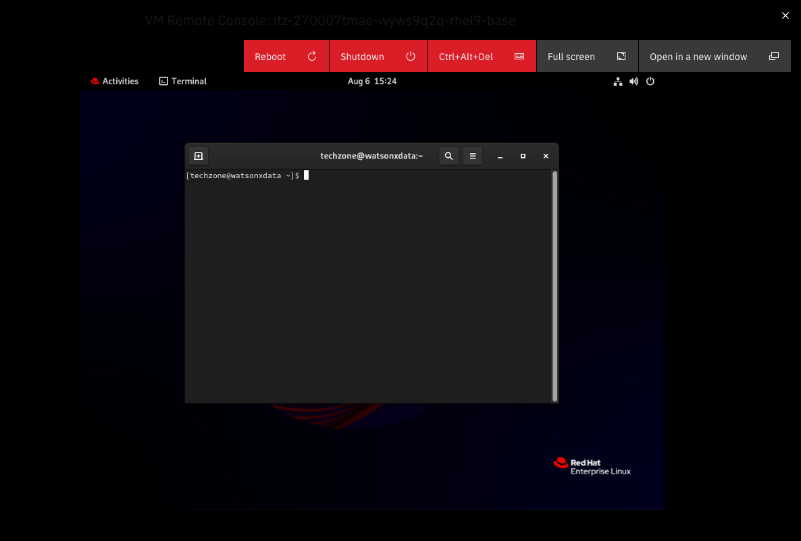

Type the following commands into the terminal window (you cannot cut and paste).

sudo systemctl stop vncserver@:1

sudo systemctl disable vncserver@:1

exit

Once this is done, select the power button at the top of the screen.

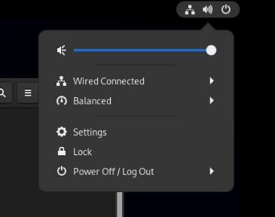

Select the Power Off/Logout Button.

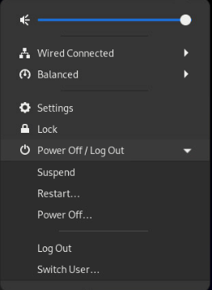

Select Log Out from the menu. **Do not power off the machine at any time, otherwise you will need to restart the machine.**

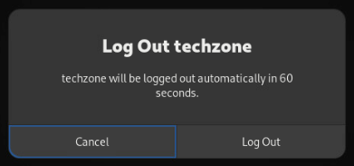

And finally confirm Log Out of this userid.

Next log in as the watsonx user. The password is watsonx.data. At the top of the screen select the Open in a new window box.

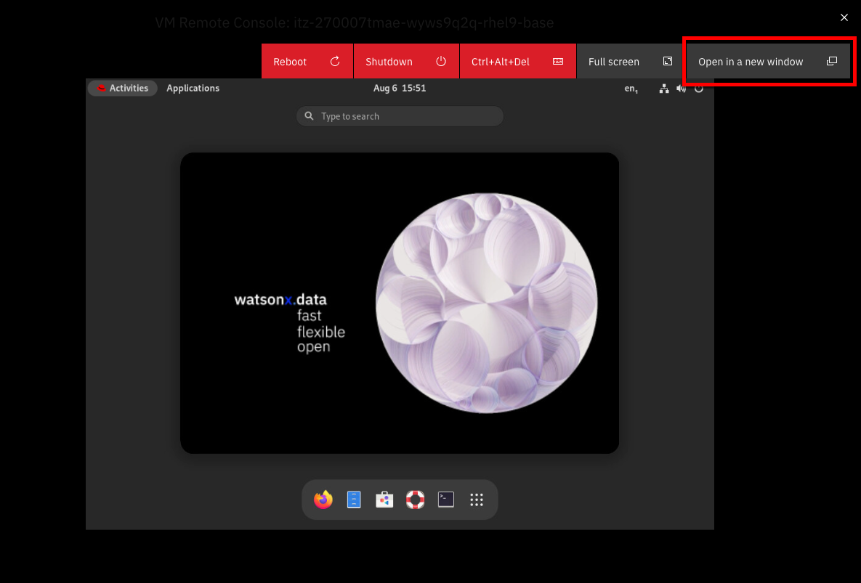

Once in fullscreen mode, select the URL in the browser. Note that you may need to increase the size of your browser window (or change the scaling in the browser) to see all the virtual desktop.

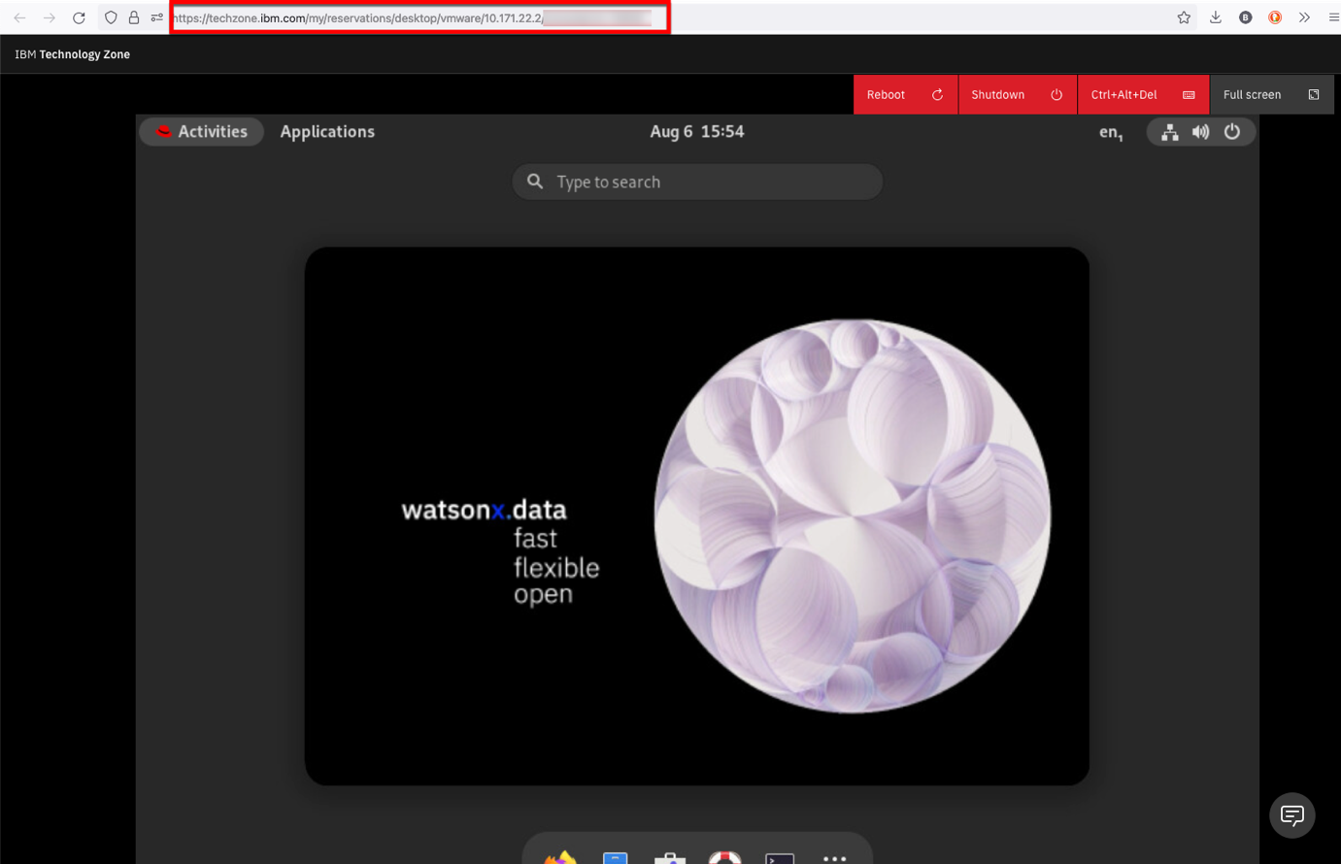

The URL will be similar to https://techzone.ibm.com/my/reservations/desktop/vmware.... You can share this URL will other people who may want access to the console.

Please review [Restrictions on using VNC](https://db2-dte-poc.github.io/wxddemo/wxd-reference-vnc/#restrictions-on-using-the-vm-remote-console-or-vnc) below.

## **Restrictions on using the VM Remote Console or VNC**

The VNC console provides access to the virtual machine console. When someone connects through VNC they are viewing the Linux desktop of that machine. Multiple users can use the same VNC link to view the desktop at the same time. Whatever activity takes place in the console will be viewed simultaneously by all users. This also means that all users will be able to interact with the console, including the ability to issue commands.

# SSH Access

You have the choice of using the VNC connection to the virtual machine, or using a local terminal shell (iterm, Hyper, terminal) to run commands against the watsonx.data server.

To connect to the server, open a terminal session and issue the following command to connect as the watsonx user:

ssh watsonx@192.168.252.2

When connected as the watsonx user, you can become the root user by entering the following command in the terminal window.

sudo su -

The password for watsonx and root is watsonx.data.

You can have multiple connections into the machine at any one time. You may find it is easier to cut-and-paste commands into a local terminal shell rather than using the VNC console.

## **Copying Files**

If you need to move files into or out of the virtual machine, you can use the following commands.

To copy a file into the virtual machine use the following syntax:

scp myfile.txt watsonx@192.168.252.2:/tmp

The filename myfile.txt will be copied to the /tmp directory. The temporary directory is useful since you can copy the file to multiple places from within the Linux environment.

Multiple files can be moved by using wildcard characters using the following syntax:

scp myfile.* watsonx@192.168.252.2:/tmp

To move files from the image back to your local system requires you reverse the file specification.

scp watsonx@192.168.252.2:/tmp/myfile.txt /Downloads/myfile.txt

You can also use wildcards to select more than one file.

watsonx.data Ports

The following URLs and Ports are used to access the watsonx.data services. The ports that are used in the lab are listed below.

* <https://192.168.252.2:9443> - watsonx.data management console
* <http://192.168.252.2:8080> - Presto console
* <http://192.168.252.2:9001> - MinIO console (S3 buckets)
* <https://192.168.252.2:6443> - Portainer (Docker container management)
* <http://192.168.252.2:8088> - Apache Superset (Query and Graphing)
* vnc://192.168.252.2:5901 - VNC Access (Access to GUI in the machine)
* 8443 - Presto External Port
* 5432 - Postgres External Port
* 50000 - Db2 Database Port

**The Apache Superset link will not be active until started as part of the lab.**

Some of the links will result in a Certificate error in Firefox:

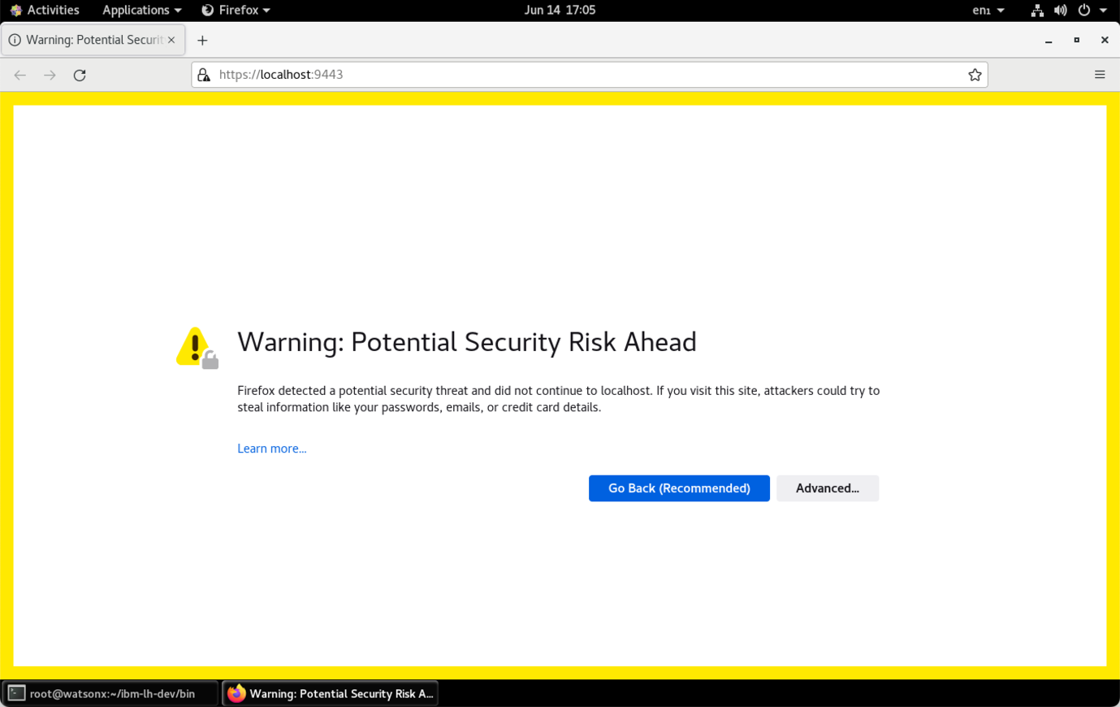

Select Advanced.

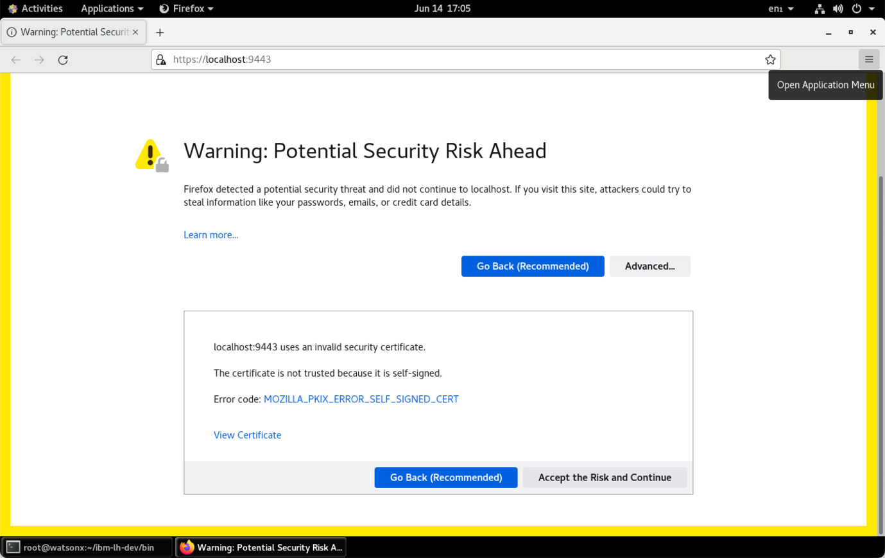

Choose “Accept the Risk and Continue”. If you are using Google Chrome, you can bypass the error message by typing in “thisisunsafe” or clicking on the "Proceed to 192.168.252.2 (unsafe)" link.

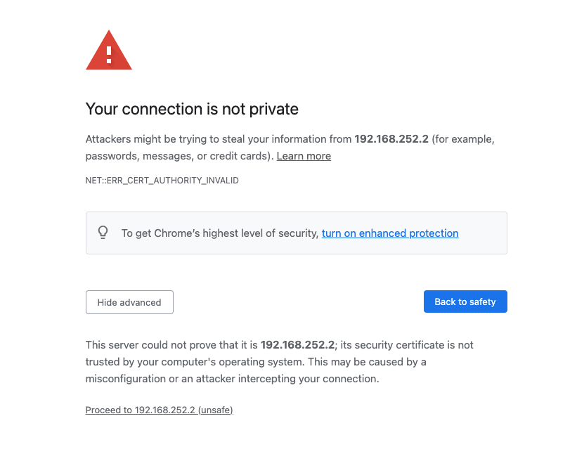

Passwords

This table lists the passwords for the services that have "fixed" userids and passwords.

| **Service** | **Userid** | **Password** |
| --- | --- | --- |
| Virtual Machine | watsonx | watsonx.data |
| Virtual Machine | root | watsonx.data |
| watsonx.data UI | ibmlhadmin | password |
| Presto | None | None |
| Minio | Generated | Generated |
| Postgres | admin | Generated |
| Apache Superset | admin | admin |
| Portainer | admin | watsonx.data |
| Db2 | db2inst1 | db2inst1 |

Use the following commands to get the generated userid and password for MinIO.

export LH_S3_ACCESS_KEY=$(docker exec ibm-lh-presto printenv | grep LH_S3_ACCESS_KEY | sed 's/.*=//')

export LH_S3_SECRET_KEY=$(docker exec ibm-lh-presto printenv | grep LH_S3_SECRET_KEY | sed 's/.*=//')

echo "MinIO Userid : " $LH_S3_ACCESS_KEY

echo "MinIO Password: " $LH_S3_SECRET_KEY

Use the following command to get the password for Postgres.

export POSTGRES_PASSWORD=$(docker exec ibm-lh-postgres printenv | grep POSTGRES_PASSWORD | sed 's/.*=//')

echo "Postgres Userid : admin"

echo "Postgres Password : " $POSTGRES_PASSWORD

You can get all passwords for the system when you are logged in as the watsonx user by using the following command.

passwords

If you receive the following message:

(zenity:29252): Gtk-WARNING **: 11:27:32.683: cannot open display:

You will need to issue the command with the text option.

passwords text

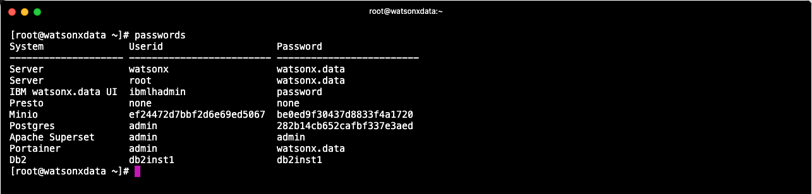

When running this command from within the virtual machine, it will display a list that you can select values from.

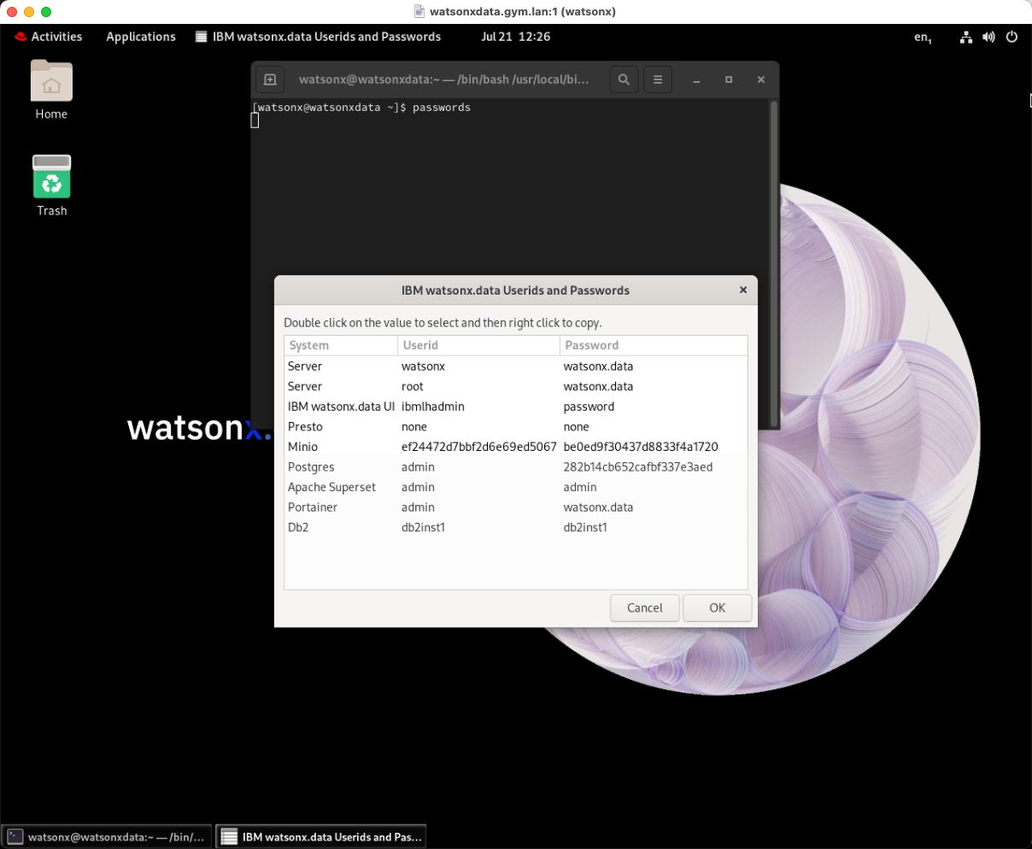

**Note:** You cannot cut-and-paste values into the VNC window.

Portainer

This lab system has Portainer installed. Portainer provides an administrative interface to the Docker images that are running on this system. You can use this console to check that all the containers are running and see what resources they are using. Open your browser and navigate to:

* Portainer console - <https://192.168.252.2:6443>
* Credentials: userid:admin password: watsonx.data

Once you have logged in, you should select “Get Started”.

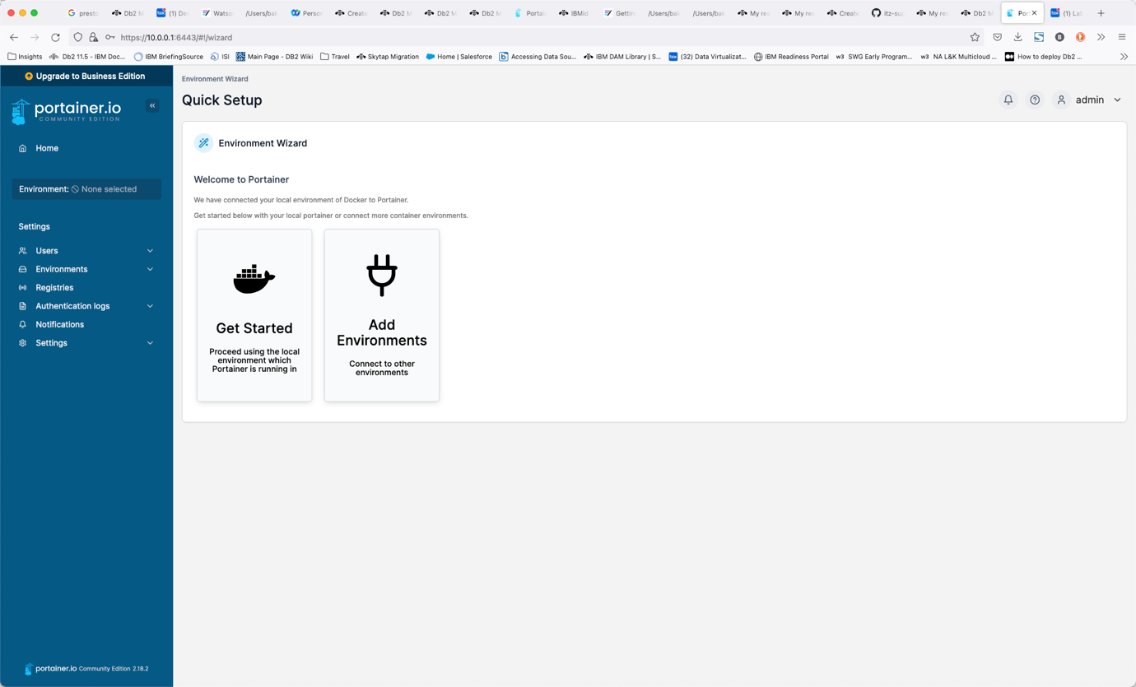

The next screen displays the main control panel for Portainer.

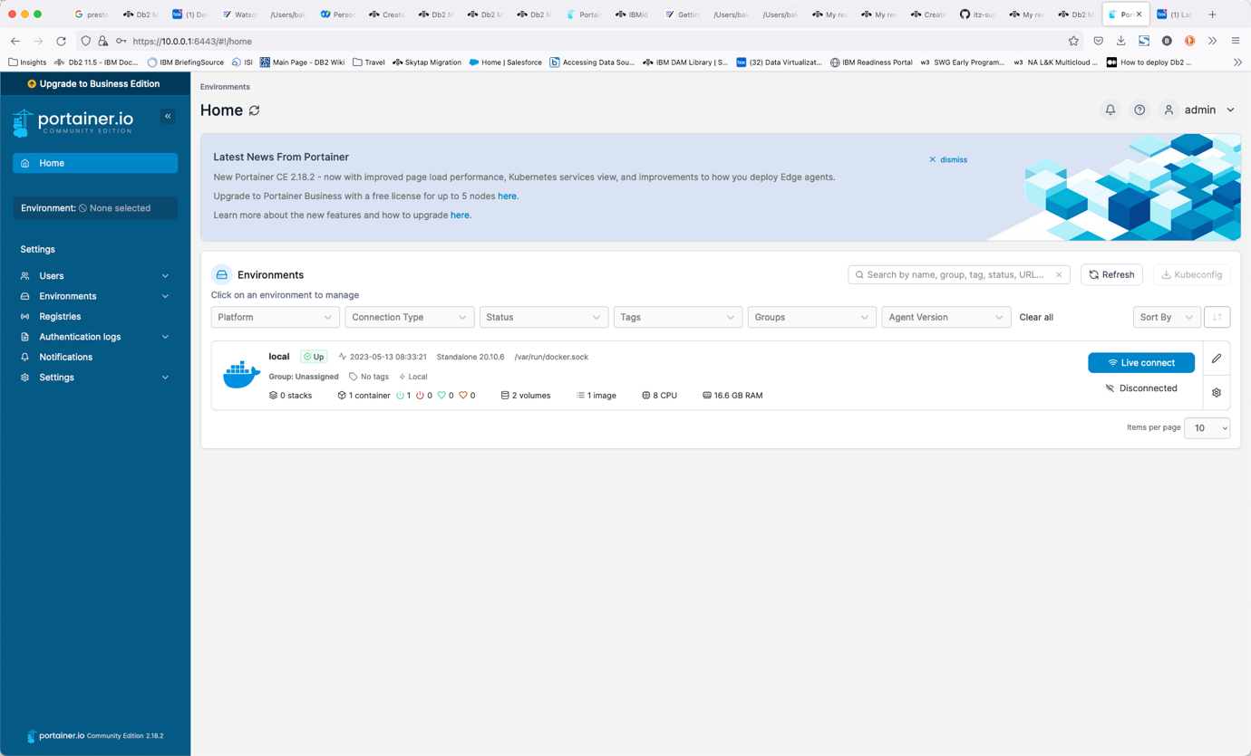

Select the Local server.

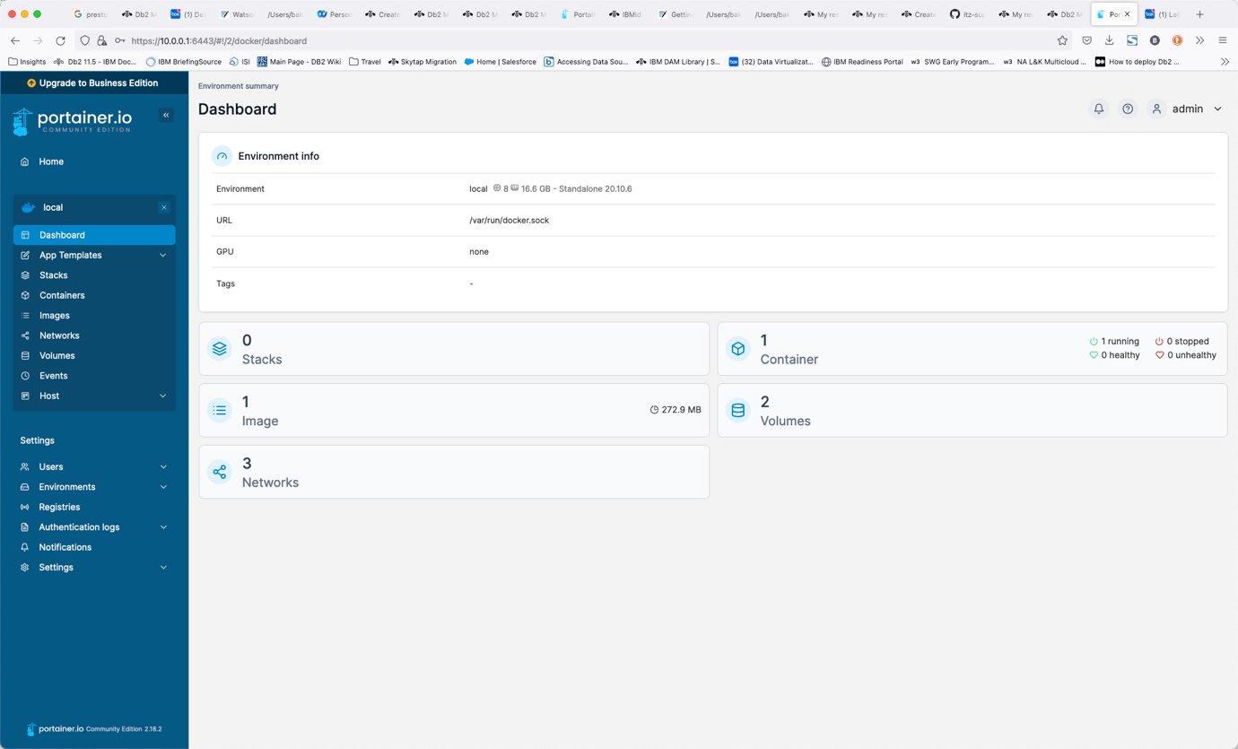

This screen provides details on the containers, images, volumes, and networks that make up your docker installation. To view the containers that are running, select the container icon.

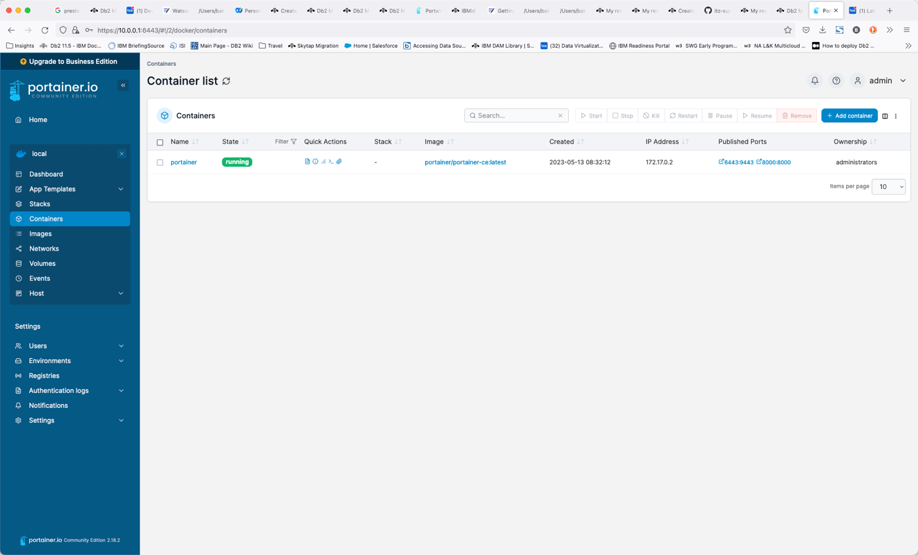

From within this view, you can view the details of any container, including the environment settings, the current logs, and allow you to shell into the environment. For more details on Portainer, see the [Portainer documentation](https://docs.portainer.io/user/home).

Documentation

The following links provide more information on the components in this lab.

* watsonx.data - <https://www.ibm.com/docs/en/watsonxdata/1.0.x>
* Presto SQL - <https://prestodb.io/docs/current/sql.html>
* Presto Console - <https://prestodb.io/docs/current/admin/web-interface.html>
* MinIO - <https://min.io/docs/minio/linux/administration/minio-console.html>
* Apache Superset - <https://superset.apache.org/docs/creating-charts-dashboards/exploring-data>
* dBeaver - <https://dbeaver.com/docs/wiki/Application-Window-Overview/>
* Db2 SQL - <https://www.ibm.com/docs/en/db2/11.5?topic=queries-select-statement>
* PostgreSQL SQL - <https://www.postgresql.org/docs/current/sql.html>

# Troubleshooting watsonx.data

Although we have tried to make the lab as error-free as possible, occasionally things will go wrong. Here is a list of common questions, problems, and potential solutions.

* [What are the passwords for the serviers](https://db2-dte-poc.github.io/wxddemo/wxd-troubleshooting/#what-are-the-passwords-for-the-services)
* [I Can't Open up a Terminal Window with VNC or Guacamole](https://db2-dte-poc.github.io/wxddemo/wxd-troubleshooting/#i-cant-open-up-a-terminal-window-with-vnc-or-guacamole)
* [A SQL Statement failed but there are no error messages](https://db2-dte-poc.github.io/wxddemo/wxd-troubleshooting/#a-sql-statement-failed-but-there-are-no-error-messages)
* [Apache Superset isn't Starting](https://db2-dte-poc.github.io/wxddemo/wxd-troubleshooting/#apache-superset-isnt-starting)
* [Apache Superset screens differ from the lab](https://db2-dte-poc.github.io/wxddemo/wxd-troubleshooting/#apache-superset-screens-differ-from-the-lab)
* [My VPN doesn't work](https://db2-dte-poc.github.io/wxddemo/wxd-troubleshooting/#my-vpn-doesnt-work)
* [I am unable to use VPN](https://db2-dte-poc.github.io/wxddemo/wxd-troubleshooting/#i-am-unable-to-use-a-vpn)
* [Too many incorrect logins using VNC and now I'm blocked](https://db2-dte-poc.github.io/wxddemo/wxd-troubleshooting/#too-many-incorrect-logins-using-vnc-and-now-im-blocked-from-connecting)
* [Presto doesn't appear to be working](https://db2-dte-poc.github.io/wxddemo/wxd-troubleshooting/#presto-doesnt-appear-to-be-working)
* [Displaying Db2 Schema is failing](https://db2-dte-poc.github.io/wxddemo/wxd-troubleshooting/#displaying-db2-schema-is-failing)
* [Queries are failing with a 400 code](https://db2-dte-poc.github.io/wxddemo/wxd-troubleshooting/#queries-are-failing-with-a-400-code)
* [Queries are failing with a 500 code](https://db2-dte-poc.github.io/wxddemo/wxd-troubleshooting/#queries-are-failing-with-a-500-code)
* [Queries are failing with memory errors](https://db2-dte-poc.github.io/wxddemo/wxd-troubleshooting/#queries-fail-become-of-insufficient-memory)
* [SSH, VNC and watsonx.data UI are not working](https://db2-dte-poc.github.io/wxddemo/wxd-troubleshooting/#ssh-vnc-and-watsonxdata-ui-are-not-working)
* [Wireguard not starting](https://db2-dte-poc.github.io/wxddemo/wxd-troubleshooting/#wireguard-not-starting)
* [No access to Presto/Minio UI after restart](https://db2-dte-poc.github.io/wxddemo/wxd-troubleshooting/#no-access-to-prestominio-ui-after-restart)
* [Firefox and Chrome freeze when connecting to MinIO](https://db2-dte-poc.github.io/wxddemo/wxd-troubleshooting/#firefox-and-chrome-freeze-when-connecting-to-minio)

### **What are the passwords for the services?**

See the section on [Passwords](https://db2-dte-poc.github.io/wxddemo/wxd-troubleshooting/wxd-reference-passwords#passwords).

You can get all passwords for the system when you are logged in as the watsonx user by using the following command.

passwords

If you are logged in as the root user, the syntax is slightly different:

SSH_TTY=true SSH_CLIENT=true passwords

### **I Can't Open up a Terminal Window with VNC or Guacamole**

First thing to remember is that you can't use VNC and the TechZone VM Remote Console (Guacamole) interface at the same time. Only one can be active at a time.

#### If you can't use terminal windows in VNC

If you find that the terminal icons "spins" inside the VNC window, this is caused by attempting to connect to the virtual machine by using the VM Remote Console button in your reservation details screen. To fix this problem, you must log out of the VNC session (top right corner of the Linux desktop - press the power button and choose logout). Once VNC logs back in you will be able use the terminal window.

#### If you really want to use the Techzone VM Remote Console

If you start with VNC, you need to fully shut it down if you want to switch to the TechZone Guacamole version.

Commands to stop the VNC service are:

ssh watsonx@192.168.252.2

sudo su -

Once you have become root, issue the following commands:

systemctl stop vncserver@:1

systemctl disable vncserver@:1

Now you can close the VNC window and use the Techzone Remote Console interface.

### **A SQL Statement failed, but there are no error messages**

You need to use the Presto console <http://192.168.252.2:8080> and search for the SQL statement. Click on the Query ID to find more details of the statement execution and scroll to the bottom of the web page to see any error details.

### **Apache Superset isn't Starting**

If Superset doesn't start for some reason, you will need to reset it completely to try it again. First make sure you are connected as the watsonx user **not** root.

Make sure you have stopped the terminal session that is running Apache Superset. Next remove the Apache Superset directory.

sudo rm -rf /home/watsonx/superset

We remove the docker images associated with Apache Superset. If no containers or volumes exist you will get an error message.

docker ps -a -q --filter "name=superset" | xargs docker container rm --force

docker volume list -q --filter "name=superset" | xargs docker volume rm --force

Download the superset code again.

git clone https://github.com/apache/superset.git

The docker-compose-non-dev.yml file needs to be updated so that Apache Superset can access the same network that watsonx.data is using.

cd ./superset

cp docker-compose-non-dev.yml docker-compose-non-dev-backup.yml

sed '/version: "3.7"/q' docker-compose-non-dev.yml > yamlfix.txt

cat <<EOF >> yamlfix.txt

networks:

default:

external: True

name: ibm-lh-network

EOF

sed -e '1,/version: "3.7"/ d' docker-compose-non-dev.yml >> yamlfix.txt

We update the Apache Superset code to version 2.1.0.

sed 's/\${TAG:-latest-dev}/2.1.0/' yamlfix.txt > docker-compose-non-dev.yml

Use docker-compose to start Apache Superset.

nohup docker compose -f docker-compose-non-dev.yml up &

The nohup command will issue a message indicating that output will be directed to the nohup.out file. It takes some time for the service to start, so be patient! You can view any output from the Apache Superset system by viewing the nohup.out file in the directory where you installed superset.

### **Apache Superset screens differ from the lab**

The Apache Superset project makes frequent changes to the types of charts that are available. In some cases they remove or merge charts. Since these charts changes are dynamic, we are not able to guarantee that our examples will look the same as what you might have on your system.

### **My VPN doesn't work**

If you downloaded a VPN certificate, and it doesn't appear to work, locate the file on your file system and attempt to view it. If the contents of the file contains the word disabled, this indicates that you did not request the VPN certificate to be enabled. You will need to request another image in order to connect with VPN. The other option is to use the Virtual console (guacamole) provided with the reservation. This requires that all exercises in this lab be done in that machine environment.

### **I am unable to use a VPN**

If you are blocked from using a VPN tunnel, you must use the guacamole interface provided in the reservation details (VM Remote Console). In this case, all URLs will need to be accessed using the Firefox browser that is in the image. Cut-and-paste only works inside the virtual machine so you must use the lab documentation inside the virtual machine.

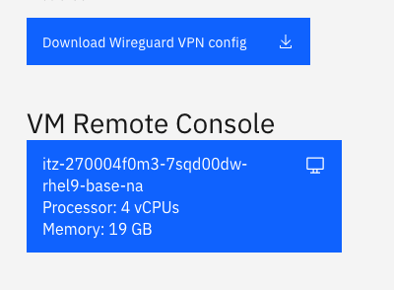

Once you click on the VM Remote Console button, the login screen for the image will be shown. Do not log into the watsonx userid yet!

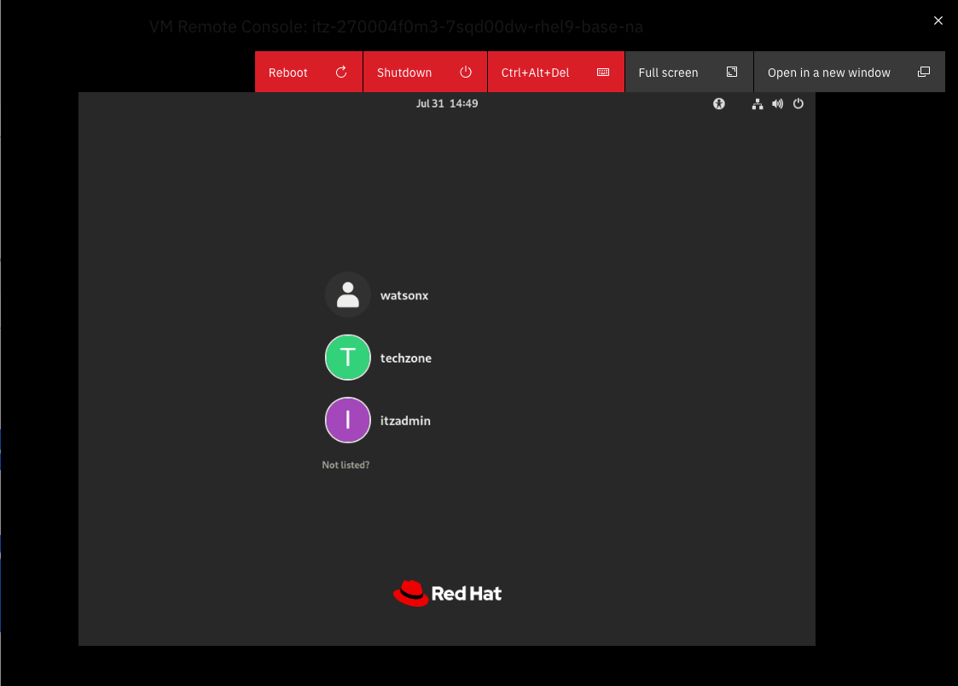

You will not be able to log on as watsonx due to the VNC service that is currently running in the machine. If you try to login you will lock up the screen! If this happens you should reboot the server.

Once you have the login screen, select Techzone from the list of users. Enter IBMDem0s! as the password. Once you have gained access to the system, click on Activities at the top of the screen and search for Terminal. Once a terminal screen has opened, issue the following instructions.

sudo su -

No password should be required.

systemctl stop vncserver@:1

systemctl disable vncserver@:1

exit

Log out of the Techzone userid and log into the watsonx user. At this point you can run the lab using this environment. Note that all URLs will continue to work in this image with IP addresses of 192.168.252.2.

### **Presto doesn't appear to be working**

If you find that the watsonx.data UI is generating error messages that suggest that queries are not running, or that the Presto service is dead, you can force a soft restart of Presto with the following command:

docker restart ibm-lh-presto

This will restart the Presto server. If you find that does not fix your problem, you will need to do a hard reset using the following commands:

sudo su -

cd /root/ibm-lh-dev/bin

./stop_service ibm-lh-presto

./start_service ibm-lh-presto

check_presto

The command will wait until the service is running before exiting.

### **Displaying Db2 Schema is failing**

Occasionally when attempting to expand the Db2 catalog (schema), the watsonx.data UI will not display any data or issue an error message. You can try refreshing the browser (not the refresh icon inside the UI) and try again. If you find that this is failing again, open the Query workspace and run the following SQL (replace db2_gosales with the name you cataloged the database with).

select count(*) from db2_gosales.gosalesdw.go_org_dim

The result should be 123 and hopefully the tables that are part of the schema will display for you.

### **Db2 is not allowing connections after a system restart**

If for reason you have stopped and restarted the server, the Db2 service may not refresh or allow for connections from the watsonx.data UI. This is caused by a setting in the Db2 container environment that attempts to rebuild the instance after a failure. The instance information is stored on a volume outside the container, so this step does not need to be performed. To enable Db2 to restart properly, run the following commands from the root user in the machine.

sed -i 's/PERSISTENT_HOME=false/PERSISTENT_HOME=true/' /Docker/.env_list

docker restart db2server

### **Queries are failing with a 400 code**

The watsonx.data UI will log you out after a period of inactivity, but doesn't tell you that this has happened. When you attempt to run a query, the error that is returned (400) indicates that you need to log back in again.

### **Queries are failing with a 500 code**

A 500 code may indicate the watsonx.data UI has a problem connecting with the Presto engine. First log out of the console and trying logging back on. If that fails to solve the problem, you will need to reboot the console. Open up a terminal window into the server:

ssh watsonx@192.168.252.2

Then restart the docker container that is running the watsonx.data UI.

docker restart lhconsole-nodeclient-svc

### **Queries fail become of insufficient memory**

If you are running a complex query, you may get an error message similar to "Query exceeded per-node user memory limit" or a something similar. Watsonx.data (Presto) attempts to limit the amount of resources being using in a query and will stop a query if it exceeds a certain threshold.

You can change the behavior of the system by making the following changes. **Note**: During this step you will disconnect anyone running a query on the server.

What you need to do is make a change to the configuration settings of the Presto engine. First, ssh into watsonx:

ssh watsonx@192.168.252.2

password=watsonx.data

Then enter the docker container for the presto engine:

docker exec -it ibm-lh-presto /bin/bash

Next, copy the original config file to a safe place in case we make an error:

cp /opt/presto/etc/config.properties /opt/presto/etc/config.properties.backup

Then update the properties file.

cat >> /opt/presto/etc/config.properties << EOL

experimental.spiller-spill-path=/tmp

experimental.spiller-max-used-space-threshold=0.7

experimental.max-spill-per-node=10GB

experimental.query-max-spill-per-node=10GB

experimental.spill-enabled=true

query.max-memory=10GB

query.max-memory-per-node=10GB

query.max-total-memory-per-node=10GB

query.max-total-memory=10GB

EOL

Doublecheck that it worked.

cat /opt/presto/etc/config.properties | grep experimental

experimental.max-spill-per-node=10GB

experimental.query-max-spill-per-node=10GB

experimental.spill-enabled=true

experimental.spiller-max-used-space-threshold=0.7

experimental.spiller-spill-path=/tmp

If it is all good then exit the container.

exit

And now we restart the container. Make sure that you don't impact other users!

docker restart ibm-lh-presto

Now try running your query again.

**Note**: Once you make this change, only restart presto using the above command, otherwise you will lose the changes.

### **Too many incorrect logins using VNC and now I'm blocked from connecting**

If you lock yourself out of VNC because of too many incorrect logins, you can reset the service with the following commands.

Connect as the root user.

ssh watsonx@192.168.252.2

sudo su -

Then run the following command and you should be able to log in again.

systemctl restart vncserver@:1

exit

### **SSH, VNC and watsonx.data UI are not working**

Symptoms:

* You've tried to use SSH to log into the system and you get a timeout error.
* All the Web-based UIs (watsonx.data UI, Presto) fail.
* VNC gets a connection error.

The first thing to check is to make sure your VPN is activated, Assuming you have already done that, here is what you need to do.

Find your email message that contains details of your reservation. Details of what the reservations and the page containing details of the reservation can be found in the [Accessing the reservation](https://db2-dte-poc.github.io/wxddemo/wxd-reference-access/) section.

Once the details appear, scroll down to the bottom of the web page, and you will see the VM Remote Console button along with the VPN certificates.



You can access the logon screen of the virtual machine by pressing the VM Remote Console button.



Clicking on this button will display the logon screen for the server.



If you see this screen, the system is running and there is something wrong with your VPN certificate or your laptop is not connecting through the VPN. You will need to post a message in the watsonx.data support channel and ask for help.

If you see the following screen:

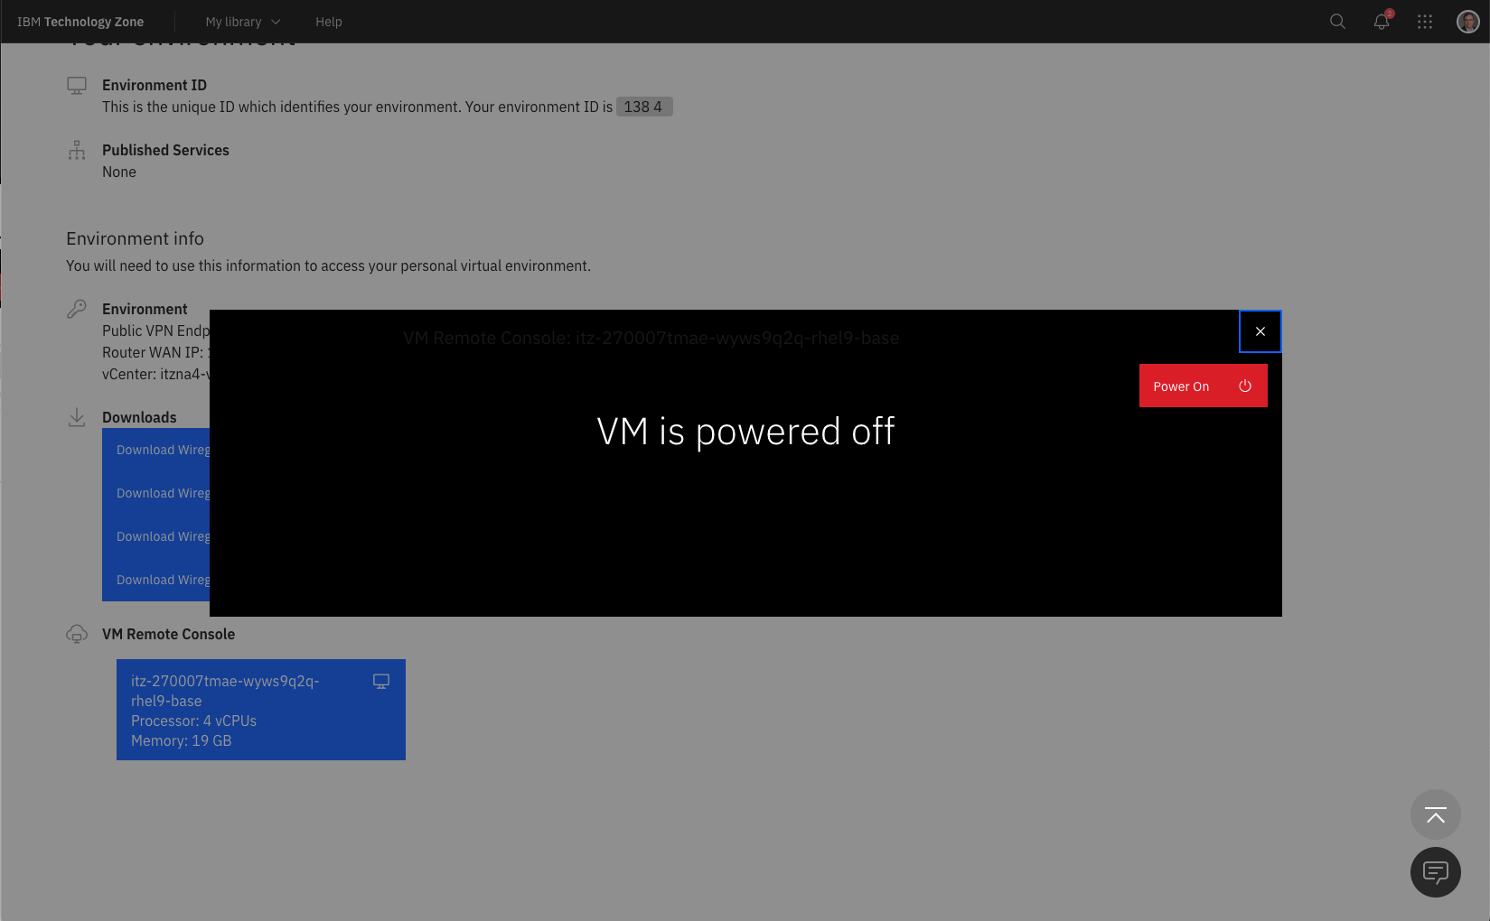

This means your server has been turned off. Click on the Power on button.

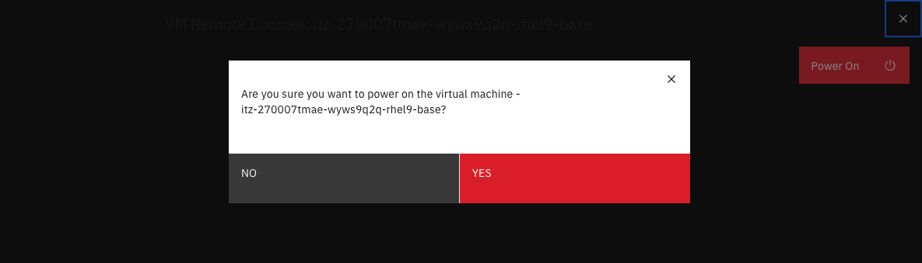

Make sure to press the Yes button to turn the power on! In a few minutes you should see the logon screen again.



Wait for a few minutes for all the services to start, and then you will be able to use SSH, VNC, and watsonx.data UI. Don't use this interface to work with watsonx.data unless you cannot install VPN software (i.e., your machine is locked down).

### **Wireguard Not Starting**

On the Mac, the Wireguard application will not always display in the Dock. If it doesn't appear to "start", it may be sitting in the Systray at the bottom or top of your screen. The icon will be gray if no connections are active.



### **No access to Presto/Minio UI after restart**

If you are using a Techzone image that has been suspended, or restarted, you may come across a situation where you are unable to connect to any service that uses the httpprotocol. The watsonx.service needs to have a diagnostic flag set that opens up these ports, and sometimes this diagnostic setting is not being updated.

To manually stop and start the system, you will need to connect with root user privileges and run the following commands:

sudo su -

cd /root/ibm-lh-dev/bin

./stop.sh

export LH_RUN_MODE=diag

./start.sh

This set of commands will stop all the services in watsonx.data and restart them in diagnostic mode. This will now open the http ports for use.

### **Firefox and Chrome freeze when connecting to MinIO**

Firefox and Chrome on OSX will occasionally freeze when connecting to the MinIO console. The Safari browser is much more reliable. This problem appears to be caused by some features which are not properly handled by these browsers.

# Datasets

There are three datasets that have been loaded into watsonx.data system for you to use while exploring the features of the product.

* [Great Outdoors Company warehouse data](https://db2-dte-poc.github.io/wxddemo/wxd-datasets-gosales/)
* [Airline On-Time performance](https://db2-dte-poc.github.io/wxddemo/wxd-datasets-ontime/)
* [Taxi fares](https://db2-dte-poc.github.io/wxddemo/wxd-datasets-taxi/)

## **Data Location**

The datasets found above have already been preloaded into the system, so there is no need to run the scripts below unless you want to modify the schemas or location of the data.

The data files can be found in the /sampledata directory. Underneath this directory you will find datasets in three different formats:

* Parquet - Data that has been formatted in Parquet format that can be loaded directly into Hive and queried by watsonx.data.
* Relational - Data that is in a delimited format that can be loaded into Db2 or PostgreSQL databases.
* CSV - Comma separated values that can be converted to multiple formats or used by watsonx.data.

Within the Parquet and Relational directories are SQL statements that can be used to catalog and load the data into the different systems.

# External Datasets

There are a variety of data sets available for you to load from external sites. Check out the following websites for a variety of public data sets that you can use.

* [Awesome Public Datasets](https://github.com/awesomedata/awesome-public-datasets)
* [Kaggle Datasets](https://www.kaggle.com/datasets)
* [US Data.Gov](https://data.gov/)
* [UCI Machine Learning Repository](https://archive.ics.uci.edu/datasets)
* [US Fuel Economy](https://www.fueleconomy.gov/feg/download.shtml)

**Note**: These sites have not been checked for license restrictions on the use of the data. You are responsible for checking that the data can be used without any licensing requirements.

## **Loading your own data**

You can use a browser or link to an external file repository (i.e., Box) and download data directly to your workstation. Data can be CSV, Parquet, JSON, or TXT formats. Once the data is on your workstation, use the following steps.

**Note**: You cannot import customer data nor any data that has restrictions associated with its use. Any use of private data is in violation of the terms and conditions of using this image.

The first step is to connect to MinIO. Extract the MinIO credentials by using the passwordscommand:

passwords text



Open your browser and navigate to:

* Minio console - <http://192.168.252.2:9001>

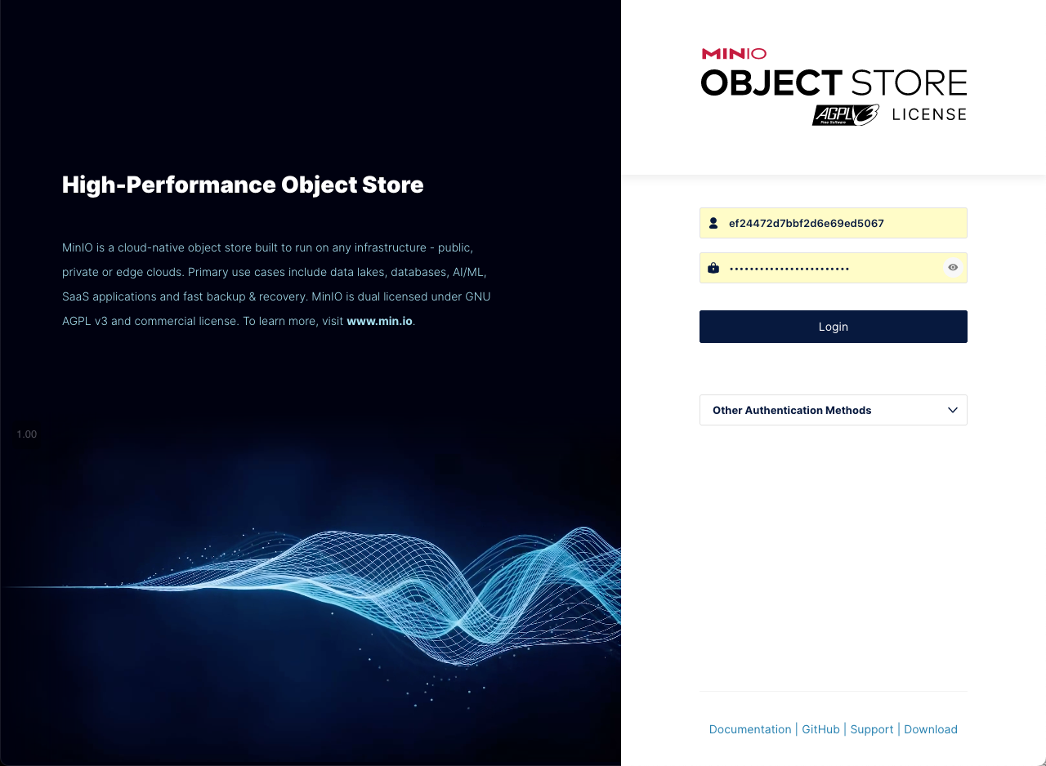

Login with object store credentials found above (These will be different for your system). You should see the current buckets in MinIO. If you don't see the buckets, click on Object Browser on the left-hand side panel.

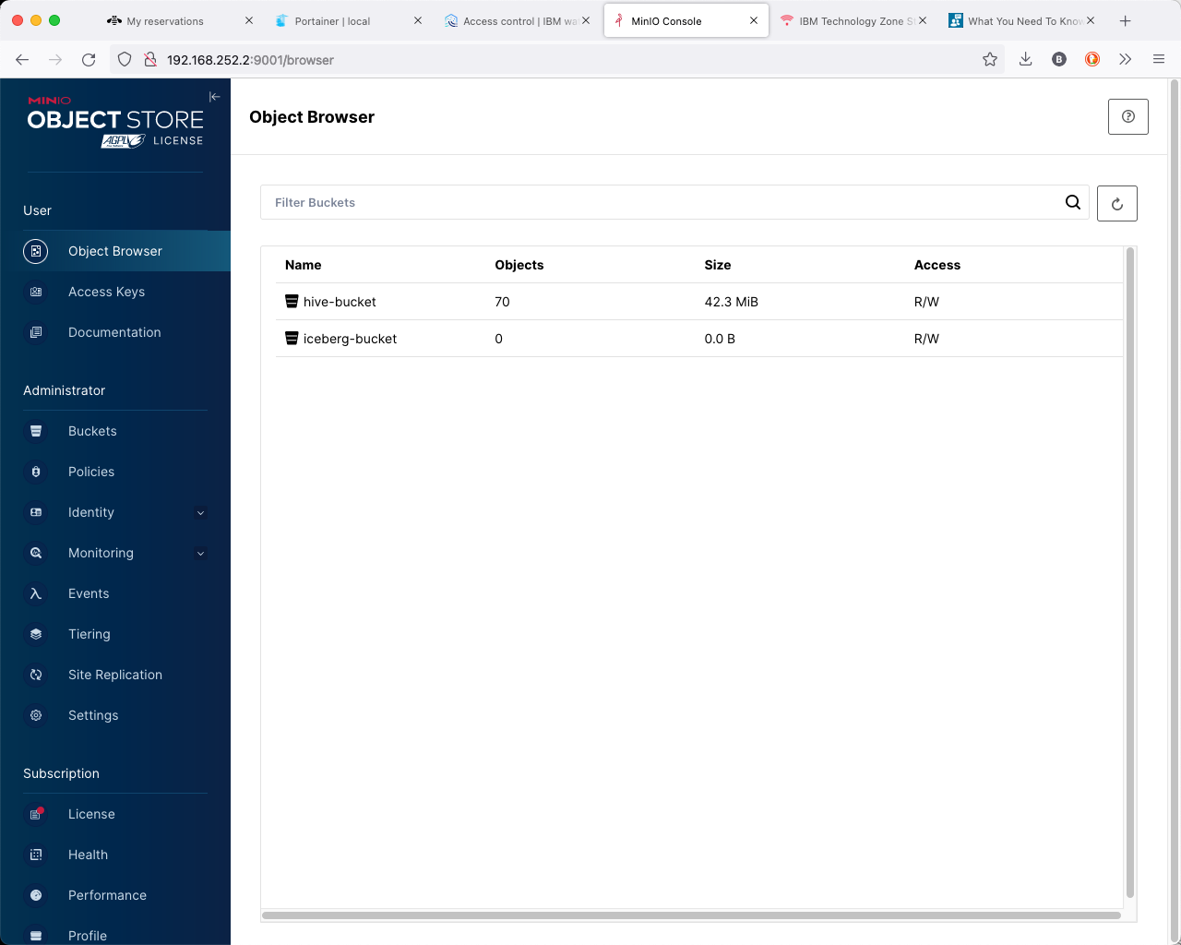

Select hive-bucket from the list of buckets.

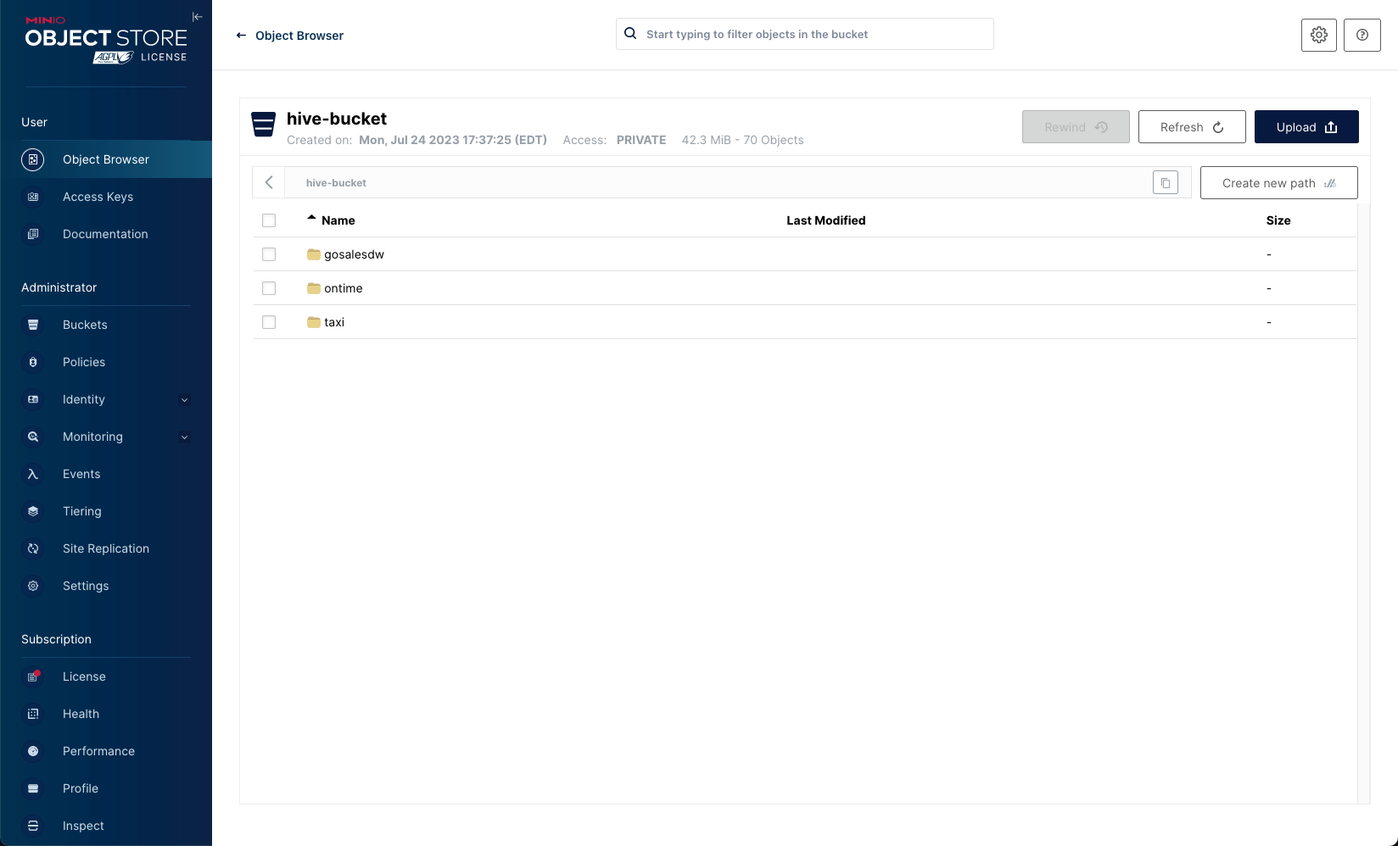

You may see other directories in this list than what is shown above. You will need to create a new path for your data set.

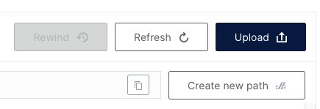

Create a new directory name for your data (fuel_economy was used for this example).

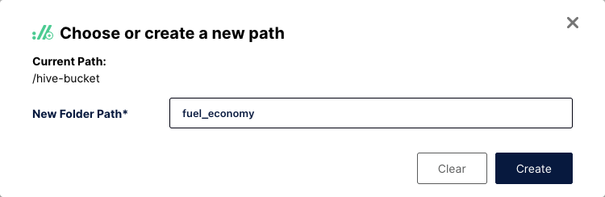

MinIO will display an empty directory and suggest you load something into it.

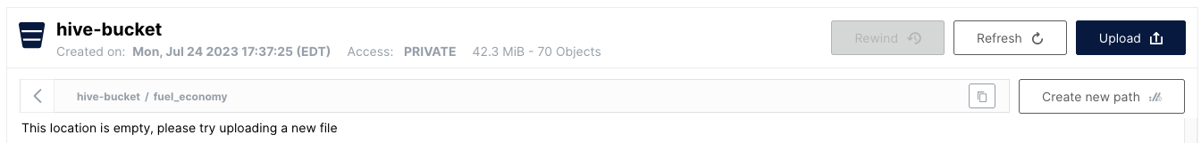

Use the Upload button on the far right side to point to your dataset on your local machine.

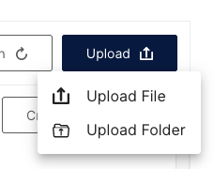

In this example, we are using a CSV file for the 2013 fuel economy estimates for automobiles sold in the US. You may need to rename you datasets to eliminate blanks and any other special characters other than "_" or "-".

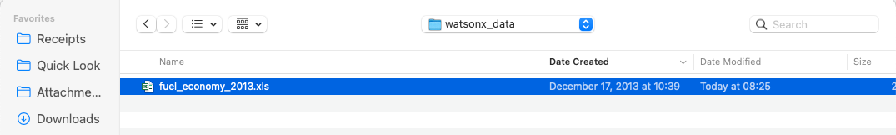

The display will show the progress of the upload into the bucket.

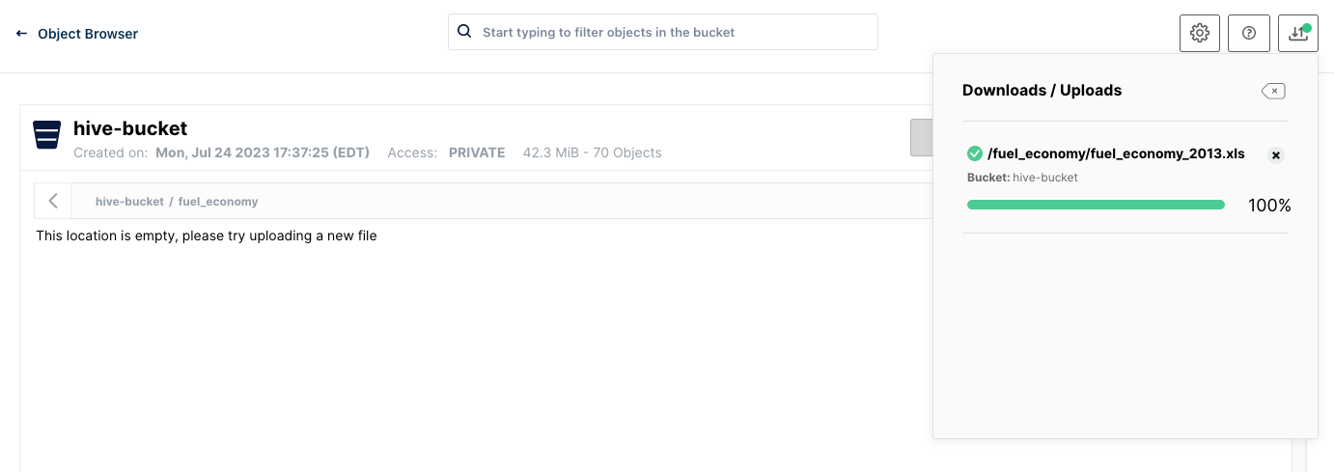

You may need to refresh your browser to see the file in the bucket.

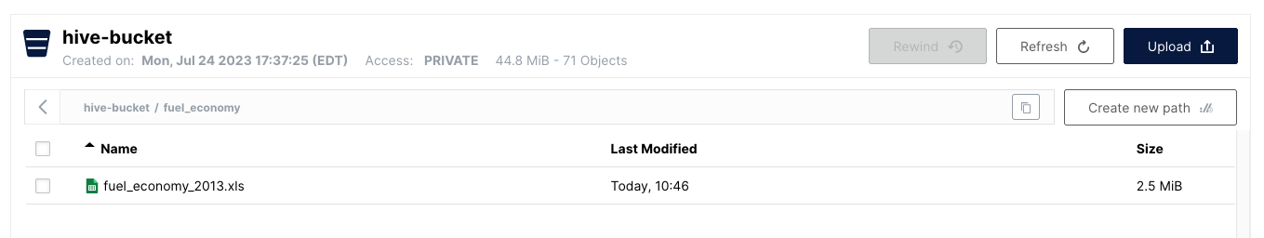

Now that the data has been loaded into a bucket, you can catalog it in the watsonx.data UI. If you created a new bucket for this data set, you will need to register it first in the watsonx.data UI. Instructions for how to do this are found in the [Working with Object Store Buckets](https://db2-dte-poc.github.io/wxddemo/wxd-objectstore/) section.

Start by navigating to the watsonx.data UI and look at the Infrastructure manager.

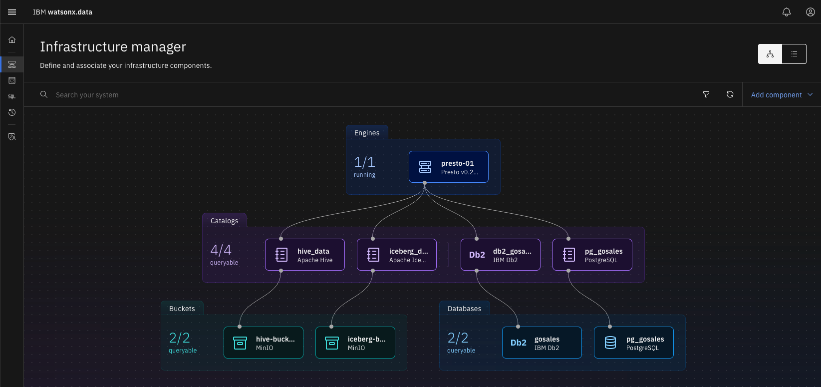

Find the bucket where you upload your data set into and note the catalog name that it is associated with. Here we can see that the hive-bucket bucket is associated with the hive_data catalog.

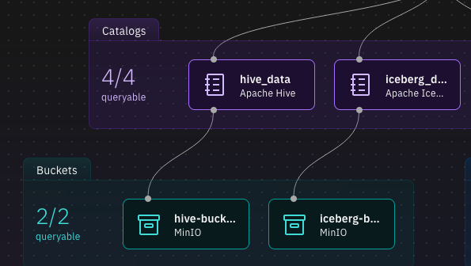

In the watsonx.data UI, select the Query workspace (SQL) icon. You will need to create a schema that links to this data set. The format of the command is shown below.

DROP SCHEMA catalog.schema_name;

CREATE SCHEMA catalog.schema_name

WITH ( location = 's3a://your-bucket/data_directory' );

You will need to change the following values:

* catalog - The catalog that the bucket you are using is associated with
* schema_name - A schema name to associate your tables with
* data_directory - The directory in which your file is located
* your_bucket - The bucket the data physically resides in

For the fuel economy example, using mpg as the schema, the You neSQL would be:

DROP SCHEMA hive_data.mpg;

CREATE SCHEMA hive_data.mpg

WITH ( location = 's3a://hive-bucket/fuel_economy' );

Run this SQL against the Presto engine:

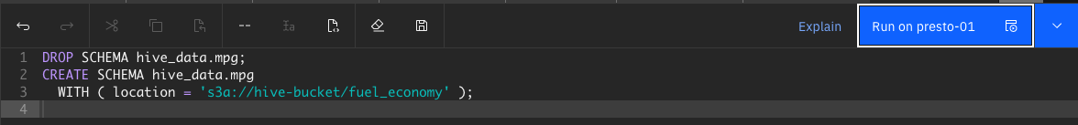

The DROP command may fail if the schema doesn't exist, but the CREATE should work.

The next step is to define what the table looks like for watsonx.data to be able to query it. The syntax of the CREATE TABLE statement is similar to:

CREATE TABLE catalog.schema.tablename

(

"column_name" "type",

...

)

WITH ( format = 'CSV',

csv_separator = ',',

external_location = 's3a://your_bucket/data_directory');

You will need to create a table definition for your CSV file in order to catalog it in watsonx.data. Note that the **only** data type that is permitted for CSV columns is varchar. This is a restriction of the current driver. Plans are to update it to include other data types over time.

If your data set does not include a header row (a row that defines the column names), you will need to create the table definition manually.

If the data set does contain a header record, you can use the following Python code to generate a CREATE TABLE statement. You will need to make sure that pandas is available.

python3 -m pip install pandas --user

Next run the python3 command in the shell to run an interactive Python session.

python3

Place the following code into your Python window.

def showcsv(catalog, schema, tablename, bucket, directory, csv_in):

import pandas as pd

df = pd.read_csv(csv_in,na_values="-")

df = df.fillna(0)

column_headers = list(df.columns.values)

print("")

print(f"DROP TABLE IF EXISTS {catalog}.{schema}.{tablename};")

print(f"CREATE TABLE {catalog}.{schema}.{tablename}")

print(" (")

comma = ""

end = ""

for header in column_headers:

print(f"{comma}",end=end)

comma = ","

end = "\n"

print(f' "{header}" varchar',end="")

print(f" )")

print(f"WITH (")

print(f" format = 'CSV',")

print(f" csv_separator = ',',")

print(f" external_location = 's3a://{bucket}/{directory}'")

print(f" );")

print("")

def makesql():

catalog = input("Catalog : ")

schema = input("Schema : ")

table = input("Table : ")

bucket = input("Bucket : ")

dir = input("Directory : ")

csv = input("CSV File : ")

showcsv(catalog,schema,table,bucket,dir,csv)

Gather the following information on your dataset:

* catalog - The catalog the schema and table are created under (hive_data)
* schema - The schema name that you created to hold your table (mpg)
* table name - The name of the table (fuel_economy)
* bucket - Where the data is located (hive-bucket)
* directory - What directory contains your data (fuel_economy)
* csv_in - The location on your local machine where the csv file is

Once you have gathered that, run the following command in your Python window and answer the prompts.

makesql()

>>> makesql()

Catalog : hive_data

Schema : mpg

Table : fueleconomy

Bucket : hive-bucket

Directory : fuel_economy

CSV File : ~/Downloads/fuel_economy_2013.csv

DROP TABLE IF EXISTS hive_data.mpg.fueleconomy;

CREATE TABLE hive_data.mpg.fueleconomy

(

"MODEL_YEAR" varchar,

"MFR_NAME" varchar,

"DIVISION" varchar,

"CARLINE" varchar,

"ENG_DISPL" varchar,

"CYL" varchar,

"TRANS_IN_FE_GUIDE" varchar,

"CITY_FE_CONVENTIONAL_FUEL" varchar,

"HWY_FE_CONVENTIONAL_FUEL" varchar,

"COMB_FE_CONVENTIONAL_FUEL" varchar,

"AIR_ASPIRATION_DESC" varchar,

"TRANS_DESC" varchar,

"GEARS" varchar,

"DRIVE_DESC" varchar,

"FUEL_UNIT_CONVENTIONAL_FUEL" varchar,

"FUEL_UNIT_DESC_CONVENTIONAL_FUEL" varchar,

"ANNUAL_FUEL_COST_CONVENTIONAL" varchar,

"FUEL_METERING_SYS_DESC" varchar )

WITH (

format = 'CSV',

csv_separator = ',',

external_location = 's3a://hive-bucket/fuel_economy'

);

Cut and paste the output from the command into the watsonx.data Data Explorer window to create the file.

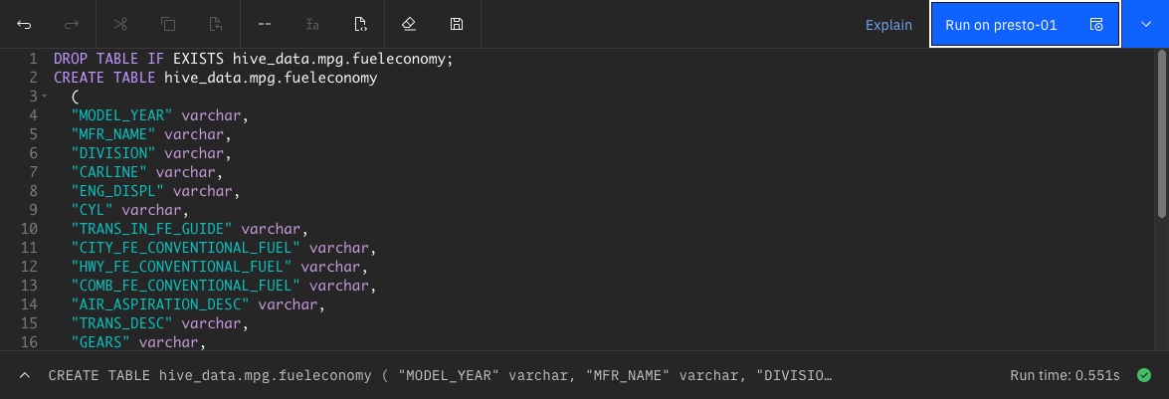

Now you can query the table with the following SQL. Note that the header record still exists in the answer set since we did not remove it from the CSV file.

SELECT * FROM hive_data.mpg.fueleconomy LIMIT 10

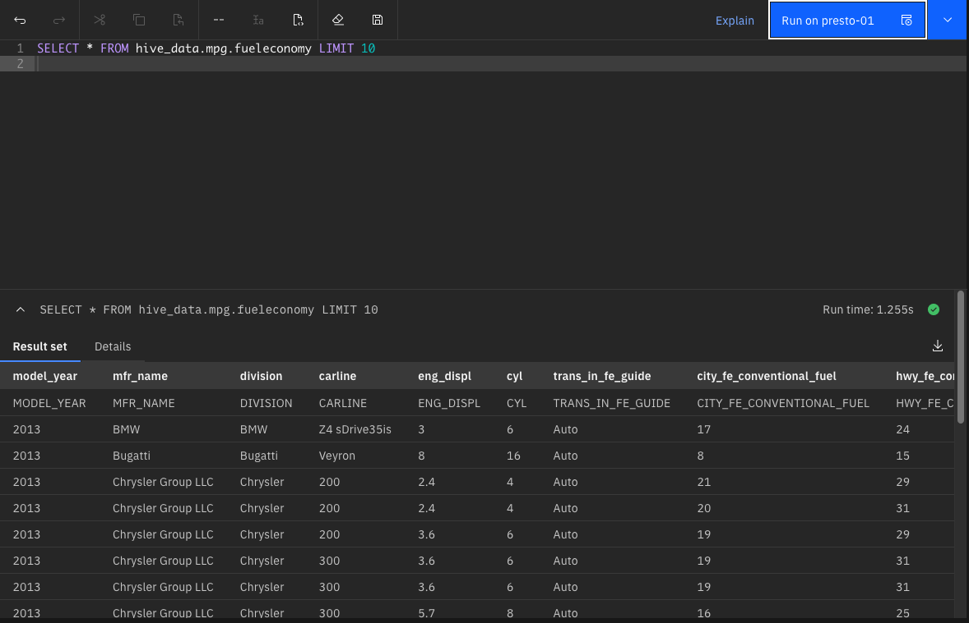

# Great Outdoors Company

The Sample Outdoors Company, or GO Sales, or any variation of the Sample Outdoors name, is the name of a fictitious business operation whose sample data is used to develop sample applications for IBM® and IBM customers. Its fictitious records include sample data for sales transactions, product distribution, finance, and human resources. Any resemblance to actual names, addresses, contact numbers, or transaction values, is coincidental.

Two links that provide more details on the database.

* [Great Outdoors Company](https://www.ibm.com/docs/en/cognos-analytics/11.1.0?topic=packages-sample-outdoors-company)
* [Great Outdoors Database Reference](https://www.ibm.com/docs/en/data-studio/4.1.1?topic=database-gsdb-reference)

The second link will say that there is no content available, but if you click on the down arrow you will see the table names.

## **Disclaimer**

The Sample Outdoors Company, or GO Sales, or any variation of the Sample Outdoors name, is the name of a fictitious business operation whose sample data is used to develop sample applications for IBM® and IBM customers. Its fictitious records include sample data for sales transactions, product distribution, finance, and human resources. Any resemblance to actual names, addresses, contact numbers, or transaction values, is coincidental. Unauthorized duplication is prohibited.

## **Table Definitions**

These tables are created under the GOSALESDW schema. Thanks to Michael Schapira for generating the following ER diagram. You may need to download the image to zoom in on the relationships.

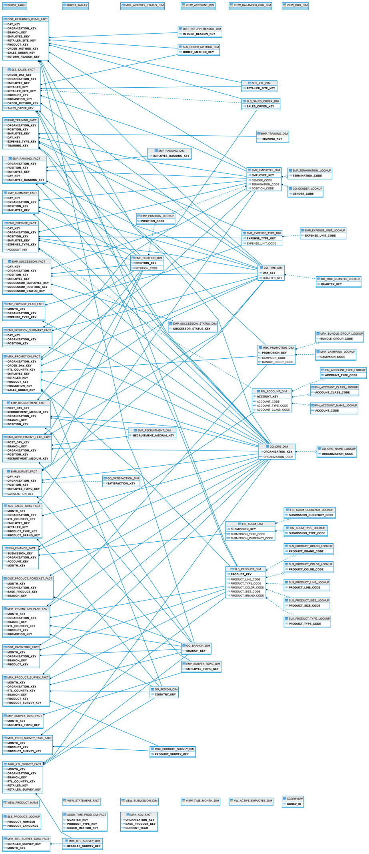

#### DIST_INVENTORY_FACT

| **Column** | **Type** |
| --- | --- |
| MONTH_KEY | INTEGER |
| ORGANIZATION_KEY | INTEGER |
| BRANCH_KEY | INTEGER |
| PRODUCT_KEY | INTEGER |
| OPENING_INVENTORY | INTEGER |
| QUANTITY_SHIPPED | INTEGER |
| ADDITIONS | INTEGER |
| UNIT_COST | DECIMAL |
| CLOSING_INVENTORY | INTEGER |
| AVERAGE_UNIT_COST | DECIMAL |

#### DIST_PRODUCT_FORECASE_FACT

| **Column** | **Type** |
| --- | --- |
| MONTH_KEY | INTEGER |
| ORGANIZATION_KEY | INTEGER |
| BASE_PRODUCT_KEY | INTEGER |
| BRANCH_KEY | INTEGER |
| UNIT_COST | DECIMAL |
| UNIT_PRICE | DECIMAL |
| EXPECTED_VOLUME | INTEGER |

#### DIST_RETURNED_ITEMS_FACT

| **Column** | **Type** |
| --- | --- |
| DAY_KEY | INTEGER |
| ORGANIZATION_KEY | INTEGER |
| BRANCH_KEY | INTEGER |
| EMPLOYEE_KEY | INTEGER |
| RETAILER_SITE_KEY | INTEGER |
| PRODUCT_KEY | INTEGER |
| ORDER_METHOD_KEY | INTEGER |
| SALES_ORDER_KEY | INTEGER |
| RETURN_REASON_KEY | INTEGER |
| RETURN_QUANTITY | INTEGER |

#### DIST_RETURN_REASON_DIM

| **Column** | **Type** |
| --- | --- |
| RETURN_REASON_KEY | INTEGER |
| RETURN_REASON_CODE | INTEGER |
| REASON_DESCRIPTION_EN | VARCHAR |

#### EMP_EMPLOYEE_DIM

| **Column** | **Type** |
| --- | --- |
| EMPLOYEE_KEY | INTEGER |
| MANAGER_CODE1 | INTEGER |
| MANAGER1 | VARCHAR |
| MANAGER_MB1 | VARCHAR |
| MANAGER_CODE2 | INTEGER |
| MANAGER2 | VARCHAR |
| MANAGER_MB2 | VARCHAR |
| MANAGER_CODE3 | INTEGER |
| MANAGER3 | VARCHAR |
| MANAGER_MB3 | VARCHAR |
| MANAGER_CODE4 | INTEGER |
| MANAGER4 | VARCHAR |
| MANAGER_MB4 | VARCHAR |
| MANAGER_CODE5 | INTEGER |
| MANAGER5 | VARCHAR |
| MANAGER_MB5 | VARCHAR |
| MANAGER_CODE6 | INTEGER |
| MANAGER6 | VARCHAR |
| MANAGER_MB6 | VARCHAR |
| EMPLOYEE_CODE | INTEGER |
| EMPLOYEE_NAME | VARCHAR |
| FIRST_NAME | VARCHAR |
| LAST_NAME | VARCHAR |
| EMPLOYEE_NAME_MB | VARCHAR |
| FIRST_NAME_MB | VARCHAR |
| LAST_NAME_MB | VARCHAR |
| MANAGER_CODE | INTEGER |
| ORGANIZATION_CODE | VARCHAR |
| ADDRESS1 | VARCHAR |
| ADDRESS2 | VARCHAR |
| ADDRESS1_MB | VARCHAR |
| ADDRESS2_MB | VARCHAR |
| CITY | VARCHAR |
| CITY_MB | VARCHAR |
| PROV_STATE | VARCHAR |
| PROV_STATE_MB | VARCHAR |
| POSTAL_ZONE | VARCHAR |
| BRANCH_CODE | INTEGER |
| BIRTH_DATE | DATE |
| GENDER_CODE | SMALLINT |
| WORK_PHONE | VARCHAR |
| EXTENSION | VARCHAR |
| FAX | VARCHAR |
| EMAIL | VARCHAR |
| DATE_HIRED | DATE |
| TERMINATION_CODE | INTEGER |
| TERMINATION_DATE | DATE |
| POSITION_START_DATE | DATE |
| POSITION_CODE | INTEGER |
| EMPLOYEE_LEVEL | SMALLINT |
| ACTIVE_INDICATOR | SMALLINT |
| RECORD_START_DATE | DATE |
| RECORD_END_DATE | DATE |
| MANAGER_KEY | INTEGER |

#### EMP_EXPENSE_FACT

| **Column** | **Type** |
| --- | --- |
| DAY_KEY | INTEGER |
| ORGANIZATION_KEY | INTEGER |
| POSITION_KEY | INTEGER |
| EMPLOYEE_KEY | INTEGER |
| EXPENSE_TYPE_KEY | INTEGER |
| ACCOUNT_KEY | INTEGER |
| EXPENSE_UNIT_QUANTITY | FLOAT |
| EXPENSE_TOTAL | DECIMAL |

#### EMP_EXPENSE_PLAN_FACT

| **Column** | **Type** |
| --- | --- |
| MONTH_KEY | INTEGER |
| ORGANIZATION_KEY | INTEGER |
| EXPENSE_TYPE_KEY | INTEGER |
| ACCOUNT_KEY | VARCHAR |
| EXPENSE_PLAN_TOTAL | DECIMAL |

#### EMP_EXPENSE_TYPE_DIM

| **Column** | **Type** |
| --- | --- |
| EXPENSE_TYPE_KEY | INTEGER |
| EXPENSE_GROUP_CODE | INTEGER |
| EXPENSE_TYPE_CODE | INTEGER |
| EXPENSE_UNIT_CODE | INTEGER |
| EXPENSE_GROUP_EN | VARCHAR |
| EXPENSE_TYPE_EN | VARCHAR |

#### EMP_EXPENSE_UNIT_LOOKUP

| **Column** | **Type** |
| --- | --- |
| EXPENSE_UNIT_CODE | INTEGER |
| EXPENSE_UNIT_EN | VARCHAR |

#### EMP_POSITION_DIM

| **Column** | **Type** |
| --- | --- |
| POSITION_KEY | INTEGER |
| POSITION_CODE1 | INTEGER |
| POSITION_CODE2 | INTEGER |
| POSITION_CODE3 | INTEGER |
| POSITION_CODE | INTEGER |
| POSITION_PARENT | INTEGER |
| MIN_SALARY | DECIMAL |
| MAX_SALARY | DECIMAL |
| PAID_HOURLY | INTEGER |
| POSITION_LEVEL | SMALLINT |

#### EMP_POSITION_LOOKUP

| **Column** | **Type** |
| --- | --- |
| POSITION_CODE | INTEGER |
| POSITION_EN | VARCHAR |

#### EMP_POSITION_SUMMARY_FACT

| **Column** | **Type** |
| --- | --- |
| DAY_KEY | INTEGER |
| ORGANIZATION_KEY | INTEGER |
| POSITION_KEY | INTEGER |
| POSITION_COUNT | INTEGER |
| PLANNED_POSITION_COUNT | INTEGER |
| INTERNAL_HIRES | INTEGER |
| EXTERNAL_HIRES | INTEGER |
| TERMINATIONS | INTEGER |

#### EMP_RANKING_DIM

| **Column** | **Type** |
| --- | --- |
| EMPLOYEE_RANKING_KEY | INTEGER |
| RANKING_CODE | INTEGER |
| RANKING_DESCRIPTION_EN | VARCHAR |

#### EMP_RANKING_FACT

| **Column** | **Type** |
| --- | --- |
| ORGANIZATION_KEY | INTEGER |
| POSITION_KEY | INTEGER |
| EMPLOYEE_KEY | INTEGER |
| DAY_KEY | INTEGER |
| EMPLOYEE_RANKING_KEY | INTEGER |
| RANKING_CODE | INTEGER |

#### EMP_RECRUITMENT_DIM

| **Column** | **Type** |
| --- | --- |
| RECRUITMENT_MEDIUM_KEY | INTEGER |
| RECRUITMENT_MEDIUM_CODE | INTEGER |
| RECRUITMENT_TYPE_CODE | INTEGER |
| RECRUITMENT_MEDIUM_NAME_EN | VARCHAR |
| RECRUITMENT_TYPE_EN | VARCHAR |

#### EMP_RECRUITMENT_FACT

| **Column** | **Type** |
| --- | --- |
| POST_DAY_KEY | INTEGER |
| RECRUITMENT_MEDIUM_KEY | INTEGER |
| ORGANIZATION_KEY | INTEGER |
| BRANCH_KEY | INTEGER |
| POSITION_KEY | INTEGER |
| POSITION_POSTING_DATE | DATE |
| POSITION_FILLED_DATE | DATE |
| POSITION_START_DATE | DATE |
| DAYS_TO_FILL | INTEGER |

#### EMP_SUCCESSION_FACT

| **Column** | **Type** |
| --- | --- |
| DAY_KEY | INTEGER |
| ORGANIZATION_KEY | INTEGER |
| POSITION_KEY | INTEGER |
| EMPLOYEE_KEY | INTEGER |
| SUCCESSOR_EMPLOYEE_KEY | INTEGER |
| SUCCESSOR_POSITION_KEY | INTEGER |
| SUCCESSOR_STATUS_KEY | INTEGER |
| PERCENT_READY | FLOAT |
| TARGET_PERCENT_READY | FLOAT |

#### EMP_SUCCESSION_STATUS_DIM

| **Column** | **Type** |
| --- | --- |
| SUCCESSOR_STATUS_KEY | INTEGER |
| SUCCESSOR_STATUS_CODE | INTEGER |
| SUCCESSOR_STATUS_EN | VARCHAR |

#### EMP_SUMMARY_FACT

| **Column** | **Type** |
| --- | --- |
| DAY_KEY | INTEGER |
| ORGANIZATION_KEY | INTEGER |
| POSITION_KEY | INTEGER |
| EMPLOYEE_KEY | INTEGER |
| SALARY | DECIMAL |
| PAY_INCREASE | FLOAT |
| BONUS | FLOAT |
| VACATION_DAYS_TAKEN | FLOAT |
| SICK_DAYS_TAKEN | FLOAT |

#### EMP_SURVEY_FACT

| **Column** | **Type** |
| --- | --- |
| DAY_KEY | INTEGER |
| ORGANIZATION_KEY | INTEGER |
| POSITION_KEY | INTEGER |
| EMPLOYEE_TOPIC_KEY | INTEGER |
| EMPLOYEE_TOPIC_SCORE | FLOAT |
| SATISFACTION_KEY | INTEGER |

#### EMP_SURVEY_TARG_FACT

| **Column** | **Type** |
| --- | --- |
| MONTH_KEY | INTEGER |
| EMPLOYEE_TOPIC_KEY | INTEGER |
| EMPLOYEE_TOPIC_TARGET | FLOAT |
| EMPLOYEE_SURVEY_BENCHMARK | FLOAT |

#### EMP_SURVEY_TOPIC_DIM

| **Column** | **Type** |
| --- | --- |
| EMPLOYEE_TOPIC_KEY | INTEGER |
| EMPLOYEE_TOPIC_CODE | INTEGER |
| EMPLOYEE_TOPIC_EN | VARCHAR |

#### EMP_TERMINATION_LOOKUP

| **Column** | **Type** |
| --- | --- |
| TERMINATION_CODE | INTEGER |
| TERMINATION_REASON_EN | VARCHAR |

#### EMP_TRAINING_DIM

| **Column** | **Type** |
| --- | --- |
| TRAINING_KEY | INTEGER |
| COURSE_CODE | INTEGER |
| COURSE_COST | DECIMAL |
| COURSE_DAYS | FLOAT |
| COURSE_NAME_EN | VARCHAR |

#### EMP_TRAINING_FACT

| **Column** | **Type** |
| --- | --- |
| ORGANIZATION_KEY | INTEGER |
| POSITION_KEY | INTEGER |
| EMPLOYEE_KEY | INTEGER |
| DAY_KEY | INTEGER |
| EXPENSE_TYPE_KEY | INTEGER |
| TRAINING_KEY | INTEGER |
| COURSE_COST | DECIMAL |
| COURSE_DAYS | FLOAT |

#### FIN_ACCOUNT_CLASS_LOOKUP

| **Column** | **Type** |
| --- | --- |
| ACCOUNT_CLASS_CODE | INTEGER |
| ACCOUNT_CLASS_EN | VARCHAR |

#### FIN_ACCOUNT_DIM

| **Column** | **Type** |
| --- | --- |
| ACCOUNT_KEY | INTEGER |
| ACCOUNT_CODE1 | VARCHAR |
| ACCOUNT_CODE2 | VARCHAR |
| ACCOUNT_CODE3 | VARCHAR |
| ACCOUNT_CODE4 | VARCHAR |
| ACCOUNT_CODE5 | VARCHAR |
| ACCOUNT_CODE6 | VARCHAR |
| ACCOUNT_CODE7 | VARCHAR |
| ACCOUNT_CODE8 | VARCHAR |
| ACCOUNT_CODE9 | VARCHAR |
| ACCOUNT_CODE10 | VARCHAR |
| ACCOUNT_CODE11 | VARCHAR |
| ACCOUNT_CODE12 | VARCHAR |
| ACCOUNT_CODE13 | VARCHAR |
| ACCOUNT_CODE14 | VARCHAR |
| ACCOUNT_CODE15 | VARCHAR |
| ACCOUNT_CODE16 | VARCHAR |
| ACCOUNT_CODE | VARCHAR |
| ACCOUNT_PARENT | VARCHAR |
| DEBIT_OR_CREDIT | CHAR(3) |
| ACCOUNT_TYPE_CODE | CHAR(3) |
| ACCOUNT_CLASS_CODE | INTEGER |
| ACCOUNT_LEVEL | INTEGER |
| AGGREGATION_SIGN | CHAR(3) |

#### FIN_ACCOUNT_NAME_LOOKUP

| **Column** | **Type** |
| --- | --- |
| ACCOUNT_CODE | VARCHAR |
| ACCOUNT_NAME_EN | VARCHAR |

#### FIN_ACCOUNT_TYPE_LOOKUP

| **Column** | **Type** |
| --- | --- |
| ACCOUNT_TYPE_CODE | CHAR(3) |
| ACCOUNT_TYPE_EN | VARCHAR |

#### FIN_FINANCE_FACT

| **Column** | **Type** |
| --- | --- |
| SUBMISSION_KEY | INTEGER |
| ORGANIZATION_KEY | INTEGER |
| ACCOUNT_KEY | INTEGER |
| MONTH_KEY | INTEGER |
| AMOUNT_YEAR_TO_DATE | DECIMAL |
| AMOUNT_MONTH | DECIMAL |

#### FIN_SUBM_CURRENCY_LOOKUP

| **Column** | **Type** |
| --- | --- |
| SUBMISSION_CURRENCY_CODE | VARCHAR |
| SUBMISSION_CURRENCY_EN | VARCHAR |

#### FIN_SUBM_DIM

| **Column** | **Type** |
| --- | --- |
| UBMISSION_KEY | INTEGER |
| UBMISSION_CODE | VARCHAR |
| UBMISSION_NAME_EN | VARCHAR |
| UBMISSION_YEAR | INTEGER |
| UBMISSION_TYPE_CODE | CHAR(3) |
| UBMISSION_CURRENCY_CODE | VARCHAR |

#### FIN_SUBM_TYPE_LOOKUP

| **Column** | **Type** |
| --- | --- |
| SUBMISSION_TYPE_CODE | CHAR(3) |
| SUBMISSION_TYPE_EN | VARCHAR |

#### GO_BRANCH_DIM

| **Column** | **Type** |
| --- | --- |
| BRANCH_KEY | INTEGER |
| BRANCH_CODE | INTEGER |
| ADDRESS1 | VARCHAR |
| ADDRESS2 | VARCHAR |
| CITY | VARCHAR |
| PROV_STATE | VARCHAR |
| ADDRESS1_MB | VARCHAR |
| ADDRESS2_MB | VARCHAR |
| CITY_MB | VARCHAR |
| PROV_STATE_MB | VARCHAR |
| POSTAL_ZONE | VARCHAR |
| COUNTRY_CODE | INTEGER |
| WAREHOUSE_BRANCH_CODE | INTEGER |

#### GO_GENDER_LOOKUP

| **Column** | **Type** |
| --- | --- |
| GENDER_CODE | SMALLINT |
| GENDER_EN | VARCHAR |

#### GO_ORG_DIM

| **Column** | **Type** |
| --- | --- |
| ORGANIZATION_KEY | INTEGER |
| ORGANIZATION_CODE1 | VARCHAR |
| ORGANIZATION_CODE2 | VARCHAR |
| ORGANIZATION_CODE3 | VARCHAR |
| ORGANIZATION_CODE4 | VARCHAR |
| ORGANIZATION_CODE | VARCHAR |
| ORGANIZATION_PARENT | VARCHAR |
| ORGANIZATION_LEVEL | SMALLINT |

#### GO_ORG_NAME_LOOKUP

| **Column** | **Type** |
| --- | --- |
| ORGANIZATION_CODE | VARCHAR |
| ORGANIZATION_NAME_EN | VARCHAR |

#### GO_REGION_DIM

| **Column** | **Type** |
| --- | --- |
| COUNTRY_KEY | INTEGER |
| COUNTRY_CODE | INTEGER |
| FLAG_IMAGE | VARCHAR |
| ISO_THREE_LETTER_CODE | VARCHAR |
| ISO_TWO_LETTER_CODE | VARCHAR |
| ISO_THREE_DIGIT_CODE | VARCHAR |
| REGION_KEY | INTEGER |
| REGION_CODE | INTEGER |
| REGION_EN | VARCHAR |
| COUNTRY_EN | VARCHAR |

#### GO_SATISFACTION_DIM

| **Column** | **Type** |
| --- | --- |
| SATISFACTION_KEY | INTEGER |
| SATISFACTION_CODE | INTEGER |
| SATISFACTION_LOWER_LIMIT | FLOAT |
| SATISFACTION_UPPER_LIMIT | FLOAT |
| SATISFACTION_DESCRIPTION_EN | VARCHAR |

#### GO_TIME_DIM

| **Column** | **Type** |
| --- | --- |
| DAY_KEY | INTEGER |
| DAY_DATE | DATE |
| MONTH_KEY | INTEGER |
| CURRENT_MONTH | SMALLINT |
| MONTH_NUMBER | INTEGER |
| QUARTER_KEY | INTEGER |
| CURRENT_QUARTER | SMALLINT |
| CURRENT_YEAR | SMALLINT |
| DAY_OF_WEEK | SMALLINT |
| DAY_OF_MONTH | SMALLINT |
| DAYS_IN_MONTH | SMALLINT |
| DAY_OF_YEAR | SMALLINT |
| WEEK_OF_MONTH | SMALLINT |
| WEEK_OF_QUARTER | SMALLINT |
| WEEK_OF_YEAR | SMALLINT |
| MONTH_EN | VARCHAR |
| WEEKDAY_EN | VARCHAR |

#### GO_TIME_QUARTER_LOOKUP

| **Column** | **Type** |
| --- | --- |
| QUARTER_KEY | INTEGER |
| QUARTER_EN | VARCHAR |

#### MRK_ACTIVITY_STATUS_DIM

| **Column** | **Type** |
| --- | --- |
| ACTIVITY_STATUS_KEY | INTEGER |
| ACTIVITY_STATUS_CODE | SMALLINT |
| ACTIVITY_STATUS_EN | VARCHAR |

#### MRK_BUNDLE_GROUP_LOOKUP

| **Column** | **Type** |
| --- | --- |
| BUNDLE_GROUP_CODE | INTEGER |
| BUNDLE_GROUP_EN | VARCHAR |

#### MRK_CAMPAIGN_LOOKUP

| **Column** | **Type** |
| --- | --- |
| CAMPAIGN_CODE | INTEGER |
| CAMPAIGN_NAME_EN | VARCHAR |

#### MRK_PRODUCT_SURVEY_DIM

| **Column** | **Type** |
| --- | --- |
| PRODUCT_SURVEY_KEY | INTEGER |
| PRODUCT_TOPIC_CODE | INTEGER |
| PRODUCT_TOPIC_EN | VARCHAR |

#### MRK_PRODUCT_SURVEY_FACT

| **Column** | **Type** |
| --- | --- |
| MONTH_KEY | INTEGER |
| ORGANIZATION_KEY | INTEGER |
| RTL_COUNTRY_KEY | INTEGER |
| BRANCH_KEY | INTEGER |
| PRODUCT_KEY | INTEGER |
| PRODUCT_SURVEY_KEY | INTEGER |
| PRODUCT_TOPIC_SCORE | FLOAT |

#### MRK_PROD_SURVEY_TARG_FACT

| **Column** | **Type** |
| --- | --- |
| MONTH_KEY | INTEGER |
| PRODUCT_KEY | INTEGER |
| PRODUCT_SURVEY_KEY | INTEGER |
| PRODUCT_TOPIC_TARGET | FLOAT |

#### MRK_PROMOTION_DIM

| **Column** | **Type** |
| --- | --- |
| PROMOTION_KEY | INTEGER |
| PROMOTION_CODE | INTEGER |
| CAMPAIGN_CODE | INTEGER |
| BUNDLE_GROUP_CODE | INTEGER |
| PROMOTION_NAME_EN | VARCHAR |

#### MRK_PROMOTION_FACT

| **Column** | **Type** |
| --- | --- |
| ORGANIZATION_KEY | INTEGER |
| ORDER_DAY_KEY | INTEGER |
| RTL_COUNTRY_KEY | INTEGER |
| EMPLOYEE_KEY | INTEGER |
| RETAILER_KEY | INTEGER |
| PRODUCT_KEY | INTEGER |
| PROMOTION_KEY | INTEGER |
| SALES_ORDER_KEY | INTEGER |
| QUANTITY | SMALLINT |
| UNIT_COST | DECIMAL |
| UNIT_PRICE | DECIMAL |
| UNIT_SALE_PRICE | DECIMAL |
| GROSS_MARGIN | FLOAT |
| SALE_TOTAL | DECIMAL |
| GROSS_PROFIT | DECIMAL |

#### MRK_PROMOTION_PLAN_FACT

| **Column** | **Type** |
| --- | --- |
| MONTH_KEY | INTEGER |
| ORGANIZATION_KEY | INTEGER |
| BRANCH_KEY | INTEGER |
| RTL_COUNTRY_KEY | INTEGER |
| PRODUCT_KEY | INTEGER |
| PROMOTION_KEY | INTEGER |
| UNIT_COST | DECIMAL |
| UNIT_PRICE | DECIMAL |
| UNIT_SALE_PRICE | DECIMAL |
| PROMOTION_PLAN_QUANTITY | INTEGER |
| PROMOTION_PLAN_REVENUE | DECIMAL |

#### MRK_RTL_SURVEY_DIM

| **Column** | **Type** |
| --- | --- |
| RETAILER_SURVEY_KEY | INTEGER |
| RETAILER_TOPIC_CODE | INTEGER |
| RETAILER_TOPIC_EN | VARCHAR |

#### MRK_RTL_SURVEY_FACT

| **Column** | **Type** |
| --- | --- |
| MONTH_KEY | INTEGER |
| ORGANIZATION_KEY | INTEGER |
| BRANCH_KEY | INTEGER |
| RTL_COUNTRY_KEY | INTEGER |
| RETAILER_KEY | INTEGER |
| RETAILER_SURVEY_KEY | INTEGER |
| RETAILER_TOPIC_SCORE | FLOAT |

#### MRK_RTL_SURVEY_TARG_FACT

| **Column** | **Type** |
| --- | --- |
| RETAILER_SURVEY_KEY | INTEGER |
| MONTH_KEY | INTEGER |
| RETAILER_TOPIC_WEIGHT | INTEGER |
| RETAILER_TOPIC_TARGET | FLOAT |

#### SLS_ORDER_METHOD_DIM

| **Column** | **Type** |
| --- | --- |
| ORDER_METHOD_KEY | INTEGER |
| ORDER_METHOD_CODE | INTEGER |
| ORDER_METHOD_EN | VARCHAR |

#### SLS_PRODUCT_BRAND_LOOKUP

| **Column** | **Type** |
| --- | --- |
| PRODUCT_BRAND_CODE | INTEGER |
| PRODUCT_BRAND_EN | VARCHAR |

#### SLS_PRODUCT_COLOR_LOOKUP

| **Column** | **Type** |
| --- | --- |
| PRODUCT_COLOR_CODE | INTEGER |
| PRODUCT_COLOR_EN | VARCHAR |

#### SLS_PRODUCT_DIM

| **Column** | **Type** |
| --- | --- |
| PRODUCT_KEY | INTEGER |
| PRODUCT_LINE_CODE | INTEGER |
| PRODUCT_TYPE_KEY | INTEGER |
| PRODUCT_TYPE_CODE | INTEGER |
| PRODUCT_NUMBER | INTEGER |
| BASE_PRODUCT_KEY | INTEGER |
| BASE_PRODUCT_NUMBER | INTEGER |
| PRODUCT_COLOR_CODE | INTEGER |
| PRODUCT_SIZE_CODE | INTEGER |
| PRODUCT_BRAND_KEY | INTEGER |
| PRODUCT_BRAND_CODE | INTEGER |
| PRODUCT_IMAGE | VARCHAR |
| INTRODUCTION_DATE DATE |  |
| DISCONTINUED_DATE DATE |  |

#### SLS_PRODUCT_LINE_LOOKUP

| **Column** | **Type** |
| --- | --- |
| PRODUCT_LINE_CODE | INTEGER |
| PRODUCT_LINE_EN | VARCHAR |

#### SLS_PRODUCT_LOOKUP

| **Column** | **Type** |
| --- | --- |
| PRODUCT_NUMBER | INTEGER |
| PRODUCT_LANGUAGE | VARCHAR |
| PRODUCT_NAME | VARCHAR |
| PRODUCT_DESCRIPTION | VARCHAR |

#### SLS_PRODUCT_SIZE_LOOKUP

| **Column** | **Type** |
| --- | --- |
| PRODUCT_SIZE_CODE | INTEGER |
| PRODUCT_SIZE_EN | VARCHAR |

#### SLS_PRODUCT_TYPE_LOOKUP

| **Column** | **Type** |
| --- | --- |
| PRODUCT_TYPE_CODE | INTEGER |
| PRODUCT_TYPE_EN | VARCHAR |

#### SLS_RTL_DIM

| **Column** | **Type** |
| --- | --- |
| RETAILER_SITE_KEY | INTEGER |
| RETAILER_SITE_CODE | INTEGER |
| RETAILER_KEY | INTEGER |
| RETAILER_CODE | INTEGER |
| RETAILER_NAME | VARCHAR |
| RETAILER_NAME_MB | VARCHAR |
| RETAILER_CONTACT_CODE | INTEGER |
| CONTACT_FIRST_NAME | VARCHAR |
| CONTACT_LAST_NAME | VARCHAR |
| GENDER_CODE | SMALLINT |
| CONTACT_PHONE_NUMBER | VARCHAR |
| CONTACT_EXTENSION | VARCHAR |
| CONTACT_FAX | VARCHAR |
| CONTACT_EMAIL | VARCHAR |
| RTL_ADDRESS1 | VARCHAR |
| RTL_ADDRESS2 | VARCHAR |
| RTL_CITY | VARCHAR |
| RTL_PROV_STATE | VARCHAR |
| CONTACT_FIRST_NAME_MB | VARCHAR |
| CONTACT_LAST_NAME_MB | VARCHAR |
| RTL_ADDRESS1_MB | VARCHAR |
| RTL_ADDRESS2_MB | VARCHAR |
| RTL_CITY_MB | VARCHAR |
| RTL_PROV_STATE_MB | VARCHAR |
| RTL_POSTAL_ZONE | VARCHAR |
| RTL_COUNTRY_CODE | INTEGER |
| RETAILER_START_DATE | DATE |
| RETAILER_TYPE_CODE | INTEGER |
| RETAILER_TYPE_EN | VARCHAR |
| JOB_POSITION_EN | VARCHAR |

#### SLS_SALES_FACT

| **Column** | **Type** |
| --- | --- |
| ORDER_DAY_KEY | INTEGER |
| ORGANIZATION_KEY | INTEGER |
| EMPLOYEE_KEY | INTEGER |
| RETAILER_KEY | INTEGER |
| RETAILER_SITE_KEY | INTEGER |
| PRODUCT_KEY | INTEGER |
| PROMOTION_KEY | INTEGER |
| ORDER_METHOD_KEY | INTEGER |
| SALES_ORDER_KEY | INTEGER |
| SHIP_DAY_KEY | INTEGER |
| CLOSE_DAY_KEY | INTEGER |
| QUANTITY | BIGINT |
| UNIT_COST | DECIMAL |
| UNIT_PRICE | DECIMAL |
| UNIT_SALE_PRICE | DECIMAL |
| GROSS_MARGIN | FLOAT |
| SALE_TOTAL | DECIMAL |
| GROSS_PROFIT | DECIMAL |

#### SLS_SALES_ORDER_DIM

| **Column** | **Type** |
| --- | --- |
| SALES_ORDER_KEY | INTEGER |
| ORDER_DETAIL_CODE | INTEGER |
| ORDER_NUMBER | INTEGER |
| WAREHOUSE_BRANCH_CODE | INTEGER |

#### SLS_SALES_TARG_FACT

| **Column** | **Type** |
| --- | --- |
| MONTH_KEY | INTEGER |
| ORGANIZATION_KEY | INTEGER |
| RTL_COUNTRY_KEY | INTEGER |
| EMPLOYEE_KEY | INTEGER |
| RETAILER_KEY | INTEGER |
| PRODUCT_TYPE_KEY | INTEGER |
| PRODUCT_BRAND_KEY | INTEGER |
| SALES_TARGET | DECIMAL |

# On-Time Performance Dataset

The Airline On-Time performance database contains information on flights within the US from 1987 through 2020. This is a very large dataset, so only the records from January 2013 have been included inside this image.

The following link provides more information on the dataset and the columns that are found in the records. Note that in the version of the data used in this system does not contain the diversion records 1 through 5. These fields are blank in the data sample used. Note that the initial diversion airport does exist in the record.

[Airline Report On-Time Performance Dataset](https://dax-cdn.cdn.appdomain.cloud/dax-airline/1.0.1/data-preview/index.html)

## **Disclaimer**

Except as expressly set forth in this agreement, the data (including enhanced data) is provided on an “as is” basis, without warranties or conditions of any kind, either express or implied including, without limitation, any warranties or conditions of title, non-infringement, merchantability or fitness for a particular purpose.

Neither you nor any data providers shall have any liability for any direct, indirect, incidental, special, exemplary, or consequential damages (including without limitation lost profits), however caused and on any theory of liability, whether in contract, strict liability, or tort (including negligence or otherwise) arising in any way out of the use or distribution of the data or the exercise of any rights granted hereunder, even if advised of the possibility of such damages.

## **Tables**

#### AIRCRAFT

| **Column** | **Type** |
| --- | --- |
| TAIL_NUMBER | VARCHAR |
| MANUFACTURER | VARCHAR |
| MODEL | VARCHAR |

#### AIRLINE_ID

| **Column** | **Type** |
| --- | --- |
| Code | INT |
| Description | VARCHAR |

#### AIRPORT_ID

| **Column** | **Type** |
| --- | --- |
| Code | INT |
| Description | VARCHAR |

#### CANCELLATION

| **Column** | **Type** |
| --- | --- |
| Code | INT |
| Description | VARCHAR |

#### ONTIME

| **Column** | **Type** |
| --- | --- |
| Year | INT |
| Quarter | INT |
| Month | INT |
| DayofMonth | INT |
| DayOfWeek | INT |
| FlightDate | VARCHAR |
| Reporting_Airline | VARCHAR |
| DOT_ID_Reporting_Airline | INT |
| IATA_CODE_Reporting_Airline | VARCHAR |
| Tail_Number | VARCHAR |
| Flight_Number_Reporting_Airline | INT |
| OriginAirportID | INT |
| OriginAirportSeqID | INT |
| OriginCityMarketID | INT |
| Origin | VARCHAR |
| OriginCityName | VARCHAR |
| OriginState | VARCHAR |
| OriginStateFips | VARCHAR |
| OriginStateName | VARCHAR |
| OriginWac | INT |
| DestAirportID | INT |
| DestAirportSeqID | INT |
| DestCityMarketID | INT |
| Dest | VARCHAR |
| DestCityName | VARCHAR |
| DestState | VARCHAR |
| DestStateFips | VARCHAR |
| DestStateName | VARCHAR |
| DestWac | INT |
| CRSDepTime | INT |
| DepTime | INT |
| DepDelay | INT |
| DepDelayMinutes | INT |
| DepDel15 | INT |
| DepartureDelayGroups | INT |
| DepTimeBlk | VARCHAR |
| TaxiOut | INT |
| WheelsOff | INT |
| WheelsOn | INT |
| TaxiIn | INT |
| CRSArrTime | INT |
| ArrTime | INT |
| ArrDelay | INT |
| ArrDelayMinutes | INT |
| ArrDel15 | INT |
| ArrivalDelayGroups | INT |
| ArrTimeBlk | VARCHAR |
| Cancelled | INT |
| CancellationCode | INT |
| Diverted | INT |
| CRSElapsedTime | INT |
| ActualElapsedTime | INT |
| AirTime | smallINT |
| Flights | INT |
| Distance | INT |
| DistanceGroup | INT |
| CarrierDelay | INT |
| WeatherDelay | INT |
| NASDelay | INT |
| SecurityDelay | INT |
| LateAircraftDelay | INT |
| FirstDepTime | INT |
| TotalAddGTime | INT |
| LongestAddGTime | INT |
| DivAirportLandings | INT |
| DivReachedDest | INT |
| DivActualElapsedTime | INT |
| DivArrDelay | INT |
| DivDistance | INT |
| DivAirport | VARCHAR |

# Chicago Taxi Data

Taxi trips are reported to the City of Chicago in its role as a regulatory agency. To protect privacy but allow for aggregate analyses, the Taxi ID is consistent for any given taxi medallion number but does not show the number.

The data set used in this system contains records from January 1st, 2013 and does not include the census tract value nor the Taxi ID.

[Taxi Trips](https://data.cityofchicago.org/Transportation/Taxi-Trips/wrvz-psew)

## **Disclaimer**

This site provides applications using data that has been modified for use from its original source, www.cityofchicago.org, the official website of the City of Chicago. The City of Chicago makes no claims as to the content, accuracy, timeliness, or completeness of the data provided at this site. The data provided at this site is subject to change at any time. It is understood that the data provided at this site is being used at one’s own risk.

## **Tables**

#### TAXIRIDES

| **Column** | **Type** |
| --- | --- |
| TRIP_ID | int |
| COMPANY | varchar |
| DROPOFF_LATITUDE | double |
| DROPOFF_LONGITUDE | double |
| EXTRAS | double |
| FARE | double |
| PAYMENT_TYPE | varchar |
| PICKUP_LATITUDE | double |
| PICKUP_LONGITUDE | double |
| TIPS | double |
| TOLLS | double |
| TRIP_END_TIMESTAMP | timestamp |
| TRIP_MILES | double |
| TRIP_SECONDS | int |
| TRIP_START_TIMESTAMP | timestamp |
| TRIP_TOTAL | double |

# Database Connections

There are three database systems that can be accessed inside and outside the virtual machine environment: watsonx.data Presto, Db2 LUW and PostgreSQL.

In order to access these images outside the Virtual machine image, you must extract the certificates and add a host name to your workstation. Details on accessing the databases are shown below.

* [Accessing watsonx.data (Presto)](https://db2-dte-poc.github.io/wxddemo/wxd-connections/#watsonxdata-presto-access)
* [Accessing Db2](https://db2-dte-poc.github.io/wxddemo/wxd-connections/#db2-access)
* [Accessing PostgreSQL](https://db2-dte-poc.github.io/wxddemo/wxd-connections/#postgresql-access)
* [Adding a database to watsonx.data](https://db2-dte-poc.github.io/wxddemo/wxd-connections/#adding-a-database-to-watsonxdata)
* [Accessing watsonx.data via Python](https://db2-dte-poc.github.io/wxddemo/wxd-connections/#accessing-watsonxdata-via-python)
* [Accessing watsonx.data via Pandas Dataframes](https://db2-dte-poc.github.io/wxddemo/wxd-connections/#accessing-watsonxdata-via-pandas-dataframes)

## **watsonx.data Presto Access**

When connecting to the Presto engine, choose the PrestoDB driver.

### **Presto Internal Access**

For local access the following credentials are used:

* Hostname: localhost
* Port: 8443
* Username: ibmlhadmin
* Password: password
* Database: tpch

In addition, you need to set the following driver properties:

* SSL True
* SSLTrustStorePath /certs/presto-key.jks
* SSLTrustStorePassword watsonx.data

### **Presto External Access**

The watsonx.data Presto database requires that the certificate be extracted from the image and a host name be added to your workstation.

The first step is to extract the Presto certificate onto your local file system.

scp watsonx@192.168.252.2:/certs/presto-key.jks /Users/myname/Downloads

Change the target directory to a location that you can remember! Next add the following host information to your local hosts file. You may need to authenticate on your workstation in order to change the file.

echo '192.168.252.2' watsonxdata | sudo tee -a /etc/hosts

The database connection settings are:

* Hostname: watsonxdata
* Port: 8443
* Username: ibmlhadmin
* Password: password
* Database: tpch

In addition, you need to set the following driver properties:

* SSL True
* SSLTrustStorePath /mydownload/presto-key.jks
* SSLTrustStorePassword watsonx.data

**Note**: The /mydownload/presto-key.jks value needs to be replaced with the location that you copied the key in the earlier step.

## **Db2 Access**

When connecting to the Db2 engine, select the Db2 LUW driver.

### **Db2 Internal Access**

The Db2 server can be accessed on port 50000 inside the virtual machine using the following credentials:

* Hostname - watsonxdata
* Port - 50000
* Username - db2inst1
* Password - db2inst1
* Database - gosales
* SSL - off

### **Db2 External Access**

When accessing the database outside the virtual machine, you must change the host to 192.168.252.2. All the other settings remain the same.

* Hostname - 192.168.252.2
* Port - 50000
* Username - db2inst1
* Password - db2inst1
* Database - gosales
* SSL - off

## **PostgreSQL Access**

When connecting to the PostgreSQL engine, select the PostgreSQL driver. In order to connect to the PostgreSQL system, you will need to extract the admin password using the following command when connected to the watsonx.data system.

export POSTGRES_PASSWORD=$(docker exec ibm-lh-postgres printenv | grep POSTGRES_PASSWORD | sed 's/.*=//')

echo "Postgres Userid : admin"

echo "Postgres Password : " $POSTGRES_PASSWORD

echo $POSTGRES_PASSWORD > /tmp/postgres.pw

### **PostgreSQL Internal Access**

When accessing the PostgreSQL database in the system, use the following settings.

* Hostname –ibm-lh-postgres
* Port – 5432
* Username – admin
* Password – The value that was extracted in the earlier step
* Database – gosales

### **PostgreSQL External Access**

The following credentials are used for remote access.

* Hostname: 192.168.252.2
* Port: 5432
* Username: admin
* Password: The value that was extracted in the earlier step
* Database name: gosales

## **Adding a Database to watsonx.data**

When adding a database engine to the watsonx.data system, make sure to change the database display name since that needs to be unique. For instance, when you add GOSALESdatabase from Db2 to the system, the display name could be GOSALES as well. However, if you now add the PostgreSQL database to the system, the display name cannot be the same. You may want to differentiate databases with the same name by prefixing them with the database type. For instance, the GOSALES database could be shown as db2_gosales or pg_gosales so that you keep the names distinct.

Once a database has been added, make sure to wait for a few moments before attempting to access the database. The Presto server takes a few moments to start up. To make sure that it is running, run the check_presto command in a terminal window and wait until it says the service is ready.

When attempting to view the contents of a new database, the process may take a few minutes to complete. Refresh the browser window if you haven't seen any changes to the display.

## **Accessing watsonx.data via Python**

In order to access the watsonx.data database (Presto), you will need to install the Presto client using the following command on your local machine.

pip3 install presto-python-client

Once the installation is complete, extract the certificate from the watsonx.data server that we will use in the connection.

scp watsonx@192.168.252.2:/certs/lh-ssl-ts.crt /Users/myname/Downloads

Change the target directory to a location that you can remember! Next add the following host information to your local hosts file. You may need to authenticate on your workstation in order to change the file.

**Mac OSX Hosts File**

echo '192.168.252.2 watsonxdata' | sudo tee -a /etc/hosts

**Windows Hosts File**

You must run the following command as an administrative user.

echo '192.168.252.2 watsonxdata' >> %WINDIR%\System32\Drivers\Etc\Hosts

If you are not sure how to do that, first find the command shell in the program list:

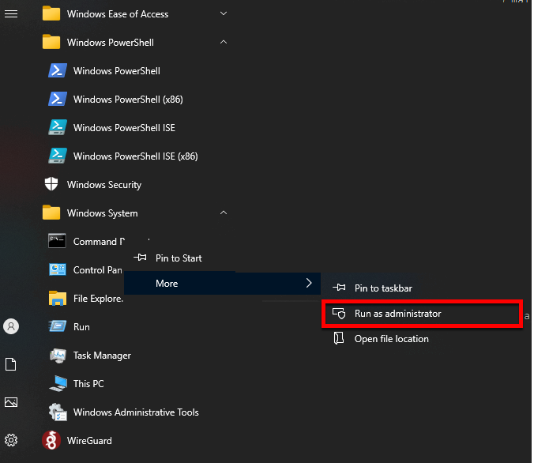

Make sure to select Run as Administrator. A confirmation dialog will appear.

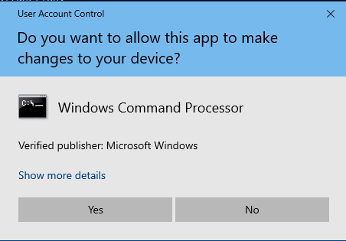

Press Yes. You should see the terminal window appear.

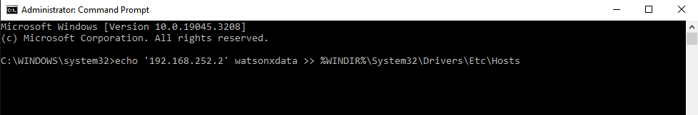

Copy the command below into the window and hit Enter to execute it.

echo '192.168.252.2 watsonxdata' >> %WINDIR%\System32\Drivers\Etc\Hosts

## **Python and Jupyter Connection Code**

Your Python or Jupyter notebook code will need to import the prestodb library and then connect to watsonx.data using the connect call.

import prestodb

conn = prestodb.dbapi.connect(

host='watsonxdata',

port=8443,

user='ibmlhadmin',

catalog='tpch',

schema='tiny',

http_scheme='https',

auth=prestodb.auth.BasicAuthentication("ibmlhadmin", "password")

)

conn._http_session.verify = '/certs/lh-ssl-ts.crt'

cur = conn.cursor()

In the above connection string, you will need to replace the following values:

* host - watsonxdata when connecting to the image externally, and  ibm-lh-presto-svcwhen connecting internally
* catalog - What is the name of the catalog that we are accessing
* schema - The schema inside the catalog that will be used

You also need to update the conn._http_session.verify value with the location where you downloaded the lh-ssl-ts.crt file. For internal connections, this value will be /certs/lh-ssl-ts.crt.

Once connected, you can run an SQL statement and return the results.

cur.execute("SELECT * FROM tpch.tiny.customer")

rows = cur.fetchall()

The rows variable contains the answer set from the select statement. You can manipulate the row variable to view the results.

rows[0]

[1,

'Customer#000000001',

'IVhzIApeRb ot,c,E',

15,

'25-989-741-2988',

711.56,

'BUILDING',

'to the even, regular platelets. regular, ironic epitaphs nag e']

The PrestoDB driver supports the DBAPI spec. For more details on the use of the DBAPI interface, please refer to <https://peps.python.org/pep-0249/>.

For instance, if you want to find the description of the columns returned, you would use the description function.

cur.description

[('custkey', 'bigint', None, None, None, None, None),

('name', 'varchar(25)', None, None, None, None, None),

('address', 'varchar(40)', None, None, None, None, None),

('nationkey', 'bigint', None, None, None, None, None),

('phone', 'varchar(15)', None, None, None, None, None),

('acctbal', 'double', None, None, None, None, None),

('mktsegment', 'varchar(10)', None, None, None, None, None),

('comment', 'varchar(117)', None, None, None, None, None)]

## **Accessing watsonx.data via Pandas Dataframes**

The following code is required for accessing watsonx.data in Jupyter notebooks. Run the following code inside a notebook code cell.

%pip install ipython-sql==0.4.1

%pip install sqlalchemy==1.4.46

%pip install sqlalchemy==1.4.46 "pyhive[presto]"

The notebook may need a restart of the kernel to pick up the changes to the driver.

If you are running in a Jupyter Lab environment, you can use the most current versions of the drivers.

%pip install ipython-sql

%pip install sqlalchemy

%pip install sqlalchemy "pyhive[presto]"

Once the drivers have been loaded, you will need to extract the certificate from the watsonx.data server that we will use in the connection.

scp watsonx@192.168.252.2:/certs/lh-ssl-ts.crt /Users/myname/Downloads

Change the target directory to a location that you can remember! Next add the following host information to your local hosts file. You may need to authenticate on your workstation in order to change the file.

**Mac OSX Hosts File**

echo '192.168.252.2' watsonxdata | sudo tee -a /etc/hosts

**Windows Hosts File**

Run the following as an administrative user.

echo '192.168.252.2' watsonxdata >> %WINDIR%\System32\Drivers\Etc\Hosts

In your Jupyter notebook, you will need to import a number of libraries.

import pandas as pd

import sqlalchemy

from sqlalchemy import create_engine

Create a notebook cell which will contain all the credentials that are required to connect. Change the catalog, schema and certfile to your values.

userid = "ibmlhadmin"

password = "password"

hostname = "watsonxdata"

port = "8443"

catalog = "tpch"

schema = "tiny"

certfile = "/certs/lh-ssl-ts.crt"

connect_args={

'protocol': 'https',

'requests_kwargs': {'verify': f'{certfile}'}

}

In the above settings, you will need to replace the following values:

* hostname - watsonxdata when connecting to the image externally, and  ibm-lh-presto-svc when connecting internally
* catalog - What is the name of the catalog that we are accessing
* schema - The schema inside the catalog that will be used

You also need to update the certfile value with the location where you downloaded the lh-ssl-ts.crt file. For internal connections, this value will be /certs/lh-ssl-ts.crt.

To create a connection to the database, use the following syntax.

engine = create_engine(

f"presto://{userid}:{password}@{hostname}:{port}/{catalog}/{schema}",

connect_args=connect_args

)

Now that you have established a connection, you can use the Pandas read_sql_queryfunction to execute a SELECT statement against the database.

mypresto = pd.read_sql_query('SELECT * from tpch.tiny.customer',engine)

The variable mypresto contains the dataframe generated from the SELECT statement.

mypresto

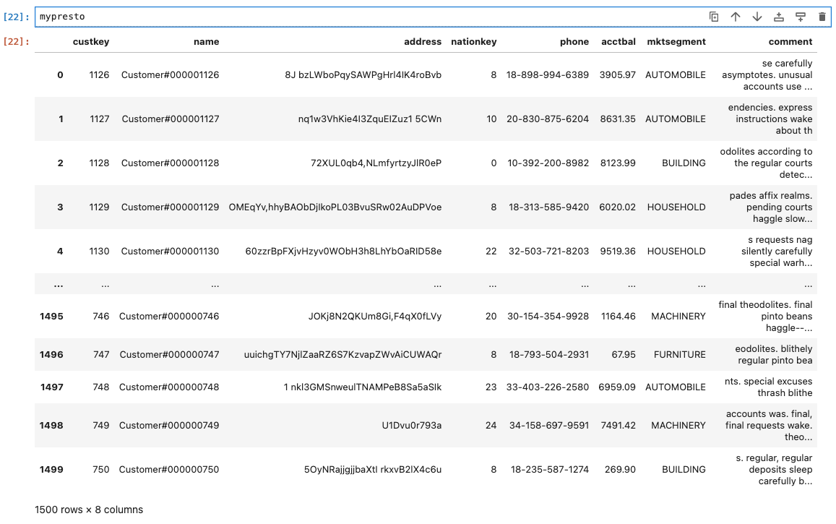

You can use the features of Pandas to generate plots of the data in your notebook. First make sure you have matplotlib installed.

%pip install matplotlib

The following query will compute the total account balance across all nation key values.

sumbynation = pd.read_sql_query('SELECT "nationkey", sum("acctbal") from tpch.tiny.customer group by "nationkey" order by 2',engine)

Finally, we plot the results.

df.plot(kind="bar", x="FirstName", y="LastName")

plt.show()

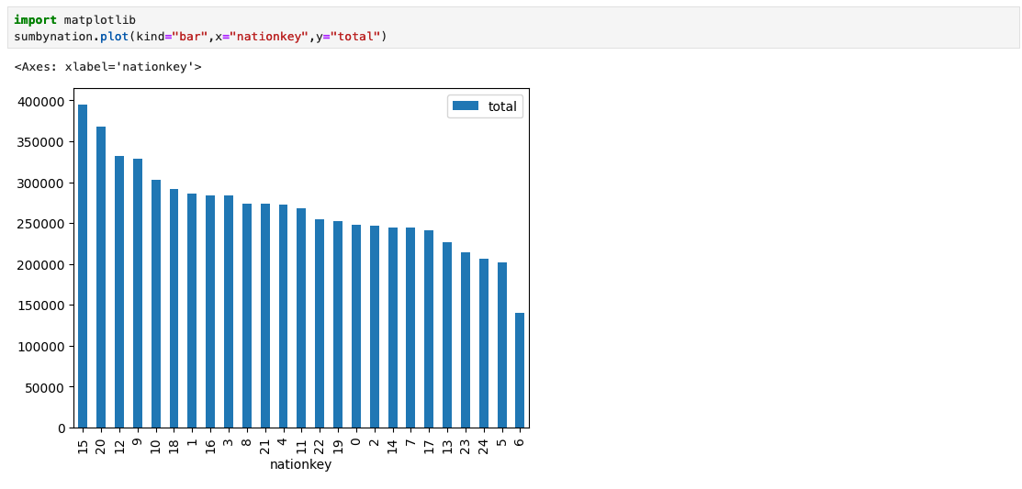

# IBM watsonx.data VMware Image

The IBM watsonx.data lab can be run in a virtual machine environment using VMWare Workstation, VMWare Fusion, or Oracle VirtualBox. The location of the OVA file (a compressed OS image format) is provided in the TechZone page for the lab:

<https://techzone.ibm.com/collection/ibm-watsonxdata-developer-base-image>

Select the resources tab to get details on how to download the file.

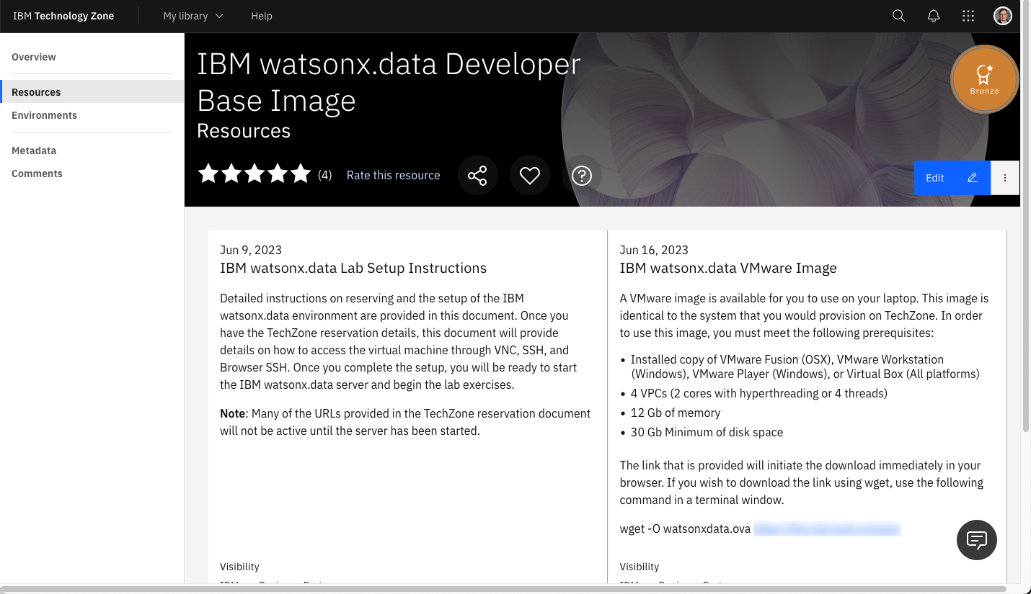

Download the watsonxdata.ova file onto your local machine and then use the import function of VMware or VirtualBox to register it with the system.

**Note**: this virtual machine was created using X64 (Intel) hardware so this may not work in an OSX environment using M1/M2 chips. Once the machine is imported you can delete the OVA file.

Before starting the machine, you may want to adjust the hardware requirements.

* vCPUs – 4 VPCs minimum
* Memory – 16Gb minimum (You can try 12Gb but tight!)
* Disk – 30Gb initial size, but the image will grow in size
* Disable side channel mitigation ON (VMware only)

### **VMware URLs**

All the URLs in the lab use 192.168.252.2 as the host. When running in the VMWware image, you must use localhost for the addresses. You must substitute localhost for the 192.168.252.2 address when you come across it in the documentation.

The following URLs and Ports are used to access the watsonx.data services. The ports that are used in the lab are listed below.

* <https://localhost:9443> - watsonx.data management console
* <http://localhost:8080> - Presto console
* <http://localhost:9001> - MinIO console (S3 buckets)
* <https://localhost:6443> - Portainer (Docker container management)
* <http://localhost:8088> - Apache Superset (Query and Graphing)
* 8443 - Presto External Port
* 5432 - Postgres External Port
* 50000 - Db2 Database Port

**The Apache Superset link will not be active until started as part of the lab.**

These links have been placed into the Firefox browser for your convenience.

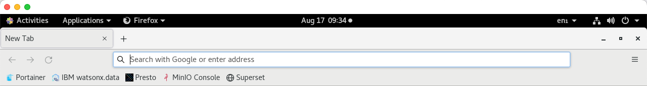

## **Starting the VMware Image**

When the machine starts, you will be prompted with the logon screen.

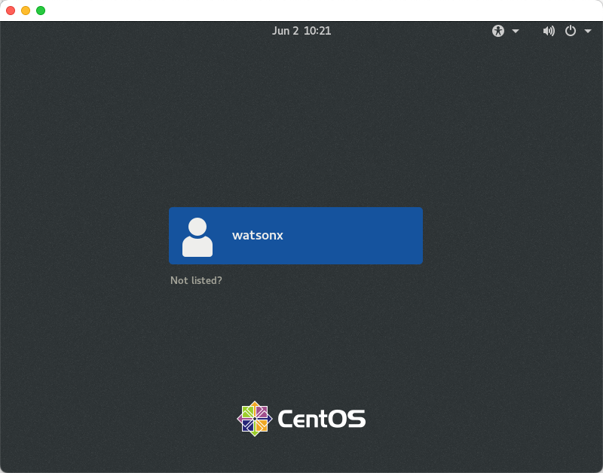

There are two userids that we will be using in the VMware image:

* root – password watsonx.data
* watsonx – password watsonx.data

When successfully logged in you should see the following screen.

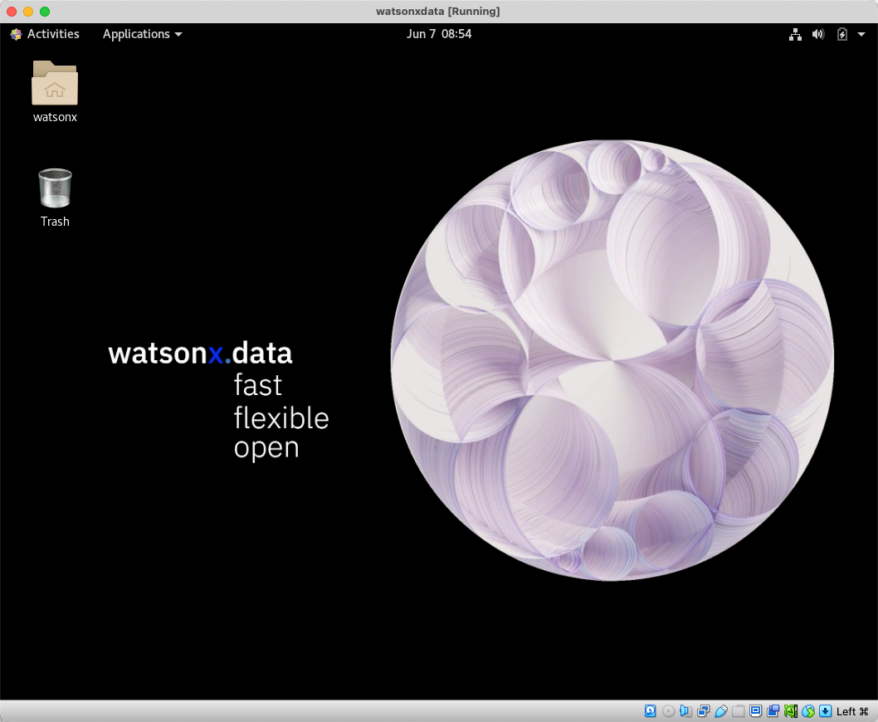

Next, check that your network connection is up and running. You will be able to see if the network is connected when the network icon appears on the top row.



If it shows Wired Off, make sure to turn it on by clicking on the arrow and choosing “Connect”.

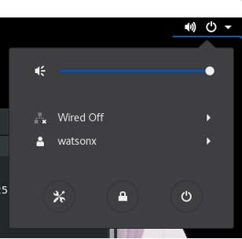

If you are using something other than an English keyboard, click on the en1 symbol on the top bar to switch to a different layout. If your keyboard is not listed, you will need to go into Settings and add your keyboard layout.

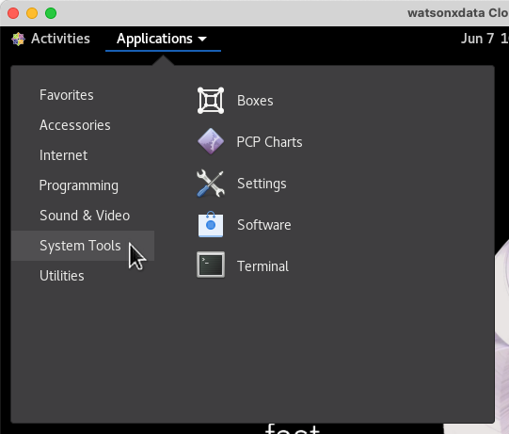

You may also want to consider making the screen size larger. Use the drop-down menu at the top of the screen to select System Tools -> Settings.



In the Devices section of the Setting menu, select Displays and choose a resolution that is suitable for your environment.

## **Using External Ports with VMware/Virtual Box**

The labs assume that you are using a browser "within" your virtual machine console. However, both VMware and VirtualBox provide a method for accessing the ports on the virtual machine in your local environment.

### **VMware**

For VMware, the easiest way to connect to the virtual machine from your host machine is to use the ifconfig command to determine your virtual machine IP address.

ifconfig

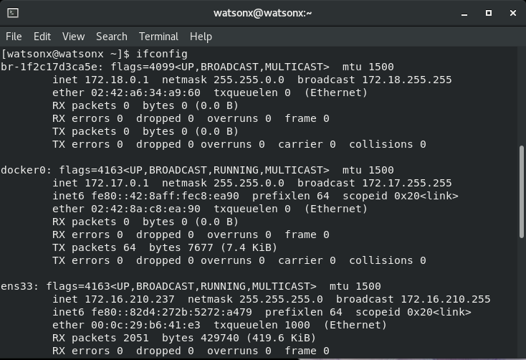

Search for an ensxx** value in the output from the command. There you should see the inet address of your virtual machine (172.16.210.237). To access the Portainer application from your local browser, you would use this address followed by the Portainer PORT number: https://172.16.210.237:6443.

Remember that inside your virtual machine, you will be using https://localhost:6443. The following PORT numbers are open in the machine:

* 9443 - IBM watsonx.data management console
* 8080 - Presto console
* 9001 - MinIO console (S3 buckets)
* 6443 - Portainer (Docker container management)
* 8088 - Apache Superset (Query and Graphing)
* 5901 - VNC Access (Access to GUI in the machine)
* 7681 - SSH (Terminal access) via Browser
* 22 - SSH (Terminal access) via local terminal program
* 8443 - Presto External Port (dBeaver connection)
* 5432 - Postgres External Port (dBeaver connection)

### **VirtualBox**

VirtualBox does not externalize the IP address of the virtual machine. The ifconfigcommand will provide an IP address of the machine, but it will not be reachable from your host browser. To open the ports, you must use the network option on the virtual machine. This step can be done while the machine is running. From the VirtualBox console, choose Settings for the machine and then click on the Network option.

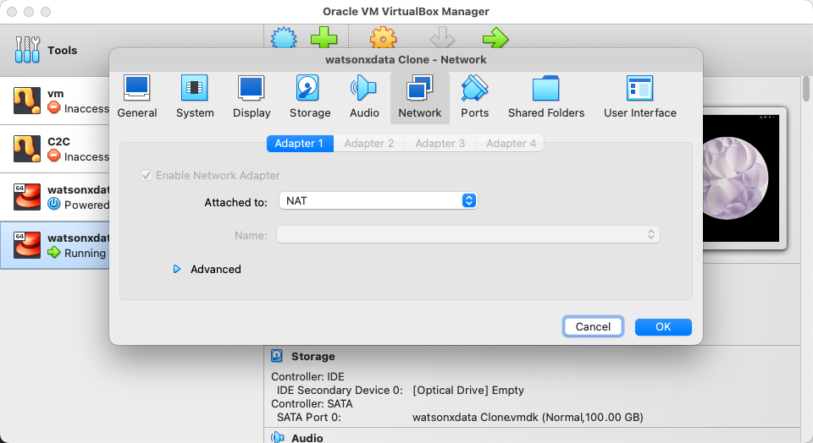

Press the Advanced option near the bottom of the dialog.

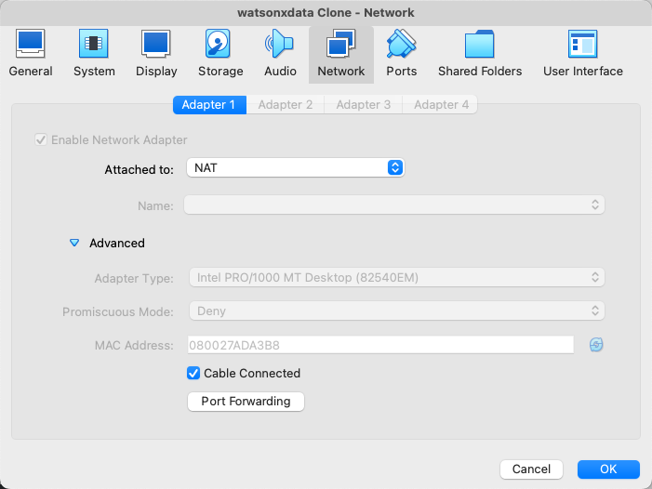

Select the Port Forwarding button. This will display the port forwarding menu.

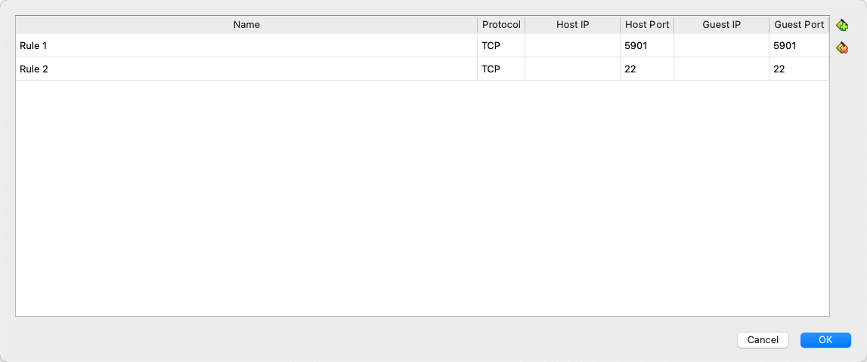

You must place an entry for each port that we want to externalize to the host machine. If the value for Host IP is empty (blank), it defaults to localhost. In the example above, the 5901 port in the Guest machine (watsonxdata) is mapped to the host machines 5901 port. To access VNC, you would use localhost:5901. If the guest machine port conflicts with the host machine port number, you can use a different port number.

## **Terminal Command Window**

All the commands in the lab will require you execute commands in a terminal window. In addition, the labs require access to the root userid, and this can be accomplished in two ways that are described below.

### **Local Terminal Shell**

Use a local terminal shell (iterm, Hyper, terminal) and use the SSH command to shell into the machine. For the VMware image, you need to know the IP address of the image and the port number that has been exposed for SSH command (default is 22). Assuming that your VMware machine has an IP address of 172.16.210.237, the command to SSH into the machine would be:

ssh watsonx@172.16.210.237

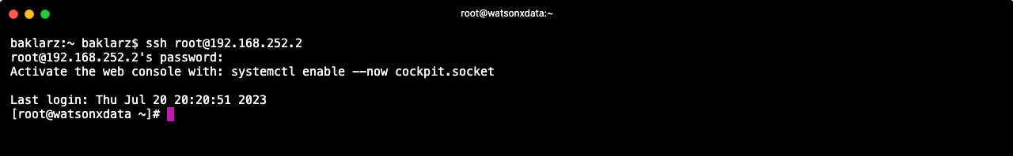

You will need to accept the unknown host warning and then provide the password for the watsonx userid: watsonx.data.

At this point you are connected as the watsonx user. To become the root user, you must enter the following command in the terminal window.

sudo su -

Now as the root user you will be ready to run the commands found in the lab.

### **Terminal Window in Virtual Machine**

You can use the Terminal application in the virtual machine to issue commands.

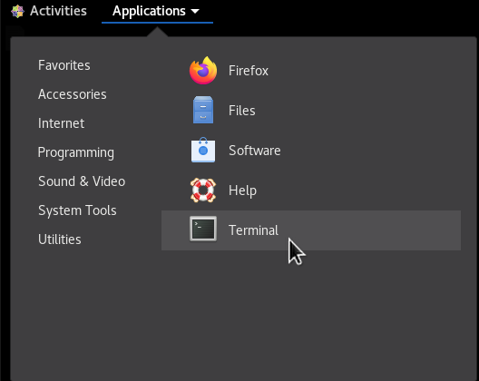

This will open up the terminal window.

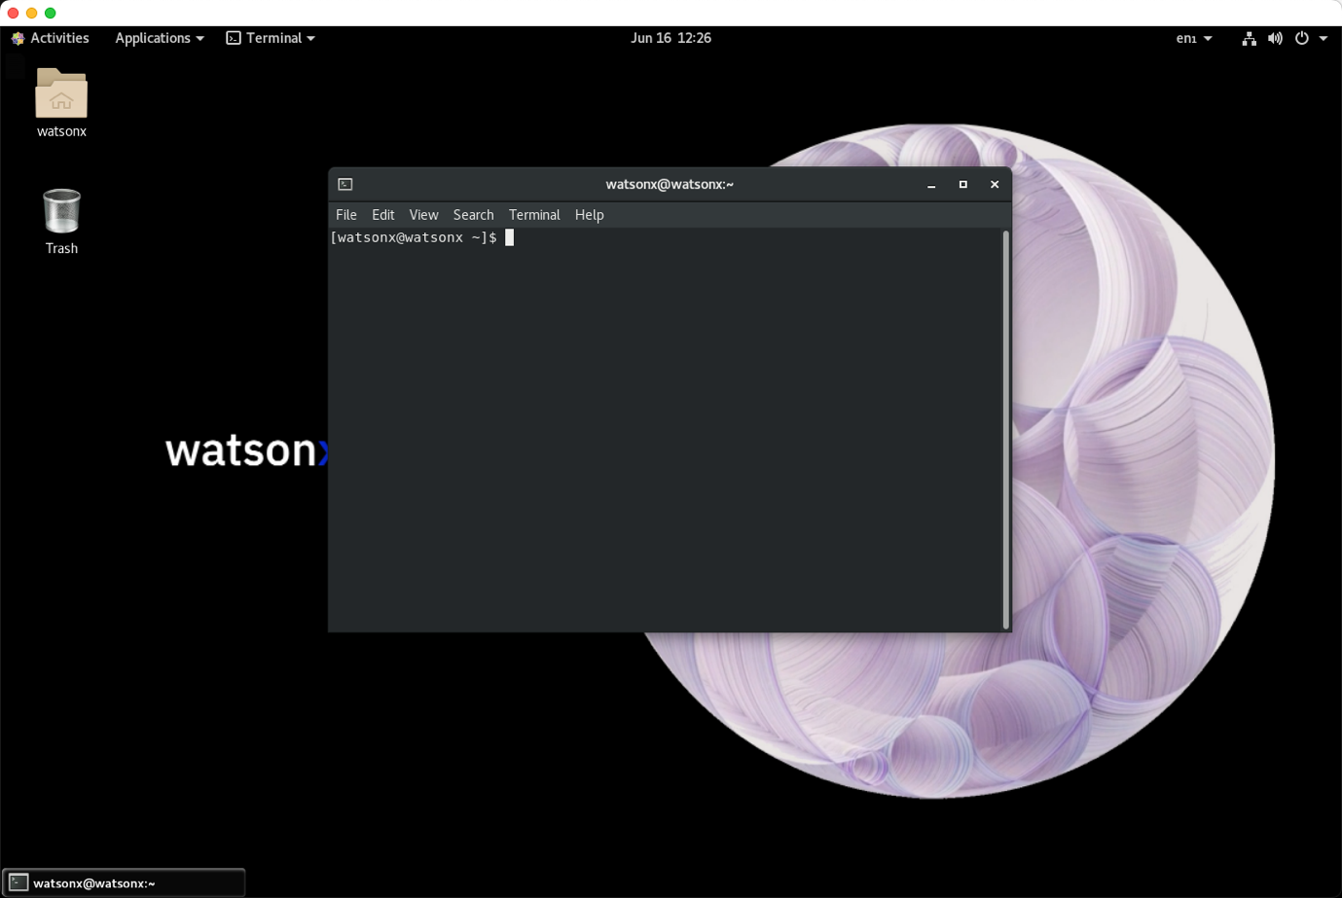

At this point you are connected as the watsonx user. You can ignore any lab instructions that ask you to ssh into the watsonx server. To become the root user, you must enter the following command in the terminal window.

sudo su -

Now as the root user you will be ready to run the commands found in the lab.

# Glossary

**Apache Superset**: Apache Superset is an open-source software application for data exploration and data visualization able to handle data at petabyte scale. Apache Superset is a modern, enterprise-ready business intelligence web application. It is fast, lightweight, intuitive, and loaded with options that make it easy for users of all skill sets to explore and visualize their data, from simple pie charts to highly detailed geospatial charts.

Application Programming Interface (API)**: Application Programming Interface (API) is a programmatic interface for executing functions of an application in an automated or manual fashion without using a CLI or User Interface.

**Buckets**: Buckets are the basic containers that hold your data. Everything that you store in Cloud Storage must be contained in a bucket. You can use buckets to organize your data and control access to your data, but unlike directories and folders, you cannot nest buckets.

**Catalog**: This term may have many meanings depending on context. Review below:

* **Service Catalog** - A service catalog is a comprehensive list of cloud computing services that an organization offers its customers. The catalog is the only portion of the company's service portfolio that is published and provided to customers as a support to the sale or delivery of offered services.
* **Data Catalog** - A collection of business information describing the available datasets within an organization.
* **Metastore Catalog** - A collection of technical and operational metadata allowing a query engine to overlay a virtual table on a collection of discrete data files.
* **Connector Catalog** - The named representation of a connector within the virtual warehouse of a presto instance.

**Command Line Interface (CLI)**: A command-line interface (CLI) is a text-based user interface (UI) used to run programs, manage computer files and interact with the computer.

**dBeaver**: DBeaver is a SQL client software application and a database administration tool. For relational databases it uses the JDBC application programming interface to interact with databases via a JDBC driver. For other databases it uses proprietary database drivers.

**Federation**: A federated database is a system in which several databases appear to function as a single entity. Each component database in the system is completely self-sustained and functional. When an application queries the federated database, the system figures out which of its component databases contains the data being requested and passes the request to it. Federated databases can be thought of as database virtualization in much the same way that storage virtualization makes several drives appear as one.

**MinIO**: MinIO is a high-performance, S3 compatible object store. It is built for large scale AI/ML, data lake and database workloads. It runs on-prem and on any cloud (public or private) and from the data center to the edge. MinIO is software-defined and open source under GNU AGPL v3.

**Object Storage**: Object storage is a data storage architecture for storing unstructured data, which sections data into units—objects—and stores them in a structurally flat data environment. Each object includes the data, metadata, and a unique identifier that applications can use for easy access and retrieval.

**Presto**: Presto is a distributed database query engine (written in Java) that uses the SQL query language. Its architecture allows users to query data sources such as Hadoop, Cassandra, Kafka, AWS S3, Alluxio, MySQL, MongoDB and Teradata, and allows use of multiple data sources within a query. Presto is community-driven open-source software released under the Apache License. Presto's architecture is very similar to other database management systems using cluster computing, sometimes called massively parallel processing (MPP).

**SPARK**: Apache Spark is an open-source unified analytics engine for large-scale data processing. Spark provides an interface for programming clusters with implicit data parallelism and fault tolerance. Spark can be used with watsonx.data but is not included in the watsonsx.data environment image provided.

**TechZone (IBM Technology Zone)**: IBM Technology Zone is the platform where the developer edition of watsonx.data with the sample data sets has been provisioned. Generally, it allows Go To Market teams and Business Partners to easily build technical 'Show Me' live environments, POTs, prototypes, and MVPs, which can then be customized and shared with peers and customers to experience IBM Technology.

**VNC (Virtual Network Computing)**: VNC is a cross-platform screen-sharing system that uses the Remote Frame Buffer (RFB) protocol. VNC was created to control another computer remotely. You may know it best for its role in tech support services. Use of VNC is optional. VNC can be used after the WireGuard VPN has been activated to access the watsonx.data server.

**WireGuard**: WireGuard is a communication protocol and free and open-source software that implements encrypted virtual private networks, and was designed with the goals of ease of use, high speed performance, and low attack surface. You will need to install the Wireguard software and download the server VPN certificate in order to access the watsonx.data server.